Robbery - Sunday, November 21, 2004
District Case #04-17-060852
Stolen from Practice Space at 1170 S. Broad Street
17th Police District, 20th & Federal
Detective Hunter (215-686-3103/3104)
Jack Hopkins (C: 215-280-9956)

Gear Stolen:
Cordalene (photos following):
- 1997 Epiphone 335 Dot autographed by Noel Gallagher of *Oasis* with hard shell case
- 1975 White Fender Stratocaster (black pickguard, maple neck) possibly bloody from use, with hard shell case
- 1990ish Gibson Les Paul Studio, cherry red, missing a couple knobs, in bag
- 2001 Gibson Les Paul Standard Classic 1960. Light tobacco sunburst, possibly bloody from use, without case
- Mandolin, electric
- custom handmade guitar, top is 3/4" purpleheart, back is 3/4" mahogany, PBC Tension Free neck, kahler tremolo, Spertzel locking tuners (B.C. Rich Mockingbird Style), superior gig bag
- 4-track analog recorder
- bag of pedals and cords, 1 tuner, 1 bass overdrive

One Star Hotel:
- fold-flat hand truck
- 1998 Fender American Telecaster clear finish, white pickguard (Serial #N7244235)
- 1970's Gibson SG with Bigsby Tremolo, brown
- Nord Lead 2 keyboard (new)
- 1985 Juno 106 keyboard
- 1680 Roland hard disk recorder
- Behringer mixer, 12 channel
- CD burner HHB 830
- Roland KC-300 amplifier

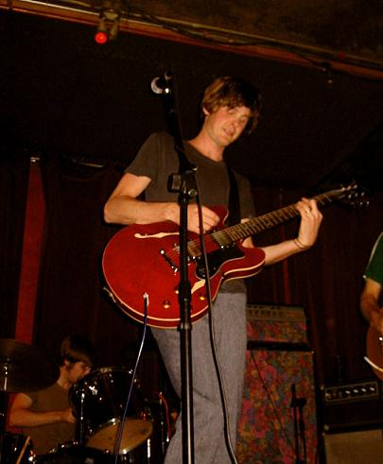
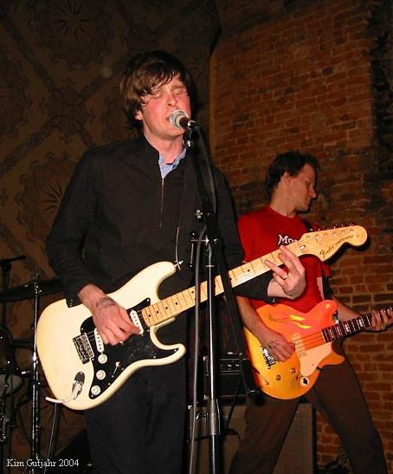
1997 Epiphone 335 Dot autographed by Noel Gallagher of *Oasis* with hard shell case

1975 White Fender Stratocaster (black pickguard, maple neck) possibly bloody from use, with hard shell case

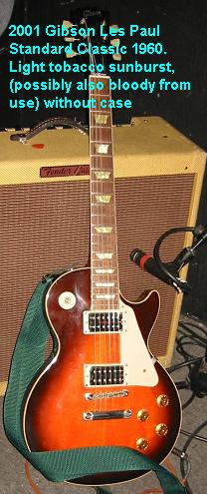
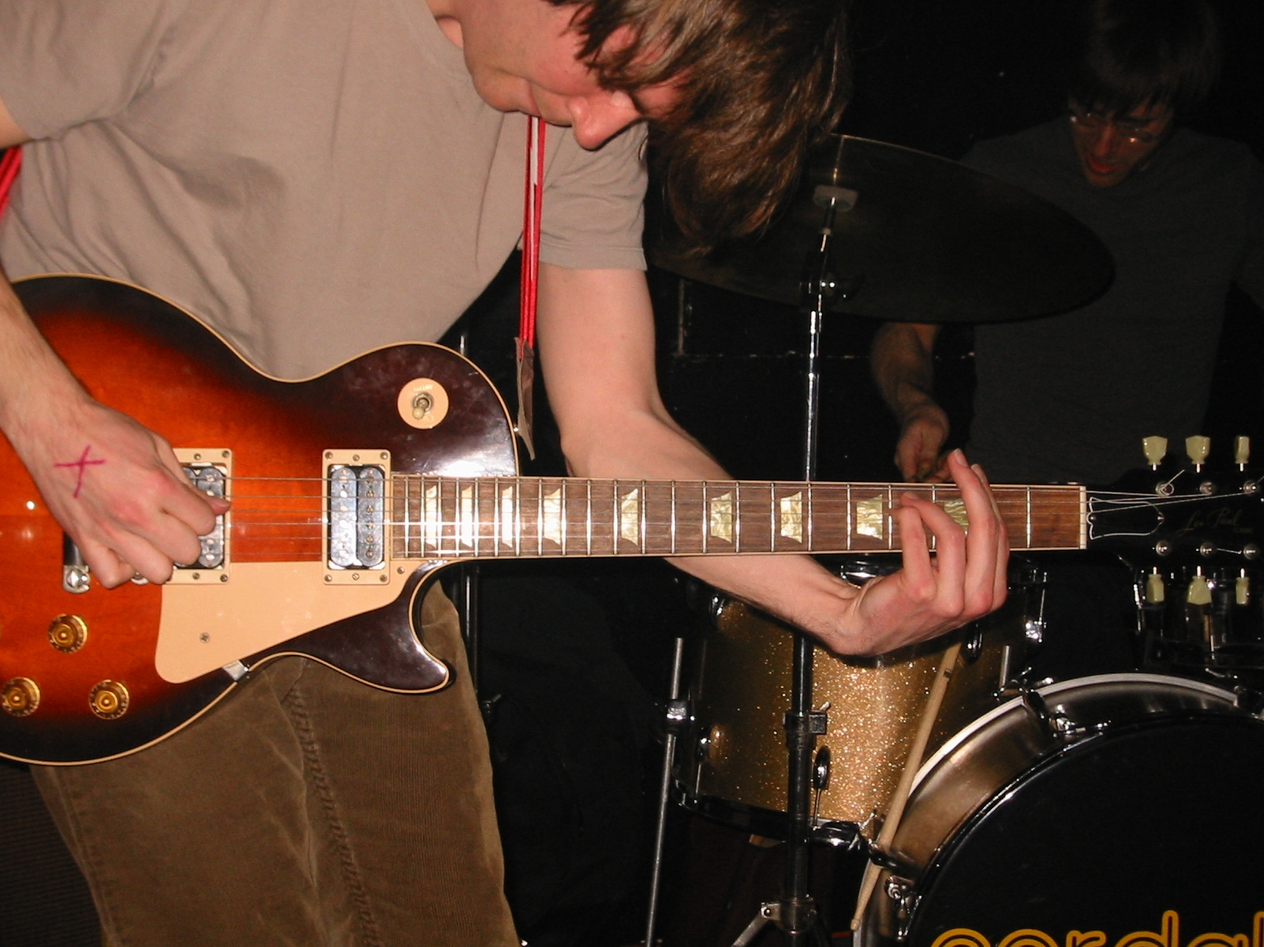
2001 Gibson Les Paul Standard Classic 1960. Light tobacco sunburst, possibly also bloody from use, without case

