2022 ABCs of Patch Design – The Flow of Our Patch Design To Production
Take a look at the flow of designs and changes. Initially, the PTC Director said they couldn’t use another PTC patch as 4 patches already covered most of the segments around this design, they didn’t have budget to make the patch, etc. As you can see, there were several renditions of the deer, the text, adding the fleur di lis, and placing more “texture” to the deer was what we were looking for in order to get as close as we could to the original rendition.
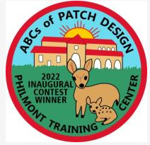  First – This was the first rendition after I took the original design and changed to fit a 3 inch patch design. | 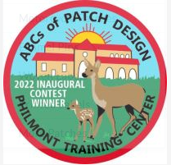  Second – change contest text from black to white. Change mule deer to look more realistic. I sent several pictures of mule deer.
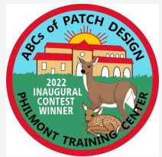  Third – Change White text to flow top to bottom, change mule deer to original positions | 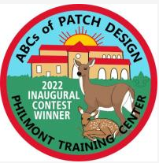  Fourth – Add Fleur Di lis but I didn’t want it ghosted.
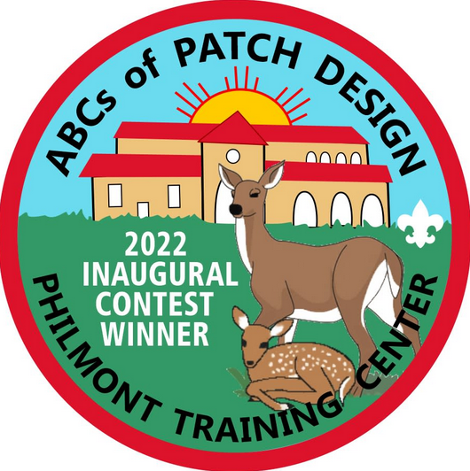  Fifth – Turn Fleur Di Lis to White so it’s not ghosted. Asked for more texture to the skin of the mule deer so this would make it more realistic. I wanted more texture but I was ok with final result. | 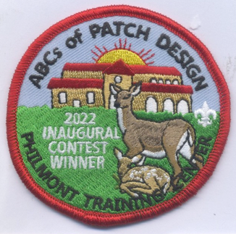  Sew Out Final – The graphic designer didn’t follow my original instructions so they were responsible for some errors and we had 5 revisions. Normally, my experience is they allow 3 revisions but their mistakes allowed 5.

