1992 OA Philmont Fund Raiser – Actual Campaign

We began our Order of the Arrow Lodge 489 Woapalanne Chapter Winter “Kanik” Philmont program during 1991. Although we promoted our opportunity within Woapalanne Chapter, we accepted Scouts from all over Lodge 489 for any of our Philmont adventures.

(Note: These are true stories. My interest in providing these stories is not to brag but rather let you see what worked, what didn’t, be cost efficient, generate participation, and inspire our Scouts and Scouters. I’ve been successful because I’ve failed … and I learned how to be successful from the events that didn’t go well. )

Compelling Reason:
OA Scouts all over Longhorn Council wanted to go to Philmont but were restricted because their own Troop wasn’t ready. Our Chapter fulfilled that desire. In addition, we were the FIRST from Longhorn Council to attend the Winter Kanik program (Now known as Winter Philmont).

Patch Design

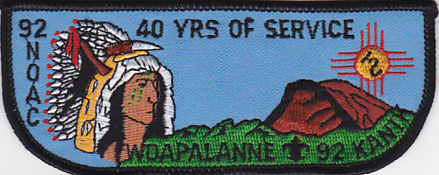 | Although 1992 was our second Winter Kanik adventure, our patch did extremely well because it featured our participation at Philmont, recognized 40 years of Nishkin Lodge 489 service, and our chapter participants purchased it for trading at the 1992 NOAC.

Patchonomics

Assumptions:
- OA Chapter Trading Post at Camporees 1988-1997.
- 300 2 inch by 5 inch Flap style patches = $ 300. The Lodge Advisor would not give us permission to use the Lodge name/number but he said we could create a “Chapter Flap” with our Chapter name on it.
- Spring OA Lodge Ordeal – Chapter Trading Post.
- Success Factors. All these are potential “targeted audiences” who would purchase one or more patches.
  - Philmont Collectors. A Philmont Winter Kanik Trek patch
  - OA Collectors. An OA Philmont Kanik Trek from Lodge 489 – FIRST known OA Flap Style patch for Kanik program.
  - ISCA Member. Nationwide patch collector magazine where we could post Ads.
  - Trading Post at more events where there were many patch buyers from different areas
- Patchonomics (all are approx. numbers)
  - 300 2 inch by 5 inch quantity at $ 1 each = $ 300 cost.
  - 12 FREE for contingent members
  - 24 extra sold to contingent members at $ 3 each = $ 72. Telling them they could purchase at lower than our sales prices generated these sales.
  - ISCA Magazine Ad. Placed Ad in the March ISCA News and it generated sales. $ 25 Ad cost but magazine went out to patch traders nationwide.
32 - 1992 patches @ $ 5 each Or 2 for $ 8 = $ 80
  - 1988-1991 Patches sold for approx (Individually or as sets) $ 35
  - Spring Camporee – 20 sold @ $ 3 = $ 60. OA Trading Post during District Camporee.
  - OA Ordeal - Chapter Trading Post.
30 1992 contingent patches sold @ $ 4 each = $ 128
  - Breakeven Point. At this point, the patches were paid for with 138 patches sold which means there were 162 patches left at no cost.
  - Lone Star Trade O Ree. 1992 Flap sold 20 @ $ 4 ea = $ 80. These patches added to a larger fund raising total but I only want to show the patches side of income story for our ABCs Patchonomics.
  - Fall Camporee – 10 misc patches x $ 4 ea = $ 40
  - Individual Sales. We did not have eBay, Facebook or Etsy yet, But it was always very easy to bring to each OA event because we utilized the “2 minute trading post” feature. We carried 1 box but it provided us the opportunity to sell $ 20-40 worth of patches wherever we went.

Post 1992 Philmont
- OA Philmont T - Shirts. We purchased a bulk number of T Shirts with Woapalanne Chapter text on top, the image of an Indian Peace Pipe and left the bottom portion blank. Each year, we would take about 12 T Shirts and have Philmont Kanik, Cavalcade or Philmont Trek printed on the bottom portion of the shirt. It cost very little to do this but we were always displaying our program that no one else was offering.
- Cash Donations. Scouters within our District saw that we were truly offering anyone the opportunity for Philmont so several decided to make cash donations supporting us.

Patch Ad Sample
It’s important to have ..

- *Adjective Examples – “one of a kind” “Philmont Training Conference” “First of its kind”
- *Organization. The word Philmont, Jamboree, or OA are needed on the patch when it applies.
- *Offer and Discount for volume sales $ 5 each or 2 for $ 8. If applicable, always mention if its for Boy Scout Scholarships somehow because this will generate more sales in many cases.
- *Add postage or not – you decide
- *Form of payment – check and who it’s made out to. If its for Boy Scout Scholarships, its best to have check made out to organization.
- *Name/Address for mailing
- *Urgency – “Limited Availability” OR “Selling like hotcakes … Get Yours Now!”
- *Image of patch – Use Camera Ready Art from graphic artist so it can be published in email newsletters, etc. When you have this quality, it looks good wherever you place an Ad. You need to make sure that the size of the Ad will allow a good look at the image of the patch. If no one can see it, few will buy it.
- *Size. Sometimes I place this in ad so Patch Buyers know it’s a normal or bigger than normal size patch. It lends credibility.
- *Sample Ad. See below an example of an Ad featuring last years ABCs patch. Just switch out the text in the Ad below for how it applies in your situation.
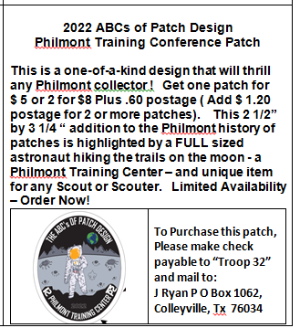

See Below For A Patch Description Page Where You Can Tape The Actual Patch Onto the paper, place the patch page/patch into a sheet protector, place in binders and you will have a ready made “2 Minute Trading Post.”

1992 Order of the Arrow
Woapalanne Chapter Contingent
Philmont Scout Ranch Kanik
Lodge 489 Woapalanne Chapter OA contingent patch to Kanik winter program during the early years of Philmont's Kanik program. The “40 ” within the red arrow honors the 1992 40th Anniversary of Nishkin Lodge 489 existence within Longhorn Council before it was merged with Huaco Lodge. During January 1992, OA Longhorn Council members flew into Amarillo Airport, drove rented cars to Philmont and participated in the “Kanik” program. Woapalanne Chapter was a pioneer in offering Lodge wide invitations to any Scout or Scouter who wished to participate.
Woapalanne Chapter was one of the first Scouting groups to participate in winter Kanik on an annual basis and blazed the trail for others to follow. During the 1991 thru 1996 series of Kanik Expeditions, Scouts from 3 Chapters and 12 Troops took advantage of this unique Philmont program.
This is a greater collectible now that Philmont has changed the program name from Kanik to Winter Adventure. This is one of only a few contingent collectibles for the Kanik Winter program. Rarity equals big increase in value.

