1991 Philmont “Kanik” Trek – OA Contingent Patch Design – The Story

Our OA Philmont program was fortunate that there was one adult who consistently wanted to hike Philmont every summer. He had 2 sons who went with him and they enjoyed it tremendously. With the advent of YPT requirements, we automatically had 1 adult and several Scouts so it was very easy to get the 2nd adult and additional Scouts to make each trek. While visiting Philmont during 1990, and since the staff at Philmont knew our Philmont leadership after so many trips, they invited him to try out the winter Philmont program called “Kanik” (Indian for snowflake).

During January 1991, we flew a contingent to Amarillo airport, they drove to New Mexico and had a great time. We were the very first to do this from Longhorn Council. It was perfect … schools were out for Martin Luther King Jr holiday, the air fares were lower during January so our DFWAMA round trip flight was around $ 35, we rented several cars that had promotional rates and then Philmont had a very low introductory program rate. It cost $ 90 for a Philmont Cross Country Ski weekend per person.

Everything came together with this patch.

(Note: These are true stories. My interest in providing these stories is not to brag but rather let you see what worked, what didn’t, be cost efficient, generate participation, and inspire our Scouts and Scouters. I’ve been successful because I’ve failed … and I learned how to be successful from the events that didn’t go well. )

Patch Design

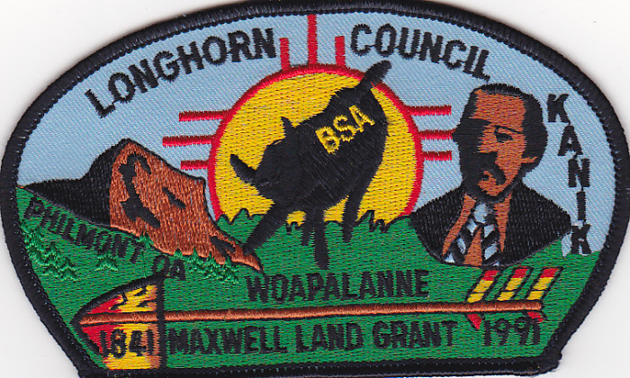 | The familiar New Mexico Sun, the figure of Maxwell (owner of original land grant that Philmont stands on), the Tooth of Time and getting permission to place “Longhorn Council” on our patch exponentially expanded our fund raising.

When we opened up our Philmont trips to OA Lodge 489 in 1991, we never had a problem raising funds, promoting our patches or any of the normal difficulties that everyone else was having for the remainder of our trips. When this happened, our program accepted Scouts Lodgewide, Scouts of our Chapter began leading the Lodge, new Scouts going to Philmont began leading our Chapter and we offered a trip to PHILMONT FOR LESS THAN THE PHILMONT FEE because all our fund raising was exceeding estimates. When my son left Cub Scouts for Boy Scouts, and our annual Philmont Leadership moved to North Carolina, our last trip was a Philmont Cavalcade during 1997.
Patchonomics
If we knew all the accumulated lessons that we knew in 1991 … but could have started them in 1988, we would have exceeded all expectations 3 or 4 years earlier. This is the reason for our ABCs of Patch Design course at the Philmont Training Center.

Avoid Mistakes = Increase Success Factors = Improve Your Success Percentage

Assumptions:
- OA Chapter. Although I had reached 5 years of OA Associate Advisor, I decided to continue because, by now, we were reaping the benefits. We had Scoutmasters of Troops bringing their Scouts to our Chapter Meetings and “releasing” them to participate in the OA. We began welcoming the best leadership to our Chapter. Because of this, they were buying more of our chapter patches because they knew one of their Scouts may get a Philmont opportunity that they couldn’t offer. We asked permission for an OA Chapter Trading Post at Camporees and were allowed to do this from 1988-1997.
- 300 3 inch by 5 inch patches. This was the only patch we produced that was 3 x 5 inches (Note: the Maxwell Land Grant official New Mexico State Logo - image of Maxwell – needed to be included)
- Lodge Ordeal. We asked permission from the Lodge to have our own Chapter Trading Post at the Ordeal … we told them we weren’t going to sell any Lodge stuff so we weren’t competing with them.
- Several Mothers sewing Neckerchiefs as a donation. We did minimal Neckerchiefs and Hats but it increases the “package” price to generate more money.
- Success Factors. All these are potential “targeted audiences” who would purchase one or more patches.
  - Philmont Collectors. One patch – 2 Philmont programs: A Philmont Winter Kanik Trek patch AND a Philmont Trek patch during the same year.
  - OA Collectors. An OA Philmont Trek from Lodge 489 – FIRST known OA Trek from the Lodge (Scouts from 3 chapters attended). We were the first to place “OA” on a CSP … because it increased the “had to get it” value of the patch.
  - CSP Collectors. The addition of “Longhorn Council” on a CSP increased the value exponentially
  - Join ISCA. Nationwide patch collector magazine.
  - Trading Post at more events where there were many patch buyers from different areas
- Patchonomics (all are approx. numbers)
  - 300 3 inch by 5 inch quantity at $ 1.50 each = $ 450 as cost. Since so many more Scouts and Scouters came forward to participate, it wasn’t work anymore as I was facilitating tasks to more people so it became so much fun. I extended my commitment until 1998 when I began another program that would involve my son entering a Boy Scout Troop.
  - 12 FREE for contingent members
  - 24 extra sold to contingent members at $ 3 each = $ 72. Telling them they could purchase at lower than our sales prices generated these sales.
  - ISCA Magazine Ad. Placed Ad in the March ISCA News and it generated the most sales we had to date. $ 25 Ad cost but magazine went out to patch traders nationwide.
40 - 1991 patches @ $ 5 each Or 2 for $ 8 = $ 160
  - Our prior patch issues from 1988-1990 sold for approx (Individually or as sets) $ 40
  - Spring Camporee – 30 sold @ $ 3 = $ 90. OA Trading Post during District Camporee.
  - OA Ordeal - Chapter Trading Post.
75 1991 contingent patches sold @ $ 4 each = $ 300
800 Hat Pins and Misc sold @ $ 2.25 each = $ 800 was our split
After receiving permission, everyone visited our trading post because we had a larger selection (based on a vendor who let us sell some of his stuff in an agreement where we received a cut). This was a huge fund raiser and allowed our chapter, for the first time, to charge a fee LOWER than the Philmont fee for those who wanted to go with us.
  - Breakeven Point. At this point, the patches were paid for with 181 patches sold and good profit that lowered our Philmont fees.
  - Lone Star Trade O Ree. 1991 CSP sold 50 @ $ 4 ea = $ 200. These patches added to a larger fund raising total but I only want to show the patches side of income story for our ABCs Patchonomics.
  - Fall Camporee – We sold so many 1991 CSPs that we wanted to hold some back but we still had sales from our inventory of past patches and misc hat pins. 40 misc x $ 2.25 ea = $ 90
  - Individual Sales. We did not have eBay, Facebook or Etsy yet, But it was always very easy to bring to each OA event because we utilized the “2 minute trading post” feature. We carried 1 box but it provided us the opportunity to sell $ 20-40 worth of patches wherever we went.
  - Intangible $$$ - Series of Patches. Each year, we added another patch to the series of patches for our Philmont Trips. If you look, they were all OA but some were CSPs, some OA Flap style, some square/round and some leather. We could be flexible on offering a series in different forms so it would appeal to different groups. This widened our potential group of people who might buy the patches.

Post 1991 Philmont – If You Are Able To Work This From The Beginning
If we would have ….
- Opened our Philmont program up to the Lodge during 1988 or 1989, then we would have increased our success in leaps and bounds. This was a lesson learned and something I want others to know so you can realize success quicker. (Note: An intangible … because our annual Philmont Leader could talk to the Scout or Scouter and determine if they were at risk for our trip.)
- Ensure “Longhorn Council,” Woapalanne Chapter, OA, and Philmont Tooth of Time text were on our patches. Permissions are worth getting. If you are able to place your Lodge name on your patch, then that is even better (Note: we knew we wouldn’t get permission to put Lodge name on patch so we didn’t try).
- Try to include Philmont brands, New Mexico Sun, etc. on each patch. If the patch design gets cluttered, then “ghost” some of these in. Collectors look for some of these and they are easy to “ghost” on the patch.
- Request Patch Donations. These were miscellaneous patches that we could sell for any price because they were donated. We would solicit these in our newsletter to OA Chapter.
Patch Ad Sample
It’s important to have ..

- Adjective Examples – “one of a kind” “Philmont Training Conference” “First of its kind”
- Organization. The word Philmont, Jamboree, or OA are needed on the patch when it applies.
- Sample Ad. See below an example of an Ad featuring last years ABCs patch. Just switch out the text in the Ad below for how it applies in your situation.
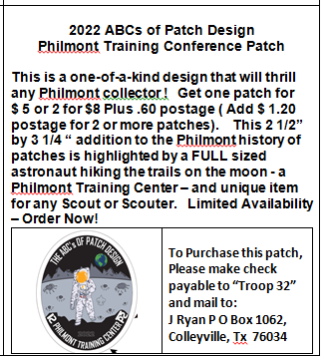
- Size – “3 x 3” Or “3 inch by 3 inch”. Sometimes I place this in ad so Patch Buyers know it’s a normal or bigger than normal size patch. It lends credibility.
- Form of payment – check and who it’s made out to. If it’s for Boy Scout Scholarships, its best to have check made out to organization.
- Name/Address for mailing
- Offer and Discount for volume sales $ 5 each or 2 for $ 8. If applicable, always mention if its for Boy Scout Scholarships somehow because this will generate more sales in many cases.
- Add postage or not – you decide
- Image of patch – Use Camera Ready Art from graphic artist so it can be published in email newsletters, etc. When you have this quality picture of your patch to use, it looks good wherever you place an Ad. You need to make sure that the size of the Ad will allow a good look at the image of the patch. If no one can see it, few will buy it.
- Urgency – “Limited Availability” OR “Selling like hotcakes … Get Yours Now!”

SEE Patch Page Description Below

SEE Patch Page Description Below

SEE Patch Page Description Below

SEE Patch Page Description Below

SEE Patch Page Description Below

SEE Patch Page Description Below

1991 Philmont Scout Ranch
Kanik OA Contingent
Longhorn Council CSP (black border)

First Known Philmont Kanik Contingent CSP is highlighted by the celebration of the 150thAnniversary of the Maxwell Land Grant.

Philmont issued instructions on a special logo celebrating the 150th Anniversary of the Maxwell Land Grant, Woaplanne Chapter organized a “Kanik” winter survival training trip that had OA Scouts from 5 different Troops attend, A video was shot and played on local Cable Television and they learned how to cross country ski in the area of Cathedral Rock. The 7 color 3 inch by 5 inch patch provides the likeness of Maxwell, a multi-colored arrow and the familiar Tooth of Time landmark featured at Philmont Scout Ranch.

Now that the winter program name has changed from Kanik "Winter Adventure," this patch becomes an even greater collectible because it was the first known Kanik contingent CSP. Its always a great pick up to get the first of anything!

