1988 50th Anniv Philmont Trek – OA Contingent Patch Design

Between 1979 and 1988, I had married, moved to a new job at American Airlines and joined Troop 7. I happened to arrive when a few of the older Scouts walked up to me and asked me about going to Philmont. This is how my patch designing and fund raising career began.

(Note: These are true stories. My interest in providing these stories is not to brag but rather let you see what worked, what didn’t, be cost efficient, generate participation, and inspire our Scouts and Scouters. I’ve been successful because I’ve failed … and I learned how to be successful from the events that didn’t go well. )

Patch Design

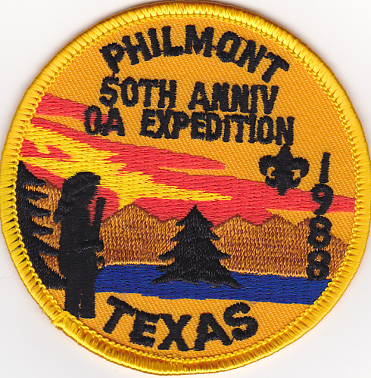 | This was my first design on my own and I was a “rookie” who made a few mistakes but placed “OA Expedition” and “50th Anniv” on the patch so it covered up my errors. I relied a lot on the patch manufacturer who really didn’t know patch design. I asked him about my design and he just said it looked good. The Philmont Collectors were nice in their ”comments” on the patch so I learned a lot about what to do.

Patchonomics

During 1988, I had become Associate Advisor of Order of the Arrow Woapalanne Chapter and our Scouts wanted to go to Philmont during the 50th Anniversary. The beginning of my policy “money should not be a reason for a Scout not to participate in a program” began because I had already seen the huge impact of the Philmont Trek on our Scouts but many Scouts who had the desire to go could not go. My Chapter Advisor let me have full rein so I began several fund raisers ... Our contingent patches became a part of that.

Assumptions:
- Committed to 3-5 years in our OA Philmont program because the Scouts who went to Philmont became active as OA Chapter officers, it drew Scouts from around our district and it generated a great deal of chapter pride.
- 300 3 inch by 3 inch patches @ approx. $ 1 each. I always ordered 300 when I knew I was going to be in a program for at least 3 - 5 years because we could begin selling “sets” of patches after 3 years.
- OA Chapter Trading Post. We asked permission for an OA Trading Post at the Spring Camporee to raise funds for Philmont Scholarship funds.
- Neckerchiefs. Several Mothers sewing Neckerchiefs as a donation. We did minimal Neckerchiefs and Hats but it increases the “package” price to generate more money.
- Success Factors. All these are potential “targeted audiences” who would purchase one or more patches.
  - Philmont Collectors.
  - OA Collectors. An OA Philmont Trek from Lodge 489 – FIRST known OA Trek from the Lodge (Scouts from 2 chapters attended because several had friends from another OA Chapter who wanted to attend).
  - ISCA Magazine. Nationwide newsletter about latest patch issues.
- These assumptions influence Quantity to order (all are approx. numbers)
  - 300 3 inch by 3 inch patch quantity at $ 1 each = $ 300 as cost.
  - 12 FREE for contingent members
  - 24 extra sold to contingent members at $ 3 each = $ 72. Telling them they could purchase at lower than our sales prices generated these sales.
  - ISCA Ad. $ 25 cost but magazine went out to patch traders nationwide.
40 - 1988 patches @ $ 5 each Or 2 for $ 8 = $ 160
  - Lone Star Trade O Ree. 1988 CSP sold 20 @ $ 4 ea = $ 80. These patches added to a larger fund raising total but I only want to show the patches side of income story for our ABCs Patchonomics.
  - Breakeven Point. At this point, the patches were paid for with 96 patches sold and good profit that lowered our Philmont transportation cost.
  - Individual Sales. We did not have eBay, Facebook or Etsy yet, But it was always very easy to bring to each OA event because we utilized the “2 minute trading post” feature. We carried 1 box but it provided us the opportunity to sell $ 20-40 worth of patches wherever we went.

Results

The Philmont fee for 1988 was approx. $ 425 per person

The contingent members used the patch for trading, sewing on the uniform, and one of the Scout mothers purchased some cloth and made neckerchiefs. She donated the neckerchief material and labor.
At Philmont, the patch and neckerchief combo traded very well.

Post – Philmont
Since this was the second Philmont trip for Troop 7 with members of the OA attending, it started a trend that went from 1988 thru 1997. We expected this to happen because there were very few Troops organized enough to send Scouts to Philmont. However, most of the Scouts wanted to go again so we were fortunate that a Scouter showed up in 1990 who wanted to go to Philmont every year with his 2 sons.
Patch Ad Sample
It’s important to have ..
*Adjective Examples – “one of a kind” “Philmont Training Conference” “First of its kind”
*Organization. The word Philmont, Jamboree, or OA are needed on the patch when it applies.
*Offer and Discount for volume sales $ 5 each or 2 for $ 8. If applicable, always mention if its for Boy Scout Scholarships somehow because this will generate more sales in many cases.
*Add postage or not – you decide
*Form of payment – check and who it’s made out to. If its for Boy Scout Scholarships, its best to have check made out to organization.
*Name/Address for mailing
*Urgency – “Limited Availability” OR “Selling like hotcakes … Get Yours Now!”
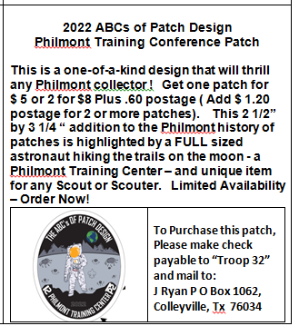
*Image of patch – Use Camera Ready Art from graphic artist so it can be published in email newsletters, etc. When you have this quality, it looks good wherever you place an Ad. You need to make sure that the size of the Ad will allow a good look at the image of the patch. If no one can see it, few will buy it.
*Size. Sometimes I place this in ad so Patch Buyers know it’s a normal or bigger than normal size patch. It lends credibility.
*Sample Ad. See below an example of an Ad featuring last years ABCs patch. Just switch out the text for how it applies in your situation.

