Nishkin Halupa A Pe Lachi Lodge 489
1952 – 2002
Fort Worth, Texas

The story of Nishkin Halupa A Pe Lachi Lodge 489 begins in 1952 when Mikinakawa Lodge 101 conducted the first Order of the Arrow Ordeals for members of the newly formed lodge in Longhorn Council. Membership at the time was restricted to Exploring members, and although early records were sparse, T32 leaders J. E. Gillespie and Bob Cunningham were charter members during the first year. Much of what is known from those days was preserved through the efforts of Ken Majka, whose archives were later reviewed by John Ryan, confirming the active participation of Troop and Exploring 32 in Lodge 489’s earliest years.

The 1950s – Foundations and Champions

From the start, Troop and Exploring 32 Scouts emerged as leaders in ceremonies, Indian dancing, and service. Names such as Albert O’Neal, A. J. Stewart Jr., Pat Riley, Tom Stewart, Hugh Helbing, Bob Sawey, and Jim Sawey rose into chapter and lodge leadership.

Among them, Albert O’Neal stood out as both a ceremonialist and dancer. As a founding member of the Lodge Dance Team, he helped lead the team to win the 1956 National OA Dance Team Championship—an extraordinary honor. O’Neal became the first Troop 32 Scout to achieve the Vigil Honor and was later elected Lodge Chief in 1958, the only Troop 32 Scout ever to hold that distinction in the life of Nishkin Lodge.

Lodge Chief Albert O’Neal | 1956 National OA Dance Team Championship
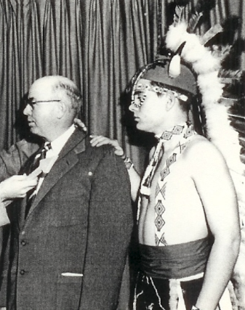 | 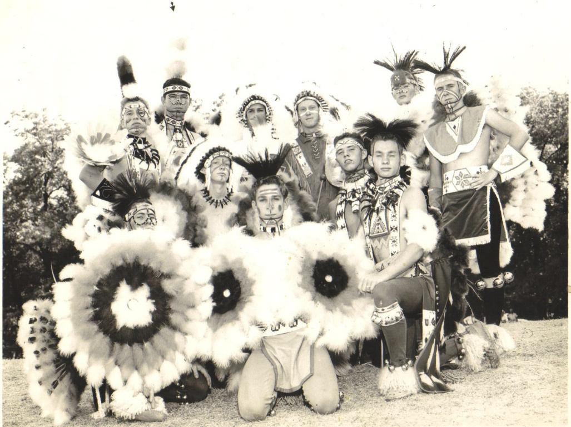

Pat Riley, another Eagle Scout from Troop 32, also distinguished himself as a Champion Indian dancer. His Indian dance outfit from the 1950s remains a treasured piece of Scouting history, and he continued to share his passion through Texas Indian Hobbyists Association events.

During the late 1950s and early 1960s, Troop and Exploring 32 were located within Arrowhead Chapter.
A.J. Stewart Jr (1959) and Pat Riley (1960) were elected Arrowhead Chapter Chiefs and ran OA Tap Outs that were the highlight of every District Camporee.

Troop and Exploring 32 exhibited a wealth of talented Scouts as Tom Stewart, Hugh Helbing, and the Sawey brothers (Bobby & Jimmy) were elected to positions at the Lodge level.

All their OA Scouting Service resulted in Vigil Honor for the following: Albert O’Neal (1958), Pat Riley (1960), J E Gillespie (1961), Jim Sawey (1964) and Ted Duncan (1964). Albert and Pat went to college or entered the working world so OA participation dropped off.

The Late 1960s–70s – Revival and Growth
After a period of quiet, Albert O’Neal returned as adult advisor in the late 1960s, inspiring a new generation of Troop 32 dancers. He enlisted former teammates like John Pat West to help demonstrate and mentor the Scouts.

By the early 1970s, Troop 32 had re-formed its dance team, featuring Scouts such as Frank Bernat, Richard Cosgrove, Marty Bush, Charlie Jennings, Mike Bartula, Donald and Joe St. John, John Franko, and John Ryan. Their signature performances included the “Fluffy Dance,” the “Snake Dance,” the Round Dance, and the crowd-favorite “Devil Dance.”

- The Devil Dance told the story of a Good Warrior attacked by the Devil and revived through the power of Good Spirits.
- The Fluffy Dance was a playful but competitive challenge centered on skillfully retrieving a feather without using hands.

1950s Pat Riley  Dance Team Champ | 1970s OA Section Conclave  Indian Dance Team Champs
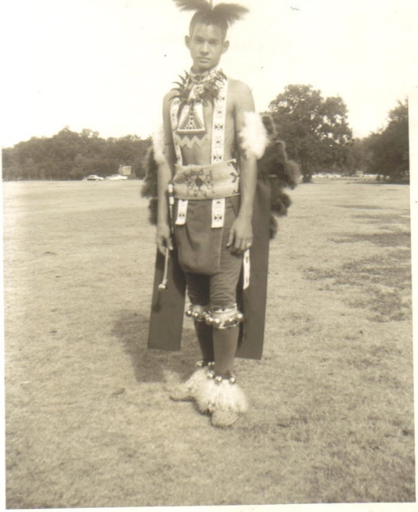 | 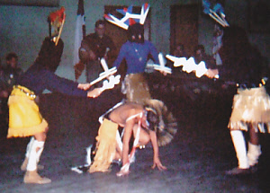

These performances weren’t just for fun—they swept competitions, earning first place honors at Area Conclaves against teams from 14 different OA Lodges.

Richard Cosgrove, another standout dancer and leader, achieved the Vigil Honor at only 15 years old.

Troop 32 Scouts also became leaders beyond the dance circle. In the 1970s, Troop 32 dominated Okhi Chapter leadership, with Scouts like John Ryan elected Chapter Chief and later representing Mustang District at the prestigious Report to the State in Austin, even meeting Texas Governor Dolph Briscoe. Future Scouting luminaries, such as Roy Williams (later BSA CEO), crossed paths with Troop 32 Scouts during this era.

Allowat Sakima at Front (T32 John Ryan) and Meteu behind (T32 John Lesinski) conducting a mid 1970s Tap Out at Mustang District Camporee. | T32 Chapter Chief John Ryan and former T32 member Richard Cosgrove are pictured with Texas Governor Dolph Briscoe. Future BSA CEO Roy Williams is 2 steps to the Left of John Ryan.
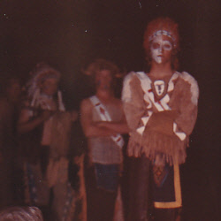 | 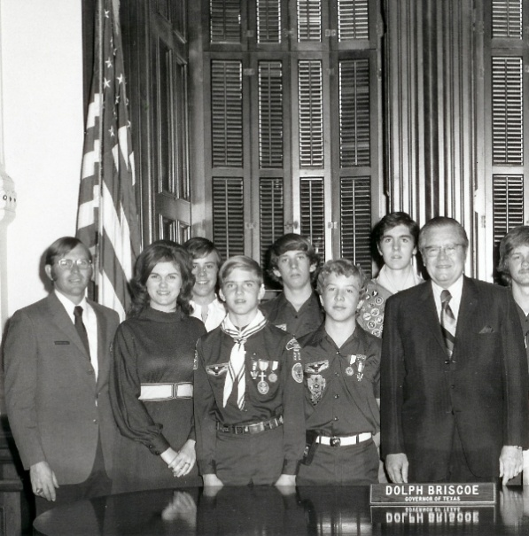

Troop 32 OA members led unprecedented programs like creating the Tri-Chapter and Quad Chapter Conclave experiences that defied the traditions of Lodge 489 – in other words – no one had ever done it before. They were so successful that many of the Chapter participants on this weekend ended up being elected to Committee positions at the Lodge level.

Ceremonies Chair John Corpany (Right) would later join Troop 32 along with his son Elliott | OA Chapter Post 32 conducted Philmont Treks within Lodge 489 with several Scouts becoming Vigil Honor. (L to R) Casey Berecka, David Berecka and Trey Anderson
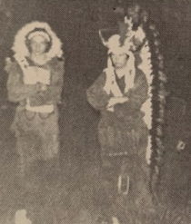 | 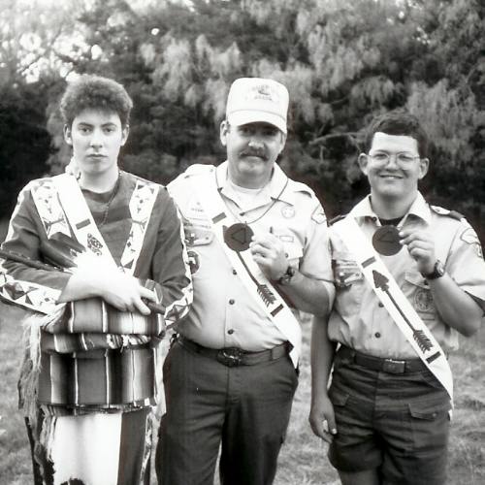
The 1980s–1990s – Tradition and Change
Through the 1980s and 1990s, Troop 32 continued to contribute strong leaders and ceremonialists to Nishkin Lodge. Chapter Chiefs often invited fellow Troop 32 Scouts onto Tap Out teams, where the tradition of dramatic (yet safe) “tap outs” kept the ceremonies memorable.

When Troop 32 went to Philmont during 1979, they experienced the magical nature of hiking through the mountains of New Mexico like long ago pioneers. Although OA was an important part of Troop 32 program, they began a decades long travel to Philmont nearly every summer. T32 still participated in OA but it was a secondary program after everyone caught the Philmont bug.

The 2000s – The Final Chapter of Lodge 489
As the new century began, Troop 32 saw a resurgence of Vigil Honor leadership. Dennis Simonsen became the first Troop 32 Scout since the 1970s to earn Vigil. Rising through Chapter Chief to Lodge Second Vice Chief, Dennis capped his service with an extraordinary honor: at the 50th Anniversary Banquet of Lodge 489 in 2002, he received the OA Founder’s Award—the only Troop 32 Scout ever to do so. It was especially meaningful, as the following year Lodge 489 combined with Huaco Lodge to form Lodge 209, marking the end of Nishkin Lodge’s 50-year history.

Dennis Simonsen Vigil Call Out | Dennis’ Founders Award
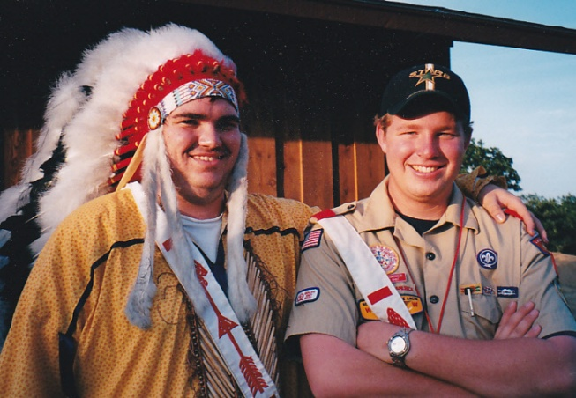 | 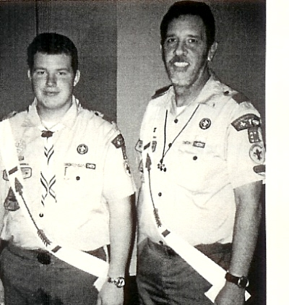

Troop 32 Scouts even ventured to Amarillo to learn the famed Kwahadi Hoop Dance, an experience that left lasting inspiration despite never fully developing into a dance team.

Legacy
From its founding in 1952 until its merger in 2002, Nishkin Halupa A Pe Lachi Lodge 489 was shaped and strengthened by the Scouts of Troop and Post 32. From national dance team championships and legendary ceremonies to Lodge Chief, Vigil Honors, and Founder’s Award recipients, Troop 32 consistently produced leaders who upheld the spirit of the Order of the Arrow.
The legacy lives on in the Scouts who carried these traditions forward—proof that service, fellowship, and brotherhood remain timeless in Scouting.

Netapolis Sipo Schipinachk Lodge 209
2002 – Present
Hurst, Texas
Lodge 209 formed on a blustery winter weekend at Worth Scout Ranch. The record of T32 accomplishments includes a resurgence in the Chapter and Lodge that ended up fueling our second Scout to become Lodge Chief.

This Account is still being written and pictures being collected.

