National Jamboree
The Greatest Show In Scouting America !

The following are snippets of Troop, Post, Air Squadron, and Crew 32 participation in National Jamboree events since 1935.

1935 National Jamboree. Articles in our archives List T32 Participants. Event Cancelled by President Roosevelt Because of Polio Outbreak.

1937 National Jamboree “Jamboree Journal”
Eagle Scout Troop 32 A. L. Crouch Mentioned

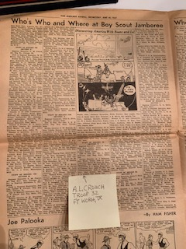 | 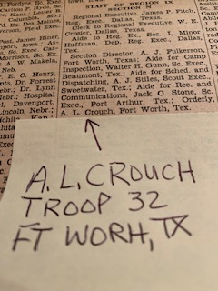

T32 Scouts and Scouters J E Gillespie, A L Crouch, James Hennessey, and David Phillips Attend 1937 National Jamboree.
1950 National Jamboree
Troop 32 Eagle Scout  Joe Scantlin  is NJ Troop SPL (middle) | J E Gillespie and other T32 participants helping here with Trailburger Meal
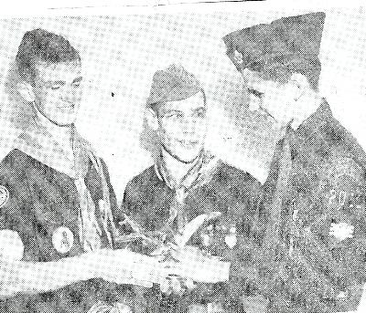 | 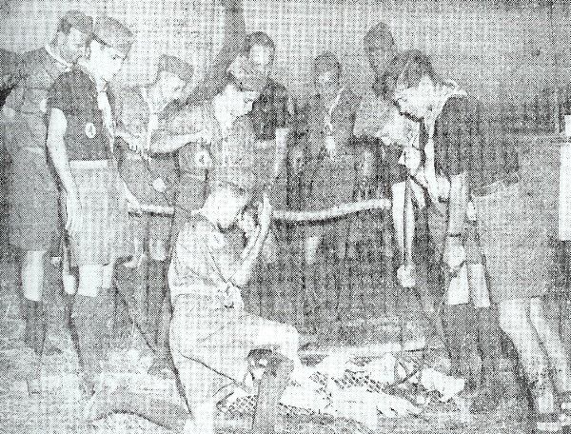

1953 National Jamboree (Irvine Ranch, CA)
Troop 32 Scouts In Camp  for Water Break | 1953 VP Richard Nixon Visiting.  Troop 32 Scouts Taking Pictures
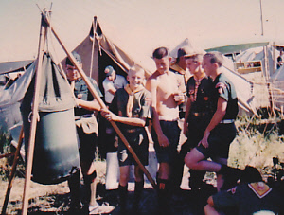 | 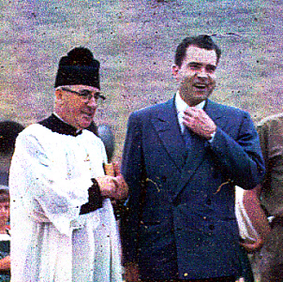

1957 National Jamboree
(Left) T32 Scouts Group Picture – (Right) Jamboree Mass Service

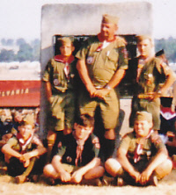 | 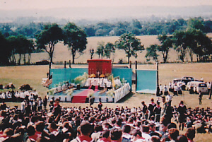

1960 National Jamboree – 50th Anniversary of Scouting
A Quick Picture of E Urner Goodman at Jamboree  By Our T32 Scouts | Air Squadron and Troop 32 Scouts at  National Jamboree
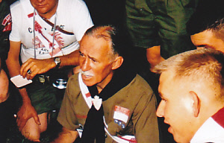 | 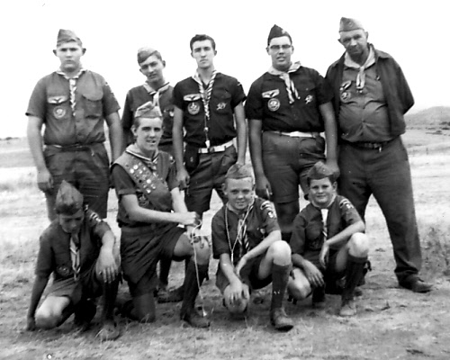

1964 National Jamboree (J E Gillespie & Others)

1967 World Jamboree (J E Gillespie, Bill Creed & Others)

1969 National Jamboree (J E Gillespie & Others)

1973 National Jamboree

T32ers Gillespie, John Ryan, John Lesinski, Doug Durham, and Kevin McPartlan attend Jamboree | T32 SM J E Gillespie Served On National Jamboree Staff In Kitchen For Subcamp 13. His Bagtag for Equipment
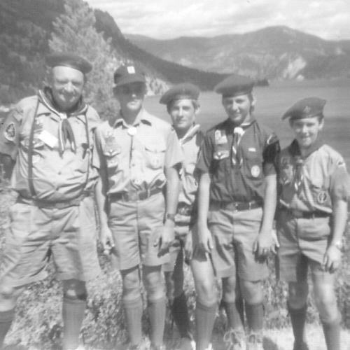 | 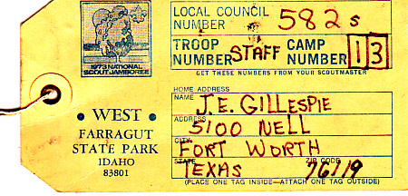

1977 National Jamboree

Troop 32 Scouts At DFW Airport  Before Flying To Jamboree | Jamboree Scout John Ryan Interviewed  Miss Teenage America Rebecca Ann Reid
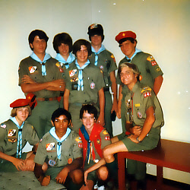 | 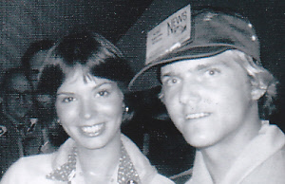

From 1981 through 2001, T32 Scouters on Jamboree Staff (no Pix)

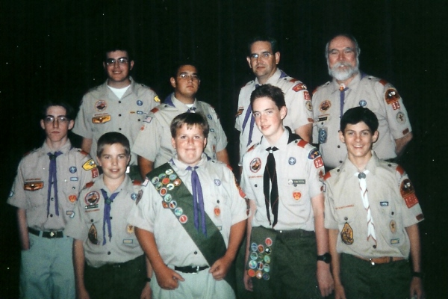 | 2001 National Jamboree Participants and Jamboree Staffers from Troop 32

2010 National Jamboree – National Exhibit – Metal Recycling Booth

T32 Staffs Exhibit at 100th Anniversary NJ | T32 Staffers visiting OA Exhibit
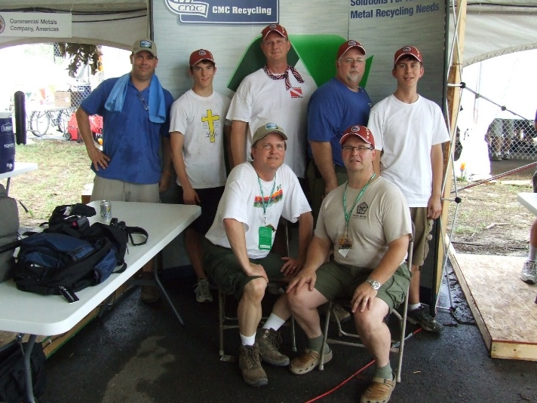 | 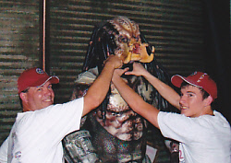

2010 National Jamboree – 100th Anniversary Jamboree
Longhorn Council Contingent
All But 1 Scout Were Troop 32 Scouts and Scouters

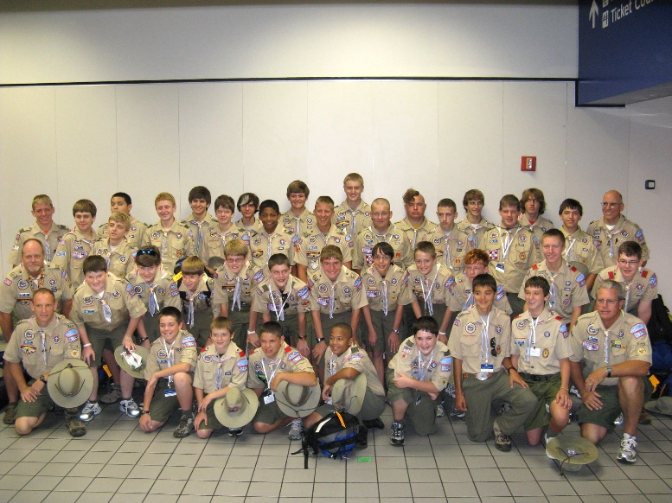 | 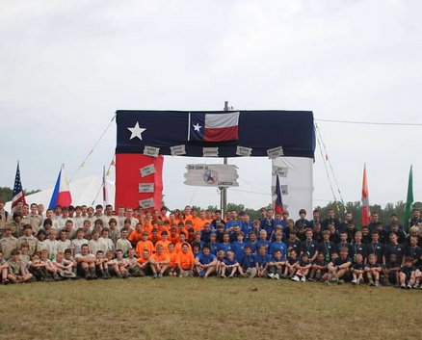

2013 National Jamboree –Bechtel Summit
First National Jamboree At Bechtel Summit – Bob Butler On Left

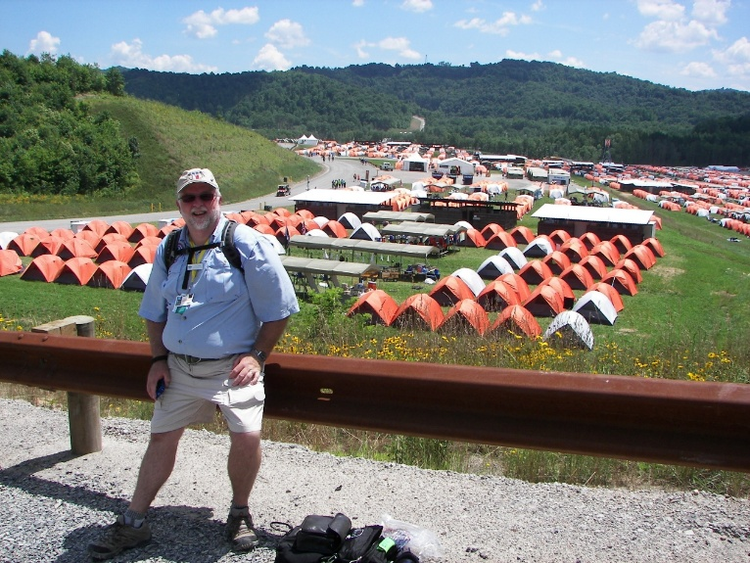 | 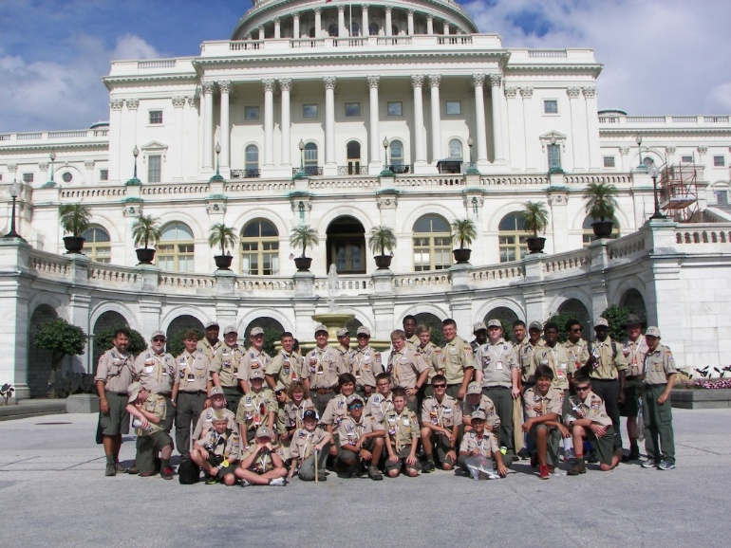

T32 Scouts and Scouters participated in the 2017 and 2023 National Jamboree.
We Are In The Process Of Updating
Our Pictorial Archives for Our 100th Anniversary Flash Drive History.

