FIRSTS of Troop 32 And Associated Units

Introduction:
Brother Barnabas FSC, a Brother of Christian Schools Order within the Catholic Church, was appointed a National BSA Field Commissioner who traveled throughout the country establishing Boy Scout Troops at Catholic institutions. He was on his way to conduct a “Boyology” Class for Scout Leaders at St Edwards University in Austin, Tx when he was struck with a heart ailment. Knights of Columbus Council # 759 allowed him to convalesce at their meeting Hall in downtown Ft Worth until he recovered. This was when Brother Barnabas met John Edward Gillespie that led to 4 Troops being established at the 4 Catholic Churches in Ft Worth. J E Gillespie, nicknamed “Ole Man,” was Scoutmaster of Troop 19 and Assistant Scoutmaster of Troop 32 but quickly became Scoutmaster of Troop 32 because the original leader was disabled and couldn’t manage campouts. To Gillespie, he found “his calling” early in life and every Scout found him a second Father. He was an innovator, a “can do” spirit, and someone who found a solution where there seemed to be none. The local Boy Scout Council involved him in every new Scouting innovation so Troop 32 had many FIRSTS. This legacy still continues today as we now reveal our FIRSTS.

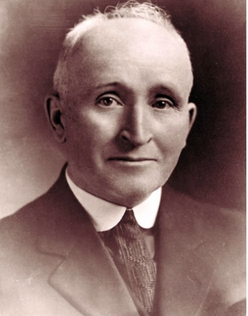 | FIRST Catholic Men From Ft Worth To Attend Brother Barnabas “Boyology” Course Within State of Texas  J E Gillespie, and other Brother Knights, were among the FIRST Catholic Men to learn how to operate a Boy Scout Troop in Texas at St Edwards University in  Austin, Tx.  Note: During 1922, the Texas Knights adopted Scouting as its official youth organization.

FIRST Catholic Troops Chartered in Council (1927)  J E Gillespie, A Knight of Columbus, was primarily responsible for establishing 4 Catholic Troops in the January to March time frame in 1927.  Troop 32 was the only one to survive WW II. | 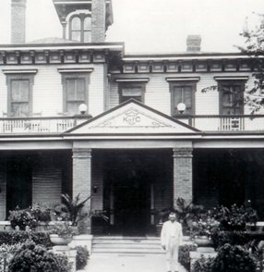

FIRST - Exploratory Expedition  National BSA Commissioner James West visited Camp Shuman on Lake Worth and found it not worthy to serve as a Boy Scout Camp. In a sense, “too citified.”  The Council established an exploratory group of Scouters who visited the properties of Joe Taylor near Palo Pinto, Tx. He led them on a tour of the entire property which led to its purchase by the local Council. SM J E Gillespie of Troop 32 was on that expedition. Pictured are Scouts of Troop 32 at Worth Ranch Summer Camp of 1931. | 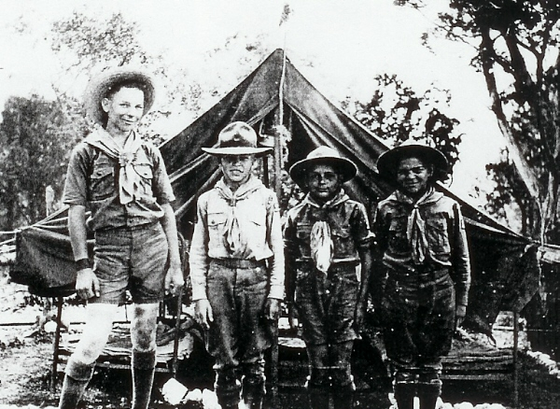

Dedication and FIRST Staff Member  Of Worth Ranch Summer Camp (1930)  On right, Troop 32 Eagle Scout Bill Davis is shown blowing the Bugle as Staff members lower the US Flag during the 1930 Dedication of Worth Ranch before its first summer camp season. Bill Davis worked on the first summer camp staff. | 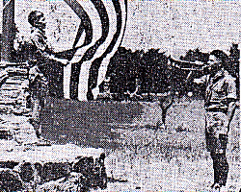

FIRST National Jamboree (Cancelled - 1935)  Literally, Scouts of Troop 32 were about to board the train for the First National Scout Jamboree when President Roosevelt cancelled the event due to the threat of a Polio outbreak. Gillespie and several Troop 32 Scouts were a part of the official contingent.  The July 24, 1935 morning edition of the Ft Worth Star Telegram newspaper published the names of the Scouts and Scouters who were to attend the 1935 National Jamboree. See arrows pointing to the names of the Troop 32 members. | 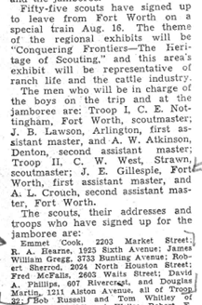

FIRST National Scout Jamboree (1937)  Troop 32 members J E Gillespie, A L Crouch, James Hennessey, David Phillips, and others participated.  FIRST Escort of Foreign Official  National Scout Jamboree (1937)  A picture published within the daily Jamboree Journal is James Hennessey (left) who had the honor of escorting Paraguan Minister Dr Don Alfredo Busk Corda. | 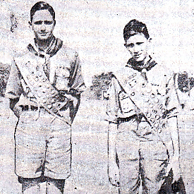

FIRST Scouting Religious Awardees in the Council (1944)  L to R. Gene Witkowski, Charles Bush, UNK  FIRST Catholic Priest Among  Catholic Scouting Awardees  Within Council (1950s)  Gene Witkowski became a priest and rose to Msgr Witkowski within Ft Worth Diocese. | 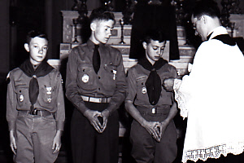

Note: Rev Tschoeppe shown awarding the Ad Altare Dei Catholic Scouting award above … was Head of Institution (member of Ship 19), drove Troop 32 Scouts to Worth Ranch Summer Camp, said mass at Worth Ranch and would later become Bishop of the Diocese of Dallas.

FIRST Catholic Scouting Sea Scout Ship 19 (Approx 1938)  Pictured are Sea Scouts of Ship 19 training and completing requirements toward the highest award in Sea Scouts – The Quartermaster Award. | 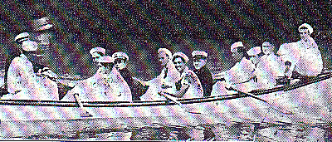

Note: During the early days of Scouting, the concept of Sister Troops was practiced where they would support each other to ensure longevity. Troop 19 was Sister Troop to Troop 32. When it was decided that Troop 19 (during the Great Depression) would go inactive and all the Scouts transfer into Troop 32, the older Scouts of Troop 19 and 32 Chartered Sea Scout Ship 19. Scouts and Scouters of Troop and Ship 19 will always be considered members of Troop 32

FIRST Known  Philmont Expedition In Longhorn Council  By Air Squadron (1951)  Scouts of Air Squadron 32 and Troop 15, sponsored by Catholic institutions, combined to conduct a Philmont Expedition. Philmont was a small operation and not frequented by many units as it was still not fully developed. Exploring units were the only units allowed to participate at the beginning as it took a lot of organization to fulfill the trip successfully. | 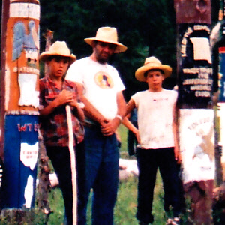

Cactus Honor Fraternity (1929). Although the Order of the Arrow fraternity did not make it to Longhorn Council until 1952, other local HONOR Societies pre-existed the OA. The Cactus Honor Fraternity was created by the Scouts of T32 for the preservation of Troop 32 and its adopted Home – Worth Scout Ranch. Formal meetings were held at least once a year, an initiation was conducted during the Thanksgiving weekend at Worth Ranch, and an annual New Years Eve Party was also part of its traditions.

FIRST Known Honor Society  Created For The Preservation of  Worth Scout Ranch (1929)  Only boys considered Top Scouts were invited, an initiation was conducted and they were fully sworn in as members. “Pig Latin” was the official language of the organization, members were sworn to secrecy regarding activities that were done at Worth Ranch and a wooden Chest of Scouting Memorabilia was buried at Worth Ranch. This Fraternity conducted regular meetings from 1929 – 1939 (CHF 10th Anniversary Book) but college, WW II, the Korean War interrupted its activities. Following the war, there were activities but infrequent and its not known what was done. When the OA was Chartered in Longhorn Council during 1952, the Cactus Honor Fraternity was merged into this National Honor Society (Right, Totem of Cactus Honor Fraternity at WR ) | 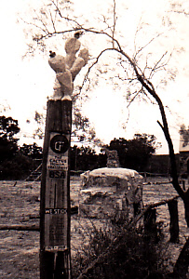

FIRST and ONLY  National OA Dance Team Champions  From Longhorn Council (1956)  Shortly after the formation of the Order of the Arrow within Longhorn Council, Explorers of Post 32 became Charter Members. J E Gillespie, Albert O’Neal, Hugh Helbing, John Pat West, etc.  Albert O’Neal led the new OA Scouts of Troop 32 in the art of competitive Indian Dancing and won the National OA Dance Team event in 1956. | 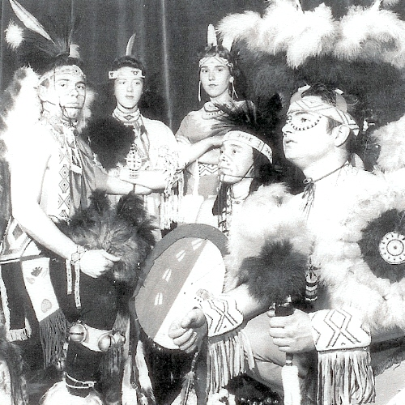

FIRST  Non-Post 52 Lodge Chief  Nishkin Halupa A Pe Lachi  Lodge 489 (1956)  Albert O’Neal (On Right, In Meteu Indian Outfit) was known for his riveting performances as “Medicine Man” during OA Ceremonies. Following his tenure as Ceremonies and Indian Dancing Chair, he was the FIRST Non-Post 52 Scout elected Lodge Chief within the first 18 years of the Lodge. This was an act of the highest respect as Post 52 dominated the Lodge Offices and could have easily won the office of Lodge Chief. | 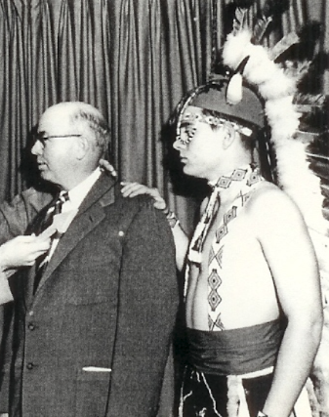

FIRST Chair  Scouting Religious Committee of  Longhorn Council  FWDCCS (1958)  Although Troop 32 had the FIRST Scouting Religious Awardees of Ft Worth during 1944, there was not an organized committee for the facilitation of this activity. When Bishop Gorman of the Catholic Diocese of Dallas energized participation in this award, he instituted a committee to run all these Catholic Awards within Ft Worth area. J E Gillespie, SM of Troop 32, was the FIRST Chair of Ft Worth Deanery entirely contained within Longhorn Council. | 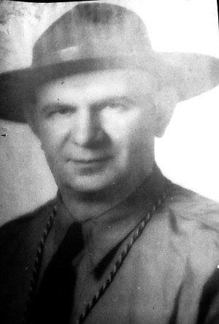

FIRST Co-Founder  Longhorn Council Catholic Retreat  (1960)  During the 1960 National Jamboree in Colorado, Scouter Bob Connelly visited with J E Gillespie from the Longhorn Council contingent. Before 1960, Diocese of Dallas would conduct a Catholic Retreat but this Jamboree meeting solidified the eventual Inaugural Catholic Scout Retreat for the Ft Worth Deanery. Later, Ft Worth would become its own Diocese … the Catholic Retreat would run continuously for over 60 years before Cov19 forced an end to this activity. | 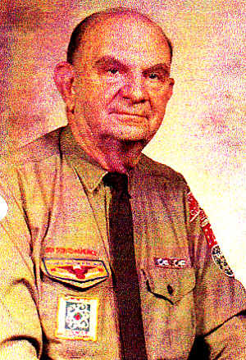

FIRST  Lodge 489 OA Cavalcade  Post 32 (1994)  Led by Scouters of Post 32, FIRST OA Cavalcade within Nishkin Lodge 489. Post 32 repeated this activity in 1997 (Picture used is from 1997)  FIRST Scouts From Japan Black Eagle OA Lodge and a US Military Base In Japan Fly In and participate. Rob and T J Pray. | 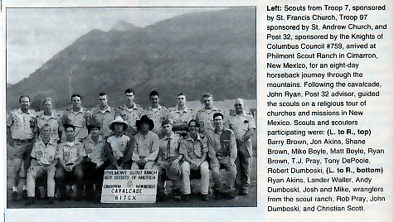

FIRST  Ad Altare Dei Pilgrimage  Troop 32 (2007)  Led by Scouters of Troop 32 and a Diocesan Appointee by Bishop Vann, FIRST pilgrimage of Scouts and Scouters from throughout Longhorn Council involving Philmont Scout Ranch. The Tour received a 92% Excellent/Good rating by Scouts and Scouters in an Exit Survey, doubled the number of religious awardees in a year and received the 2008 Award of Excellence from the National Catholic Committee. FIRST time given to Longhorn Council or our Council Religious Committee in history. Bishop Vann is pictured giving T32 Scout Jake Shearer a Religious medal. | 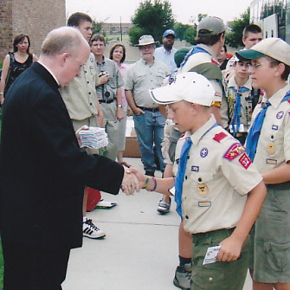

FIRST  Award of Excellence  Given To Longhorn Council For  Catholic Committee on Scouting  Program (2008)  As a result of the Director and Scouters of Troop 32 conducting the 2007 Ad Altare Dei Pilgrimage,  the 2008 Award of Excellence was awarded by the National Catholic Committee on Scouting to Longhorn Council and to the Council Religious Committee. | 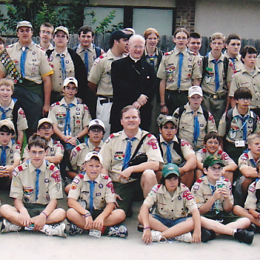

FIRST  Scouts of Japan Exchange for  Philmont Religious Pilgrimage (2012)  Led by Scouters of Troop 32, FIRST International Exchange where Scouts of Japan flew from Tokyo, joined the Pilgrimage in Bedford Tx, assisted in the program, and presented the FIRST St Paul Miki (Greatest Saint of Japan) activity patch to all participants. | 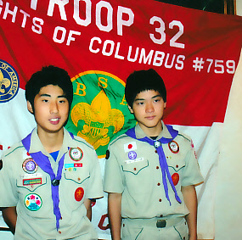

FIRST  Most International Scouting Awards Earned By Single Group  In America  International Dept/BSA (2014)  Led by Scouters of Troop 32, FIRST group to earn more International Scouting Awards than the entire nation added together. With the help of the Longhorn Council International Rep and leadership of Troop 32 Scouters, our 2014 Religious Pilgrimage to Philmont and New Mexico generated more awards than the entire nation added together.  34 Participants Included 12 - T32 Scouts/Scouters | 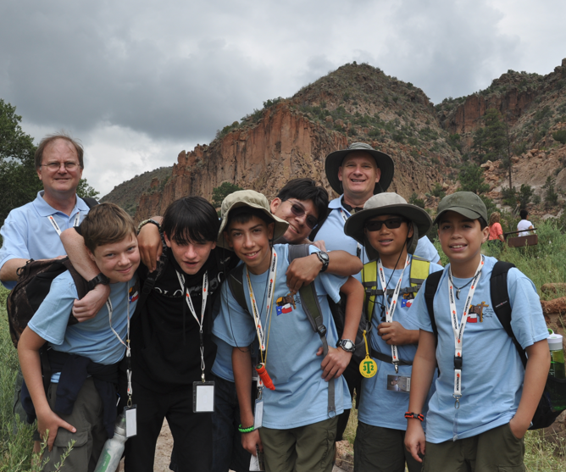

FIRST  International Exchange  BSA Scout Attends  Asia/Pacific Jamboree (2014)  FIRST Longhorn Scout To Staff This Event  T32 Scout Josh Robbins was selected as a representative of Longhorn Council Scouting Religious Committee to attend an Asia Pacific Jamboree of Scouts at the foot of Mount Fuji in Japan. On Right, T32 Scout Josh Robbins is at the top of Mount Fuji in Japan. | 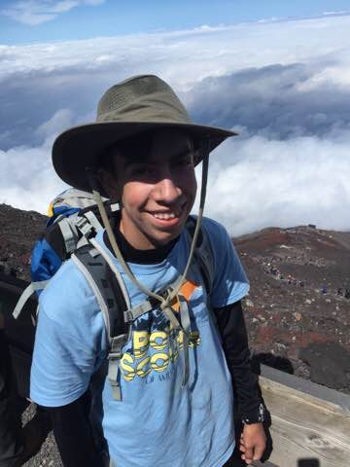

FIRST  Scouting Patch Design Conference  Conducted At  Philmont Training Center (2022)  T32 Director and T32 Participants attended the 2022 ABCs of Patch Design offered by the Philmont Training Center.  FIRST Patch Design Contest was won by T32 Scouter Trish Chell. Her patch design is shown on right. | 