Does Your Scout Believe In God?
Does Your Scout Believe in Miracles?
What Is your Scout thinking?
During the last hour of our Pilgrimage trips, we hand out our Exit Survey forms so we can find out. The only instructions are to fill it out, don’t write your name unless you want to and that we honestly make changes based on what they write. When they fill out an anonymous Exit Survey where no one knows who wrote the answers, you find out what your Scouts are thinking. Here are some samples, as you will quickly see, in their own writing:
Survey Sample 1. From one of our Scouter attendees:
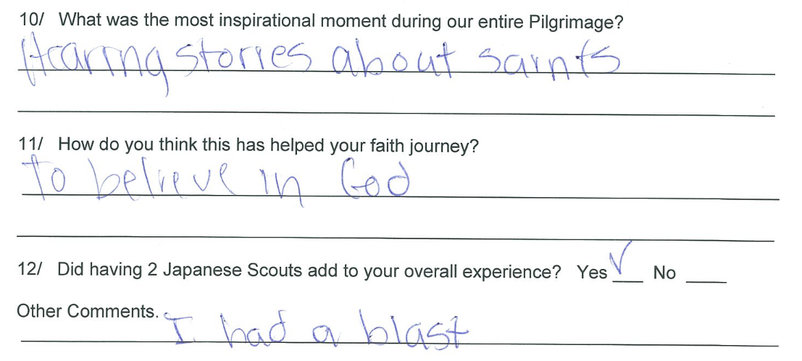
Survey Sample 2. Note: When we found out about bus drivers granddaughter going to hospital, we prayed for her on 3 separate occasions:
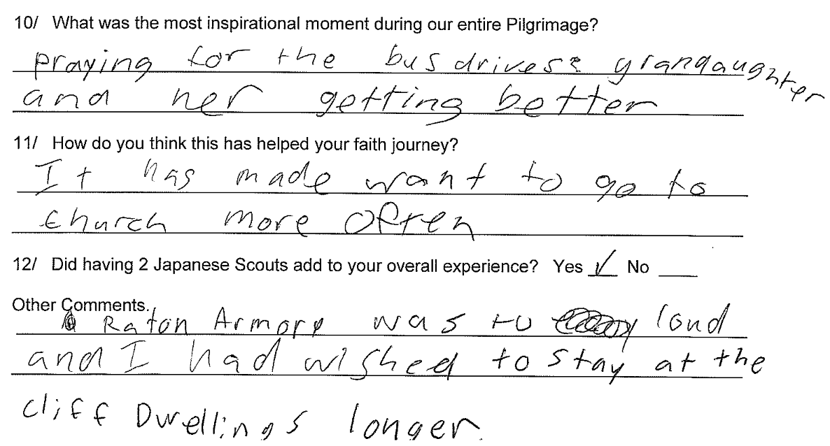
Survey Sample 3:
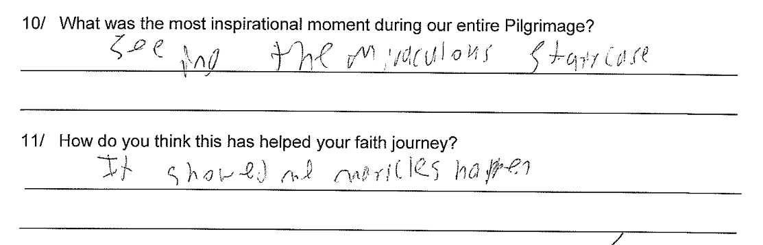
Survey Sample 4. We tell stories about Faith. Story about a summer camp trip, where a Scout fell off a galloping horse, broke his protective helmet on impact and had a concussion. The parents prayed the entire trip to hospital and he was pronounced clear of any serious complications.:
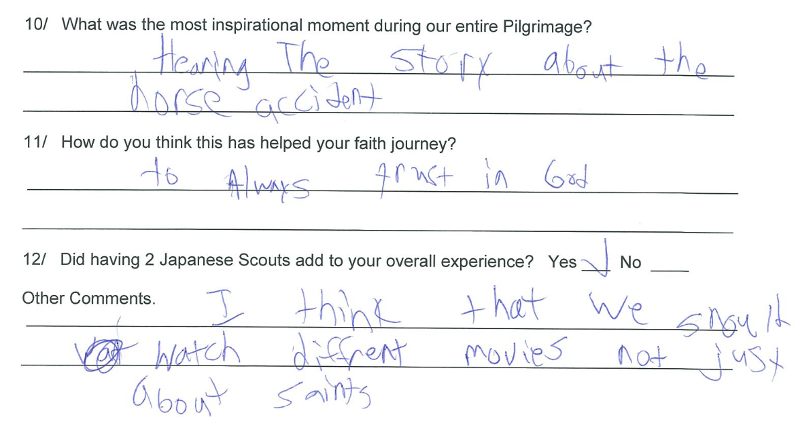

Survey Sample 5:
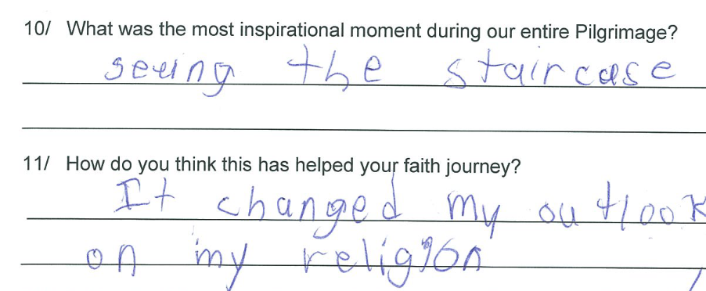
Survey Sample 6. This will be our 7th pilgrimage. However, virtually all the surveys from each pilgrimage are answered just like this below. We can’t promise visiting all of them (as some would be considered optional if time runs short) but we’ve been successful in visiting all of them and they continue to get the same rating:
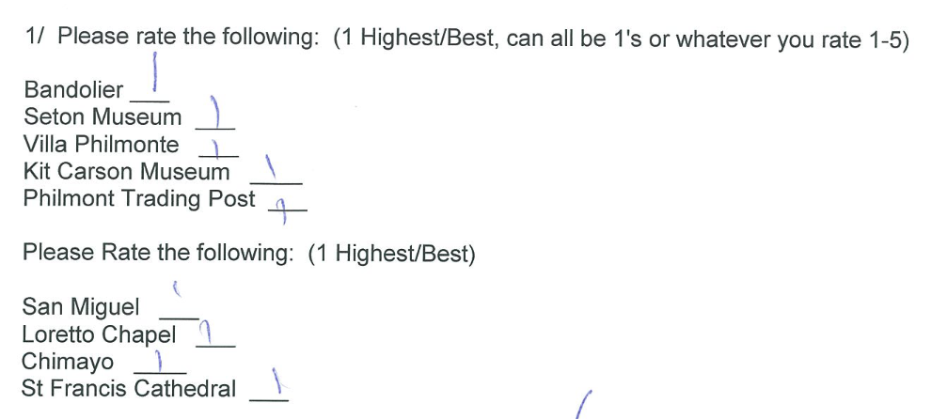

Survey Sample 7. Response of Lady Scouter to her first visit to Loretto Chapel.

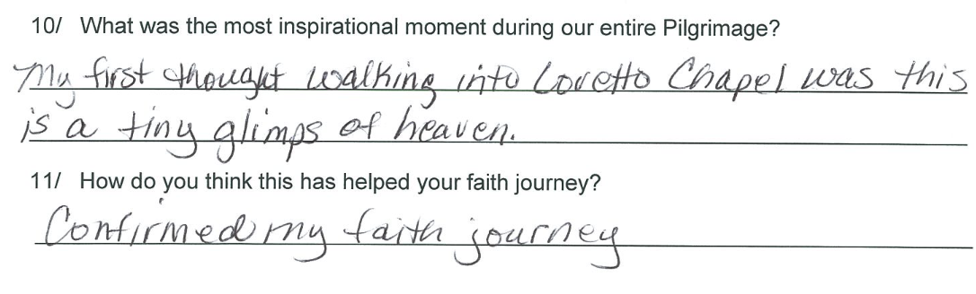
Survey Sample 8. A Scouter’s comments.
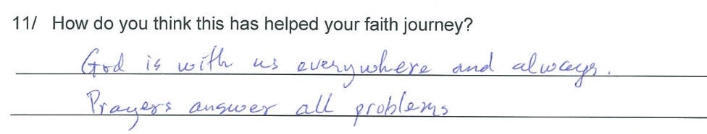
Survey Sample 9.
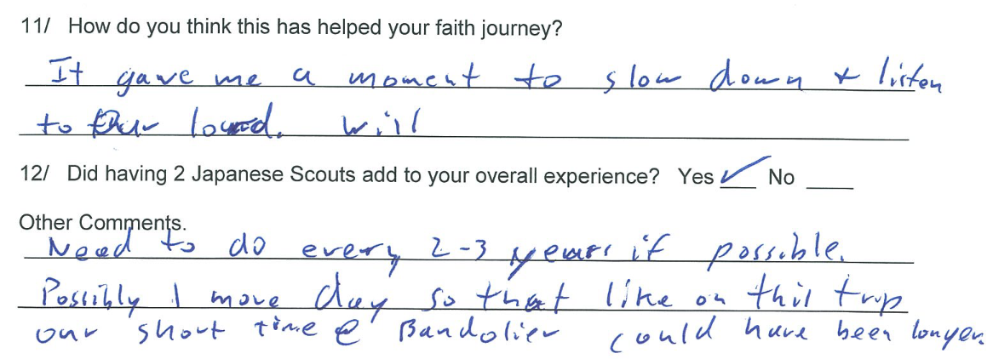

Survey Sample 10. Another Lady Scouters comments.
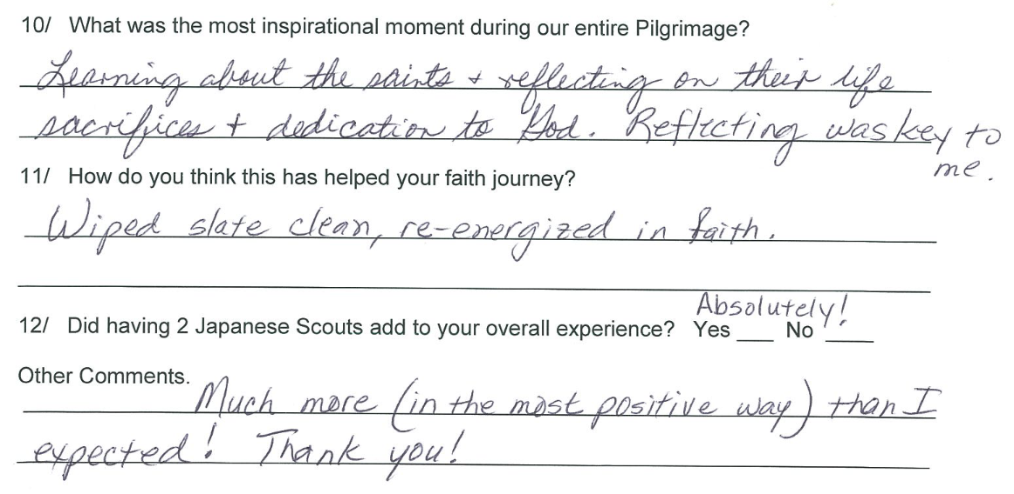
Survey Sample 11.
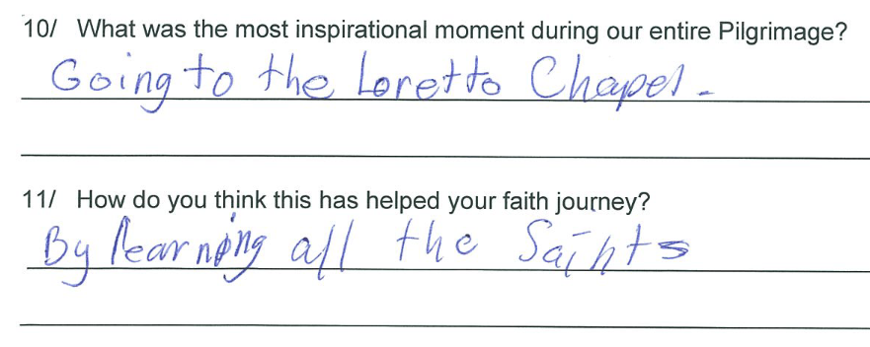

Survey Sample 12. A Scout
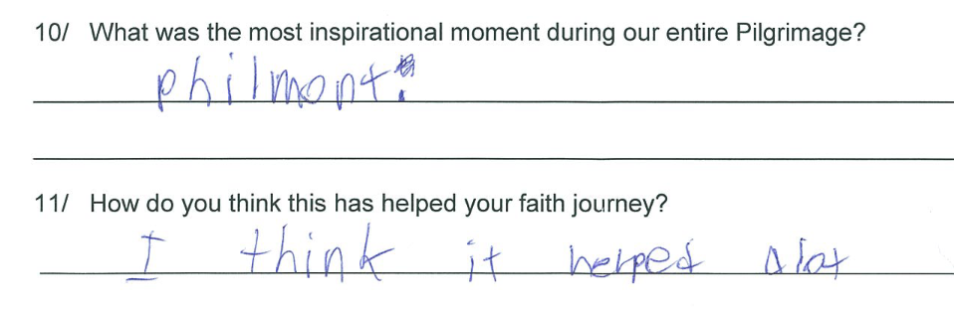
Survey Sample 13.
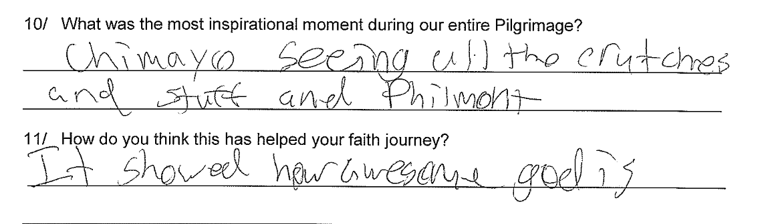
Survey Sample 14.
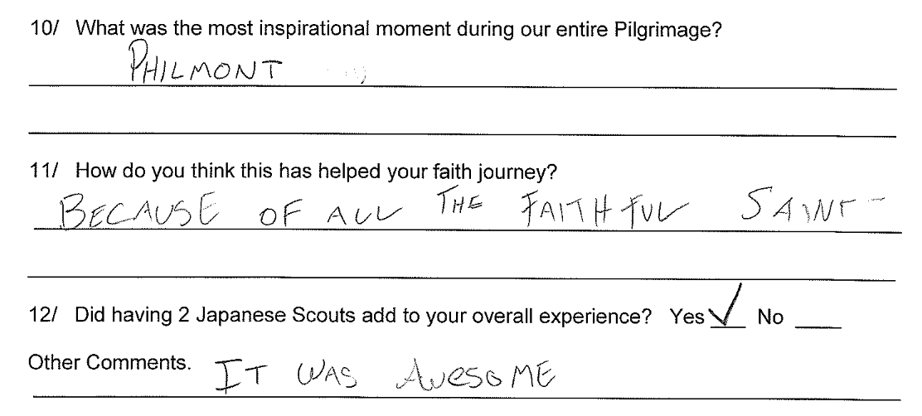

Survey Sample 15.
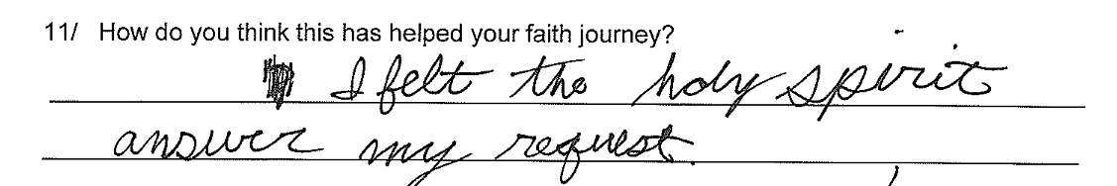
Survey Sample 16.
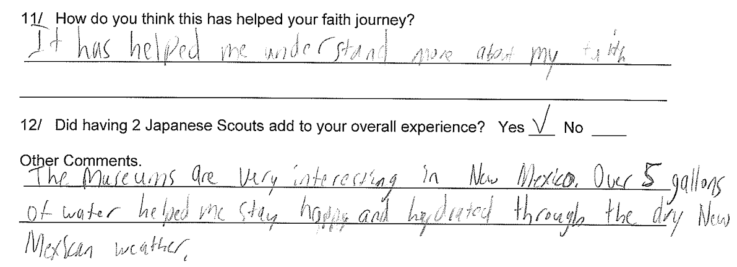
Survey Sample 17.
