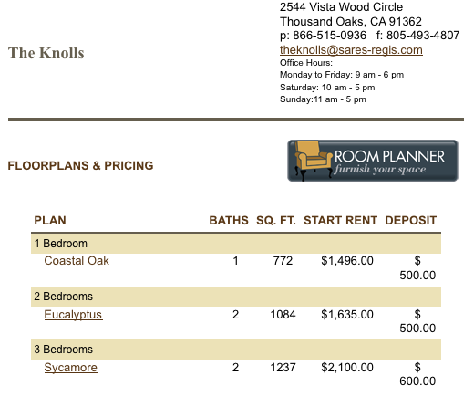
My roommates and I chose to live in the Knolls in Thousand Oaks. It has all the amenities (list amenities) we were looking for, and is close enough to the 23 freeway to allow…

My roommates and I chose AT&T Uverse as our provider for home phone, TV and Internet. We believe this was the best choice because…
I chose T-Mobile as cell phone provider…

Nothing beats the reliability of a Toyota…

