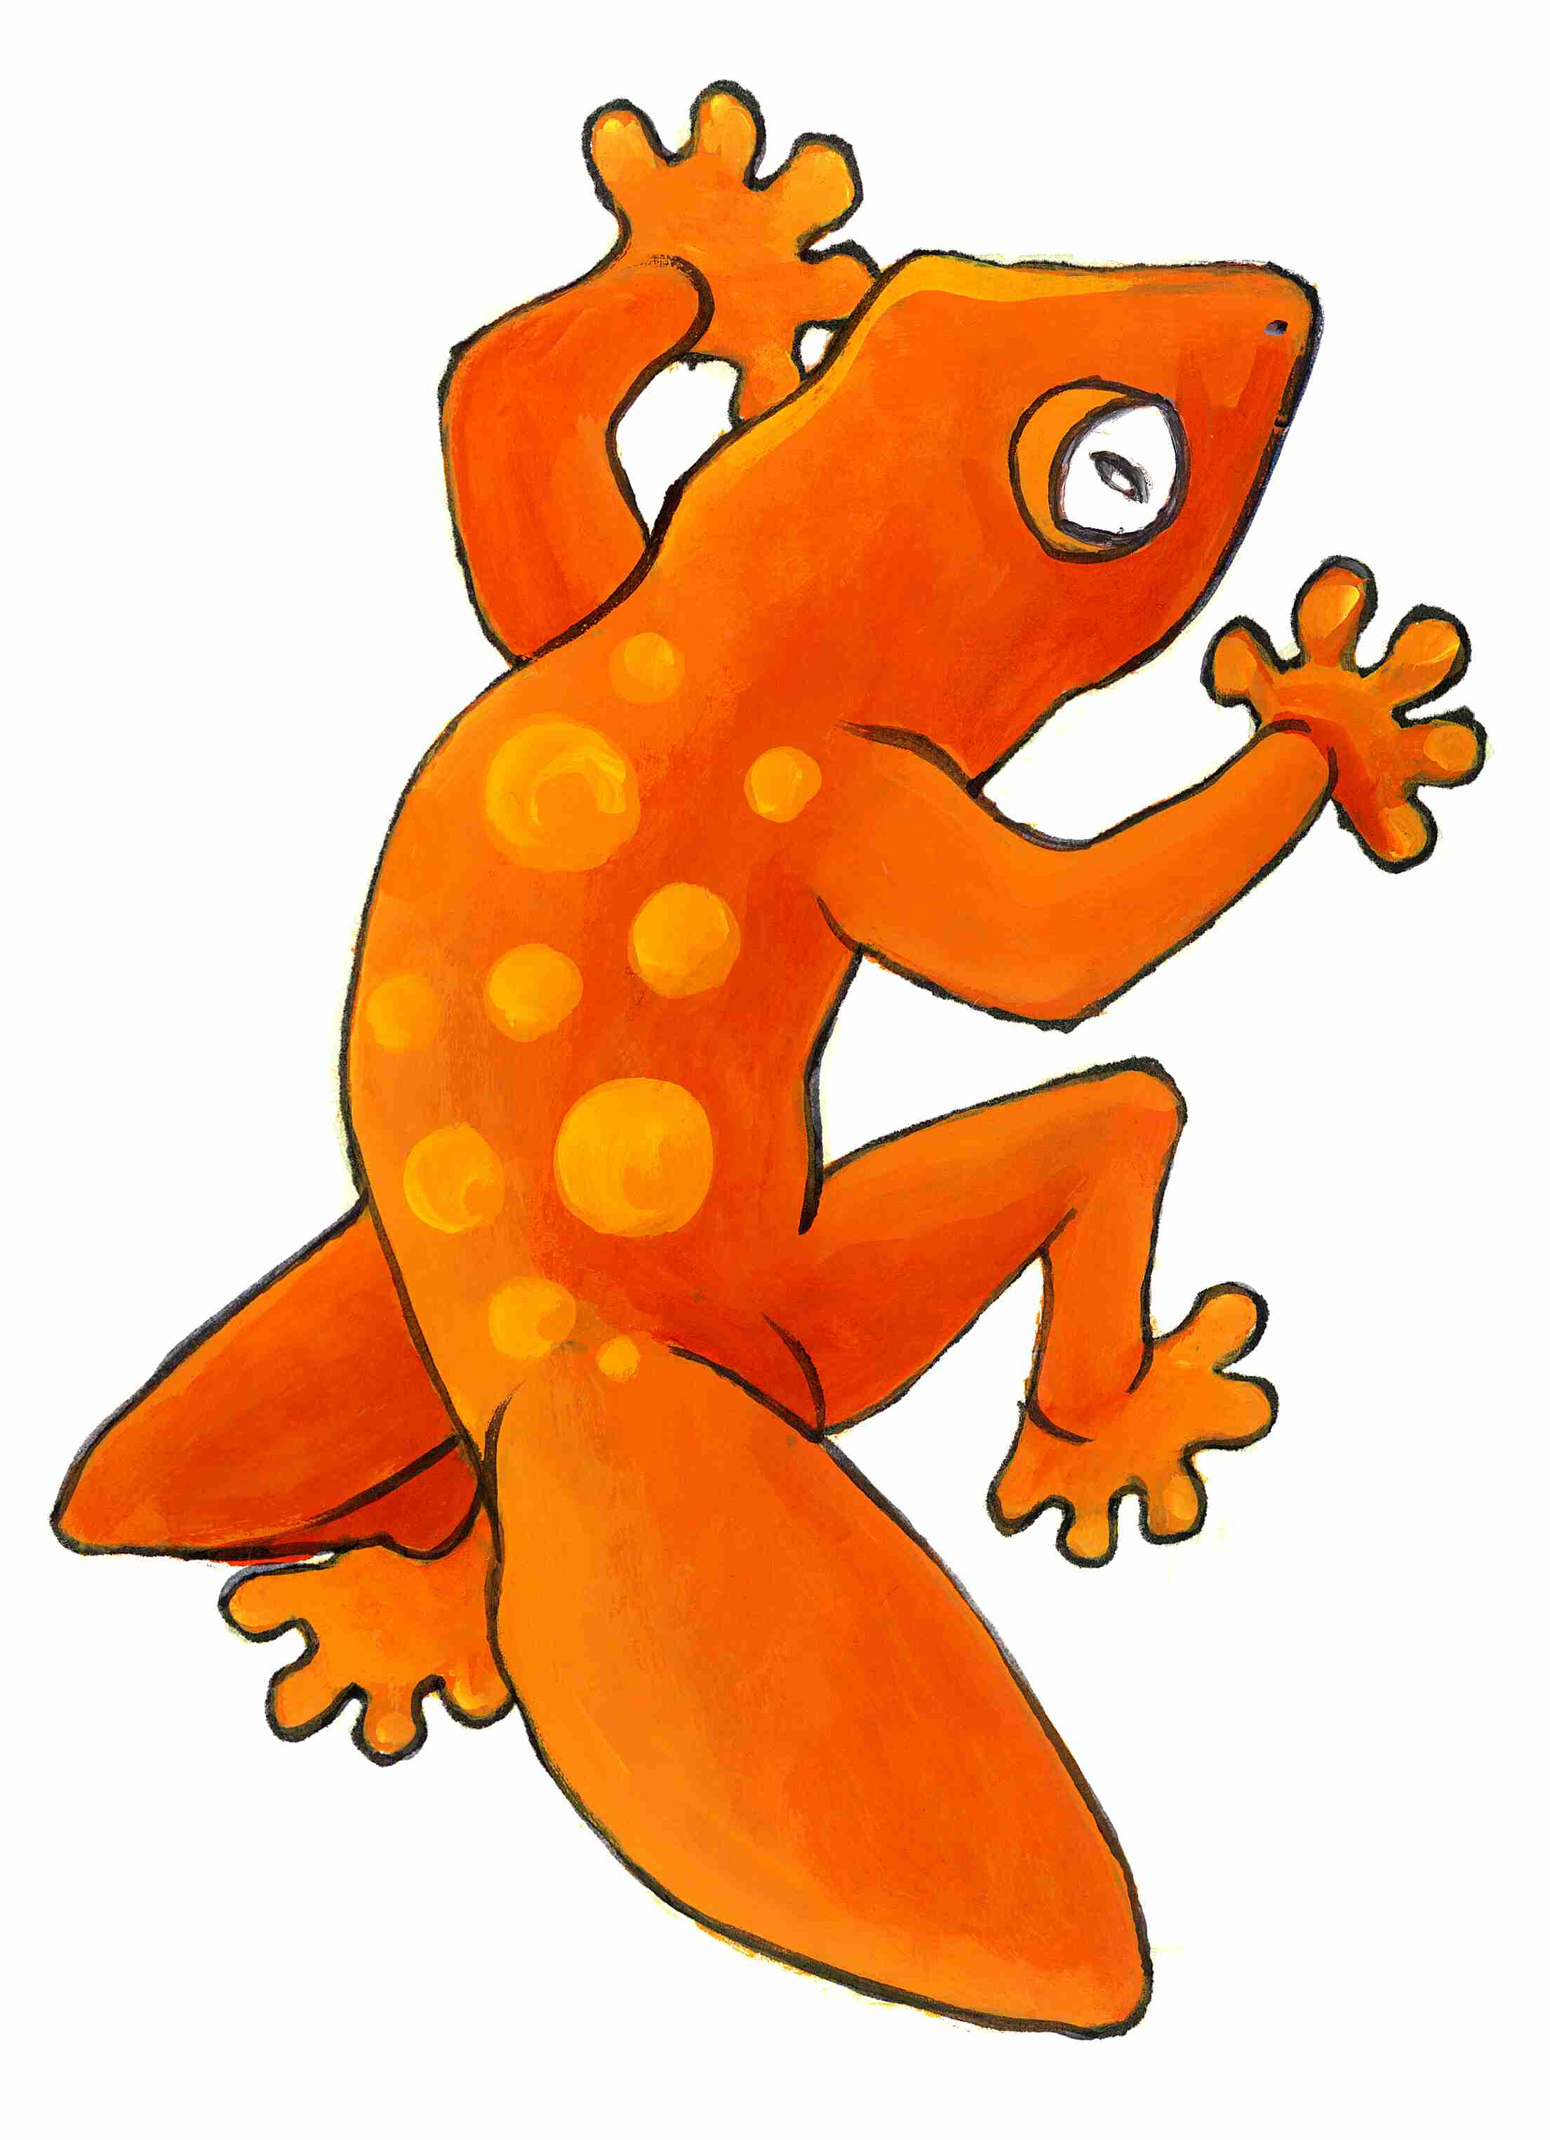
ORANGE GECKO Art– Bridges Gallery
Expression of Interest – Exhibition Participation
(The bottom section of this form should be in the hands of the Exhibition Officer at least on month prior to the date of the nominated exhibition and the ‘confirmation’ section two weeks before)

I, …………………………………………….…………, confirm my interest in having my work/s as listed below included in Bridges Gallery exhibition as indicated.

Exhibition title: …………………………………… Date (if known): ………………..

Work(s) for consideration:
1. Title of work: ………………………………………………………………
Materials: ………………………………………………………………
Size: ……………………………………….
Price: ………………………..

2. Title of work: ………………………………………………………………
Materials: ………………………………………………………………
Size: ……………………………………….
Price: ………………………..

3. Title of work: ………………………………………………………………
Materials: ………………………………………………………………
Size: ……………………………………….
Price: ………………………..
Artists Statement Attached or Use my previous statement

I understand that a fee to offset the cost of production of catalogue and labels will be levied on each piece included in the exhibition. I also understand that there is 15% commission on all sales.

Artist’s name: ………………………………… Signature: ……………………………..
Date: ………………………
------------------------------------------------------------------------------------------------------------
I,………………………………………………………….., wish to register my interest in having………..work/s included in a Bridges Gallery exhibition…………………………….
to be hang (date)………………………………….

Name:…………………………………………… Signature:………………………………..

