How to Make Birds out of Polymer Clay

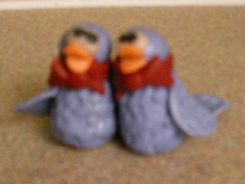

Step 1: Make two teardrop shapes for the bird’s body. Make sure they sit together the way you want them to.
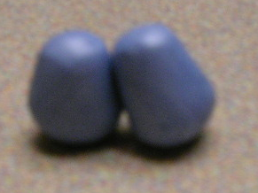

Step 2: Make feather patterns on the body with the tip of a knife.
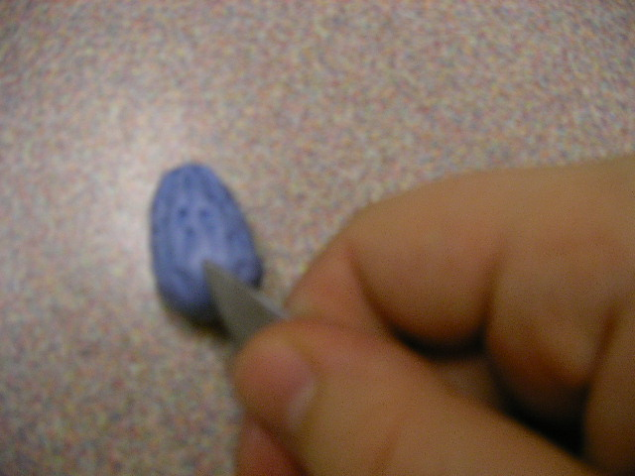
Step 3: Put heads on the bodies.
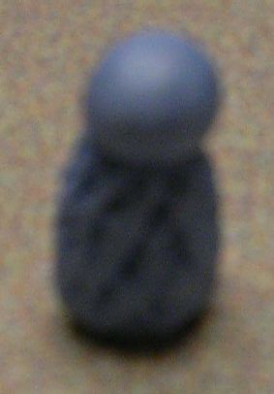
Step 4: Make a flattened snake and cut it in half. These will be the bow ties for the birds.
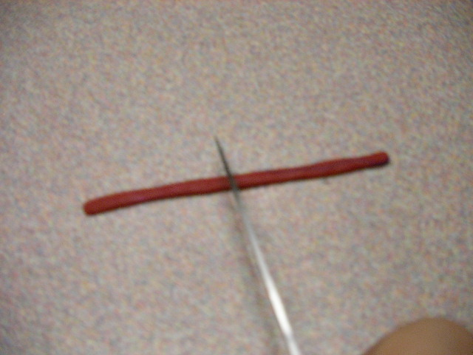

Step 5: Wrap the bow ties around the bird’s necks, and cut out the bows out of red clay. Put a tiny ball in the center of the bow.
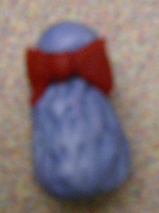
Step 6: Make eyes just like you did with the flowerpot.
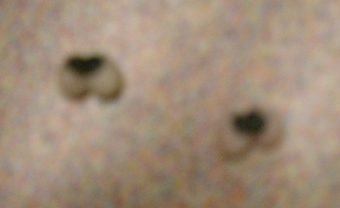
Step 7: Make two flattened ovals for the beaks.
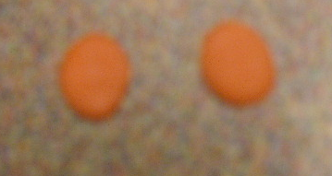

Step 8: Put the eyes on the birds. Fold the beaks in half, and put them on the birds with the knife.
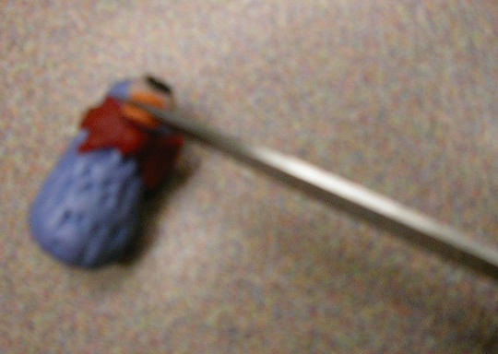
Step 9: Make four ovals for the wings.
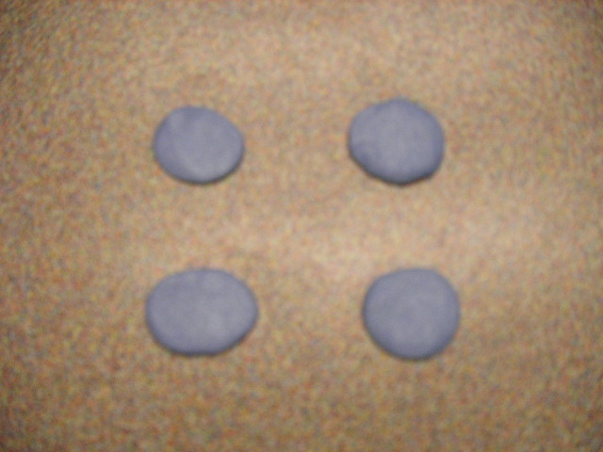

Step 10: Use the knife tip to make feather patterns on the wings.
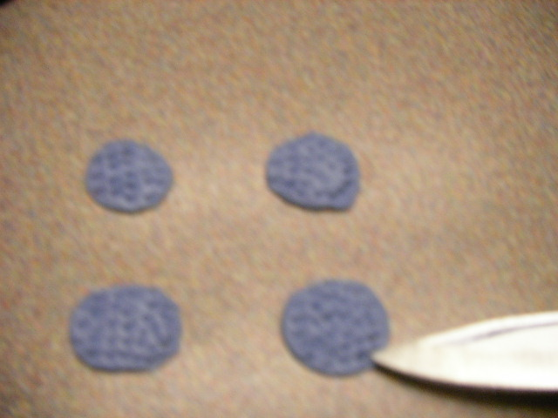
Step 11: Attach the wings to the birds with the knife.
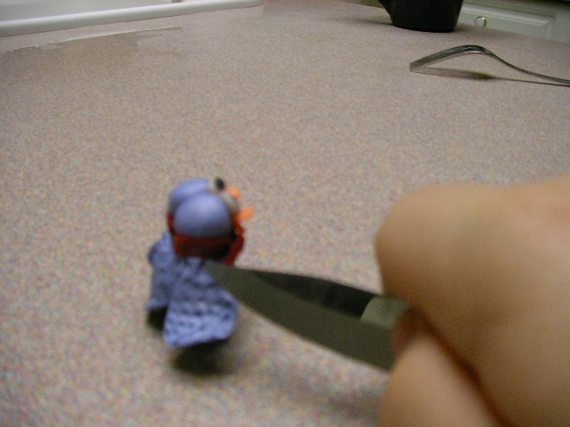

Step 12: Make tails out of long flattened ovals, and attach them with the knife.

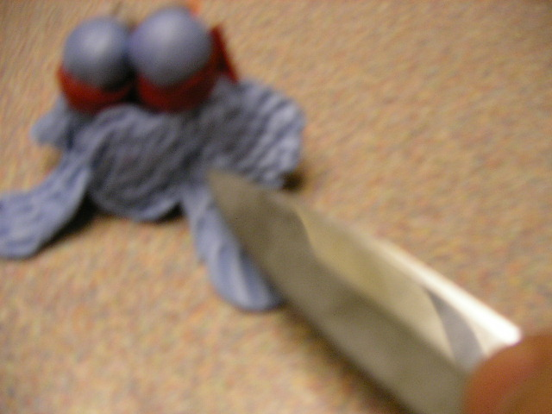
Step 13: Bake according to the instructions on your clay.

