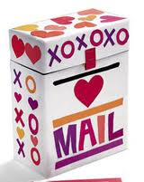
Directions: Help your Pal make a Valentine’s Day Box.
1. Cover the box with paper red wrapping paper.
2. Make sure the lid will open.
3. Help your Pal decorate the box using construction paper to make pictures, hearts, etc… Ask your Pal what they would like to put on the box.
Thank you for your help!

