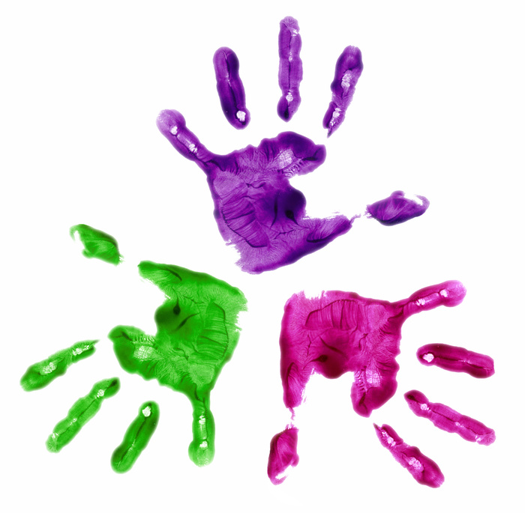
Creating Mrs. Paal’s Pals

Below are the steps taken to create our Pals Program.

- Discussed the program with my school principal

- Enlisted the help of regular education teachers to recommend and recruit typical peers

- Created a schedule of dates the Pals will meet during the school year

- Met with typical peers to discuss student needs, expectations, activities, and answered questions

- Handed out permission slips, schedule, and letters for parents

- Created conversation folders using Boardmaker to assist my students during peer conversations and to guide student-to-student talk and created picture rules

