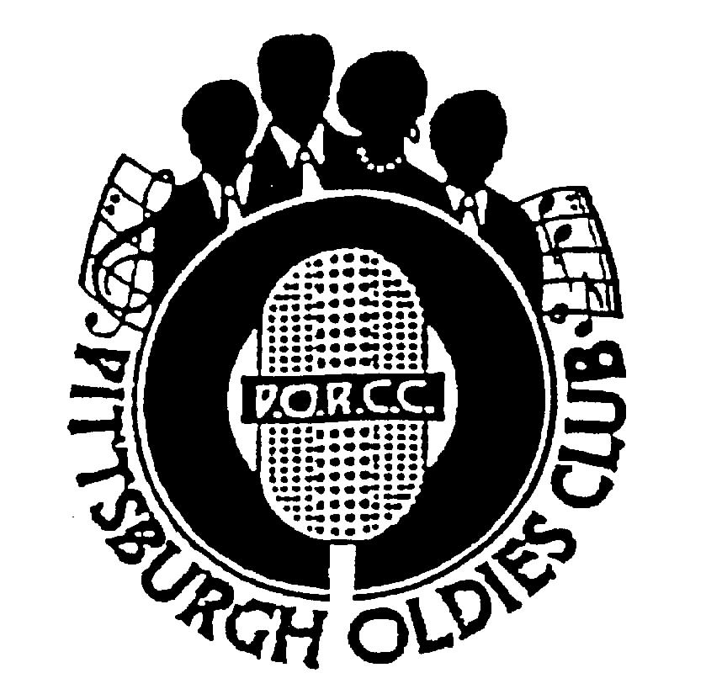
P.O.R.C.C. Newsletter
President: Jan Taper
Treasurer: Bob Azen

NEXT SHOW DATE:
SUNDAY JUNE 10, 2007

HOLIDAY INN – GREENTREE

Dinner Served at 5:30 PM Shows start at 7 PM

Our Next Show: June 10, 2007 - THE TUNEWEAVERS

The TUNEWEAVERS have returned to the stage after 43 years away from the Doo Wop scene. The group was blessed with a hit record in 1957, “Happy, Happy Birthday Baby” that sold well over two million copies. The two remaining original members, John Sylvia and Charlotte Davis-Rose, have been joined by Dr. Burt Pina and Alice Ann Fernandes in the reformed group.

Please join us and The TUNEWEAVERS on June 10th to welcome them to Pittsburgh and the PORCC Club.

Review: THE HURRICANES - By Jim Sanders

On April 21, 2007 the National Weather Service issued a severe weather warning for Western Pennsylvania. Sure enough, on Sunday, April 22, The HURRICANES struck the Greentree area. Only these HURRICANES generated nothing but pleasure!

With George Green on lead, the HURRICANES literally blew the members of PORCC away. Not only their rockin’ raucous (“Pistol Packin’ Mama”, “Yours”, etc.) but their ballads were awe inspiring. “Once In A Beautiful Lifetime”, “What Is There Left For Me” and “Dear Mother” are only a few of the beautiful ballads which brought the crowd to it’s feet.

It says here that George Green is a good a lead as there is – period, and he had the hair on my arms raised in awe on more than one occasion. This was truly a show to be remembered!!!

PORCC’s 1st Annual Doo Wop Awards Extravaganza:

Update: Several folks volunteered for this committee at our last show and we are beginning to organize this event. They are hard at work putting a ballot together, picking groups, deciding on the various categories for the ballot, planning the agenda for the show. They want your group suggestions too.

Watch your next newsletter for all the details. Please call Jan at 724-745-6898 with your group recommendations.

… Page 1
PORCC News and Events:
Check Out PORCC’s newly updated web site, the correct address is:
http://www.angelfire.com/pa4/pgholdiesrecordclub/
Or you can go to www.yahoo.com or www.google.com and enter PORCC under search.

Check out our sister club CODA at their new website: www.codakeepthemusicalive.com

EVENTS:
- Looking for something to do Thursday nights - Atria’s Restaurant, PNC Park starting 8PM,hear accappella groups like
JOHNNY ANGEL & HALOS, WILLIAM DELL and the WEE JAMS, The FOUR DOTS. Come down and enjoy great evening with our kind of music.

- Do you have 45 or 78 records come play DJ at Rustic Inn every first Monday of the month.
Call Dave at 412-276-2956. Another way to spend an evening with our kind of music and you be the DJ.

- RD Productions Proudly Presents:
  - June 16, 2007 Danny Hicks and the Continentals
  - October 6, 2007 Earl Lewis and the Channels

Doors Open at 7PM -- Music Starts at 8PM,
with DJ’s Mike and Candy from 770 KFB and Emcee Jerry Braverman of WLSW.

Tickets available through Classic Artists: 724-863-0758, Roy and Grace Deer 412-670-1904,
Candy and Mike 412-751-0313 and D&J Records in Carnegie 412-279-8888.

DUES: Don’t Forget!! 2nd Quarter dues – DUE $40.00 per quarter - Thanks!!!

Dues Mailing Address:
707 Flint Road  Allison Park, PA 15101 | Regular Members . $40/per quarter, payable quarterly  Associate Members $25/per year, payable yearly

PORCC Logo Items for Sale:
Looking for that special gift – PORCC is selling it’s logo items. They make nice gifts and show the pride of the PORCC members. See Marsha at the next show.

VIDEO SALES: We have a few videos left!
Do you wish you could see that show again that you loved so much? See Jan or Sis at the video table and order your video on the night of the show. Only $15.00!!! Can’t make a show, just send Jan a check made payable to: Media Quest for *$20.00 no later than 5 days before the show, and she’ll order a video and have Media Quest mail it to you. Send a check for the video to:

Jan Taper, 1075 Mapleview Drive, Washington, PA 15301.

Feel free to call Jan at (724) 745-6898 if you have any questions.

*Increase $18.00 to $20.00 – to help cover postage.

PLEASE NOTE: MediaQuest has requested me to ask members if they want to switch to the shows being recorded on DVD instead of VHS. The picture will be better quality and the cost would not increase. Please let Jan know your choice so she can talk to MediaQuest. Call 724-745-6898 or let her know at the next show.

CD SALES: All proceeds from the sale of CDs sold by PORCC go to the PORCC Club.

SHOWS IN 2007 Mark your calendars!: Jun 10, Jul 15, Sep 9, Oct 7, Nov 11

Greentree Holiday Inn, Located at 401 Holiday Drive,
Pittsburgh, PA 15220 (412) 922-8100

Page 2
DINNER RESERVATIONS
Sunday June 10th, 2007

Grilled Pork Medallions with Dijonnaise Sauce, English Style Cod, Whipped Potatoes, Cucumber Dill, Green Beans Almondine,Tossed Salad, Rolls and Butter, Beverages, and Dessert.

NAME: _______________________________________ Number of Persons ______ @$20.00 each = $________. Reservation and Payment are due by Tuesday, June 5th, 2007,
Call Larry for Reservations at 412-921-8352. Mail payment to: PORCC Club, P.O. BOX 16184, Pittsburgh, PA 15242. Reservations are not refundable or transferable.

If you have menu suggestions let Jan know!

Salute to the Classics:

“Salute to the Classics” is the largest outdoors oldies festival in the area. This festival is entering its 13th year at a beautiful new facility. This years event will take place at CONSOL Energy Park (formerly Falconi Field) I 70 West, in Washington PA. The event will take place on July 28, 2007 and will feature such music legends as:

The Contours
Shirley Alston Reeves
Kenny Vance and The Planotones
Jimmy Ross and The Jaggerz
The Fabulous Hubcaps
The Four Townsmen
The Vogues
Pure Gold
Plus More.

Various vendors and food booths will be set up throughout the festival grounds.

Members and guests can receive $2.00 discount off all pre-sale tickets up to July 7, 2007(cutoff date)
If you are interested please make check payable to General Talent Associates and send to:

Bob Azen
707 Flint Road
Allison Park, PA 15101

Another Sad Note:

Tim Weber sends a note about a passage from the local Meadville Tribune newspaper that Zola Mae Taylor died on Monday, April 30, 2007. The short obituary reads:

Zola Taylor, who broke gender barriers in the 1050’s as a member of the Platters, harmonizing with her male colleagues on hits like “The Great Pretender” has died, her nephew said Tuesday. She was 69.

Taylor, who later gained attention of a different sort as one of the three women who claimed to be pop idol Frankie Lymon’s widow, died Monday, said her nephew Alphie Robinson. She had been bedridden following several strokes and died at Parkview Community Hospital in Riverside County, California from complications of pneumonia.

Founding Platters member Herb Reed said he spotted Taylor, the sister of Cornell Gunther of the Coasters, rehearsing with a girl group in 1955 and knew immediately she had charisma and vocal chops the R & B group needed.

“The Great Pretender” raced to the No. 1 spot on both R&B and pop musical charts in the US and Europe, according to the “Encyclopedia of Pop and Soul” by Erwin Stambler.

But the Platter’s success began to fizzle after 1959, when four members were arrested in Cincinnati. Reed said he had been out of touch with Taylor since the early 1960’s.

Page 3


DJ’S ON THE AIR

Music Power 104 FM – WLSW

Who | Day | Time
JukeBox | Monday – Friday | 7 PM to Midnight
JukeBox – with guests Georgio, Johnny O and Big Ed | Wednesday | 7 PM to Midnight
Jeff Allen | Saturday | 6 AM to Noon
Charlie Apple | Saturday | Noon to 6 PM
Jerry Braverman | Saturday | 6 PM to Midnight
Giorgio’s Oldies Café | Sunday | 7 AM to 12 PM
Sunday oldies showcase, with Jeff Allen, Charlie Apple, Stan Wall, Cindy Gaich, Big Ed | Sunday (DJs alternate) | Noon to 6 PM
Charlie Erb | Sunday | 6 PM to 11 PM

3WS 94.5 FM

RD Summers – Sunday Oldies Diner | Sunday | 7 PM to Midnight

WJPA 1450 AM / 95.3 FM

Jim Dudas | Sunday | Noon to 6 PM

WEDO 810 AM Request 412-664-4444

Big Ray Edwards | Monday – Thursday | 3 PM to 5 PM
WKFB 770 AM
Request Line: 412-829-7100 Email: frankieday@comcast.net or kfboldies@gmail.com

Frankie Day and Caveman Ralph | Monday - Friday | 6:30 AM to 10 AM
Caveman Ralph (5/12 and 5/26) | Saturday | 6:45 AM to 9 AM
Frankie Day (5/5 and 5/19) | Saturday | 6 AM to 9 AM
Suzie Q | Saturday | 10 AM to Noon
Mike and Candy Long | Saturday | 12 PM to 3 PM
Frankie Day | Saturday | 6 PM to 8:30 PM
DJ George | Saturday and Sunday | 3 PM to 6 PM

Listen to Rich and Sunny and Have Some Fun With A Great Radio Show!!
Street Harmony Review Can be heard on the internet – www.KLAV1230AM.com

Mondays at 8-10 PM Las Vegas Time Or on www.alltalkradio.net for the show Archives

PEP RADIO – Ed Kowalski
DJ, OldiesKnight - Friends Playing Music for Friends
The Home of Doo Wop, R&B, R&R, Oldies, Vocal Group Harmony
www.DooWopRadio4U.com

The Doo Wop Show
with Host: Jim McCardle
Sundays 6-9 PM WIUP, 90.1 FM and Streaming Live at www.IUP.edu/WIUPFM

Any content to be added/removed/ changed on the PORCC Newsletter, Email me at mevans@icubed. com, Subject: “PORCC Newsletter”. This is your Newsletter, tell me the news!!
Page 4

