P.O.R.C.C. Newsletter
President: Jan Taper
Treasurer: Bob Azen
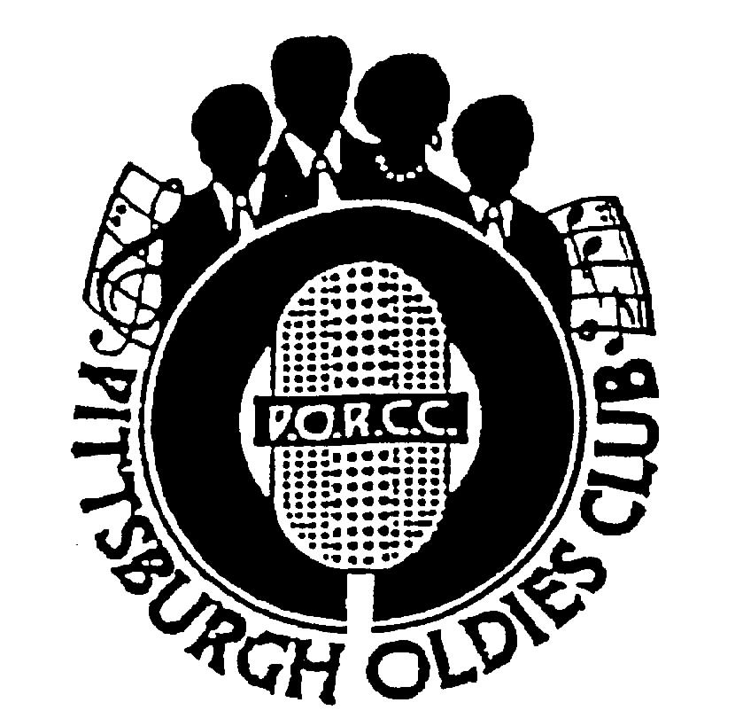
NEXT SHOW:
SUNDAY June 11, 2006

HOLIDAY INN – GREENTREE
Dinner Buffet Served at 5:30 PM,
Shows start at 7 PM

Our Next Show – Norman Fox and The Rob Roys:

“Tell Me Why”, “Dream Girl”, “Pizza Pie” – What group does that remind you of? That’s right, Norman Fox and The Rob Roys. Members of the group include: Norman Fox, Robert Thierer, Warren Tesoro, Nelson “Tino” Alvarez, and Leon McClain. Please come join us and help welcome this group to the PORCC Club. See you in June!

Review of The Harptones – By Jim Sanders:

I was escorted into Heaven at the last PORCC show. I was accompanied there by none other than the “Heavenly Harptones”. As the Harptones carried me to new heights of musical enjoyment and the celestial clouds of paradise enfolded me, I realized that only a harp at an angels hand could compete with the ethereal quality of Willie Winfield’s voice.

Oh, Harptones you have proved time and again that the immortal material penned by Cita in the 50’s is relevant to this day. With the best lead singer ever, strong harmonies and America’s greatest songwriter, the Harptones soared on high!

Thank you Heavenly Harptones for a wonderful show.

Mark Your Calendar:

Update on Mellon Arena DooWop Concert December 8, 2006:

- Little Anthony and the Imperials
- Kenny Vance and the Planotones
- Shirley Alston Reeves
- The Drifters Featuring Charlie Thomas
- The Dubs
- Larry Chance and The Earls
- William Dell and The Wee Jams

PORCC Club members will be offered a discount as in the past. We’ll keep you posted!

On A Sad Note:

Today is a sad day. John Barone, a long time member and friend of the PORCC Club has passed away on Thursday morning, May 18, 2006. He was enthusiastic about the music he loved and promoted listening to the “Oldies”. He will be sorely missed by his friends and the club and has joined our beloved Eddie and Ruth Voynick, among others in “Oldies Heaven”

Page 1
PORCC News and Events:
Check Out PORCC’s newly updated web site, the correct address is:
http://www.angelfire.com/pa4/pgholdiesrecordclub/
Or you can go to www.yahoo.com or www.google.com and enter PORCC under search.

EVENTS:
- Looking for something to do Thursday nights - Atria’s Restaurant, PNC Park starting 8PM,hear acappella groups like JOHNNY ANGEL & HALOS, The WILLIAM DELL and the WEE JAMS, The FOUR DOTS. Come down and enjoy great evening with our kind of music.
- Do you have 45 or 78 records come play DJ at Lexon in Greentree every first Monday of the month. Call
Dave at 412-276-2956. Another way to spend an evening with our kind of music and you be the DJ.
- Conneaut Lake Park’s Oldies/Doo Wop Shows for 2006 In the Historic ‘Dreamland Ballroom’

May 26, 27, 28 – Doowop Weekend - - Featuring William Dell and the WeeJams
With Headliners “Richie Johnson and The Students” on May 28, Sunday @ 8:30
July 15, Saturday @ 900 PM – Johnny Angel and The Halos
July 29, Saturday @ 900 PM – Pure Gold
September 1, 2, and 3 - Doowop Weekend –Featuring The Sweethearts of Harmony,
William Dell and the WeeJams with Headliners The Edsels on September 3rd , Sunday @ 8:30 PM

Note: Other shows are in the planning stages so watch for this spot in future newsletters for updates. Ticket prices for these shows are typically $12.00 in advance and $14.00 the day of the show, making these shows extremely affordable event. For additional information or room reservations at the Hotel Conneaut, please call Conneaut Lake Park directly at 814-382-5115 or go to the Park’s website at www.conneautlakepark.com.

DUES: Don’t Forget!!
- 2nd Quarter dues – DUE, $40.00 per quarter - Thanks!!!

Dues Mailing Address:
707 Flint Road  Allison Park, PA 15101 | Regular Members . $40/per quarter, payable quarterly  Associate Members $25/per year, payable yearly

PORCC Logo Items for Sale:
Looking for that special gift – PORCC is selling it’s logo items. They make nice gifts and show the pride of the PORCC members. See Roseann at the next show.

VIDEO SALES:

Do you wish you could see that show again that you loved so much? See Jan at the video table and order your video on the night of the show. Only $15.00!!! Can’t make a show, just send Jan a check made payable to: Media Quest for $18.00 no later than 5 days before the show, and she’ll order a video and have Media Quest mail it to you. Send a check for the video to:

Jan Taper, 1075 Mapleview Drive, Washington, PA 15301.

Feel free to call Jan at (724) 745-6898 if you have any questions.

CD SALES: All proceeds from the sale of CDs sold by PORCC go to the PORCC Club.

SHOWS in 2006: Jun 11, Jul 23, Sept 10, Oct 15, Nov 19
Greentree Holiday Inn, Located at 401 Holiday Drive,
Pittsburgh, PA 15220 (412) 922-8100

DANCES in 2006: Help us find a new Home!!!.

Page 2
DINNER RESERVATIONS
Sunday June 11th, 2006

Baked Ziti with Meat Sauce, Breaded Tilapia Filet, Dill Cucumber Salad, Medley Of Fresh Vegetables, Garlic Mashed Red Skinned Potatoes, Tossed Salad, Rolls and Butter, Beverages, and Assorted Desserts.
NAME: _______________________________________ Number of Persons ______ @$18.00 each = $________. Reservations and Payment are Due by June 6th, 2006, the Tuesday before the show. Call Larry for Reservations at 412-921-8352. Mail payment to: PORCC Club, P.O. BOX 16184, Pittsburgh, PA 15242. Reservations are not refundable or transferable.
If you have menu suggestions let Jan know!

More Events Coming Your Way…

KUZMANS

The Place Where All Good Dancers come to Meet
1025 S. State Street, Girard, Ohio 44420
330-545-8521 or 330-545-8995
Less than an hours drive from Pittsburgh

Wednesday Night Jitterbug Dancing,
Also Cha-Cha along with Line Dancing and Ballads

7:30 – 12:00
DJ – “Dr Jive”

Wednesday 5/24, 6/7, 6/21, 7/5, 7/19, 8/9, 8/23, 9/6, 9/20
Special Saturday Edition – July 8

“Just Get There – He’ll Take Your Feet The Rest Of The Way”
Admission $2.00

Thunder in the Burg…
June 9-10 at Heinz Field

Car Cruise and Drag Racing –
Co Sponsored by Pittsburgh Raceway and Fox Broadcasting,
Car Cruise by Rod Fathers

Rod Fathers Car Cruise – With 3WS


Cruise-A-Palosa

June 24 at Clearview Mall, Butler, PA
June 25 at Downtown Butler, PA

Featuring:
Johnny Angel and The Halos
William Dell and The WeeJams
and Pixie 3 on June 25

Page 3


DJ’S ON THE AIR

Music Power 104 FM – WLSW

Who | Day | Time
JukeBox | Monday – Friday | 7 PM to Midnight
JukeBox – with guests Georgio, Johnny O and Big Ed | Wednesday | 7 PM to Midnight
Jeff Allen | Saturday | 6 AM to Noon
Charlie Apple | Saturday | Noon to 6 PM
Jerry Braverman | Saturday | 6 PM to Midnight
Giorgio’s Oldies Café | Sunday | 7 AM to 12 PM
Sunday oldies showcase, with Jeff Allen, Charlie Apple, Stan Wall, Cindy Gaich, Big Ed | Sunday (DJs alternate) | Noon to 6 PM
Charlie Erb | Sunday | 6 PM to 11 PM

WJPA 1450 AM / 95.3 FM

Jim Dudas | Sunday | Noon to 6 PM
WKFB 770 AM
Request Line: 412-829-7100

Frankie Day and Caveman Ralph  Morning Memory Show | Monday - Friday | 6:15 AM to 9 AM
Mike and Candy Long | Monday - Friday | 1 PM to 4 PM
Porky Chedwick | Monday | 5 PM to 8 PM
Brandon Cunning | Tuesday & Thursday | 5 PM to 8 PM
Frankie Day and Bernie Chiniel | Wednesday | 5 Pm to 8 PM
Rick J | Friday | 5 PM to 8 PM
Caveman Ralph | Saturday | 6:45 AM to 9 AM
Porky Chedwick | Saturday | 12 PM to 3 PM
Frankie Day with DJ George | Saturday | 3 PM to 8 PM
Frankie Day with DJ George  Email frankieday@comcast.net  Website http://www.frankieday.com | Sunday | 3 PM to 8 PM


A Great Radio Show:Street Harmony Review Can be heard on the internet – www.KLAV1230AM.com
Mondays at 8-10 PM Las Vegas Time
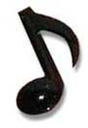
Or on www.alltalkradio.net for the show Archives

PEP RADIO – Ed Kowalski

DJ, OldiesKnight - Friends Playing Music for Friends
The Home of Doo Wop, R&B, R&R, Oldies, Vocal Group Harmony

www.DooWopRadio4U.com

Any content to be added/removed/ changed on the PORCC Newsletter, Email me at mevans@icubed. com, Subject: “PORCC Newsletter”. This is your Newsletter, tell me the news!!

Page 4

