BROAD TOP AREA COAL MINERS MUSEUM LOOKS TO THE FUTURE

We’re Proud to Announce that the Broad Top area coal Miners Historical society has purchased the 115 year-old former Robertsdale United Methodist Church with plans to relocate and expand the current exhibit area from the Reality theatre to the old Church. The project also includes expansion of the existing research library, society offices and visitors center in the theatre and future use of the cinema for various fundraising and community activities. To accomplish all of this, the society has launched a major fundraising campaign…and your help is desperately needed!

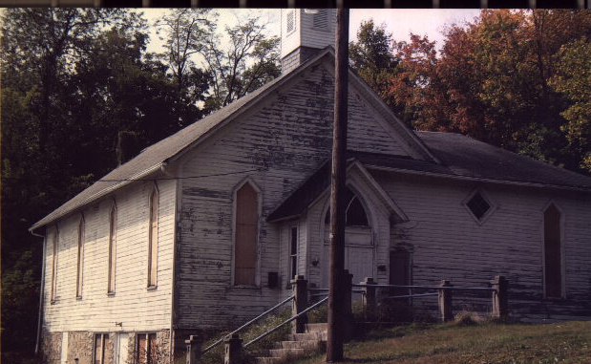

OUR TIMETABLE DEPENDS ON YOU…
We’d love to be in the new surroundings tomorrow, but a lot of building improvements are needed before that can happen. A realistic timetable depends on your generous financial support. Please dig deep and make your tax-deductible contribution today.

WHAT YOU CAN DO…
Make a major donation, sign up new members, volunteer to help with the building construction work and exhibit expansion. Whatever you can do will be appreciated.

