Schneider’s (Berber) skink Care Sheet

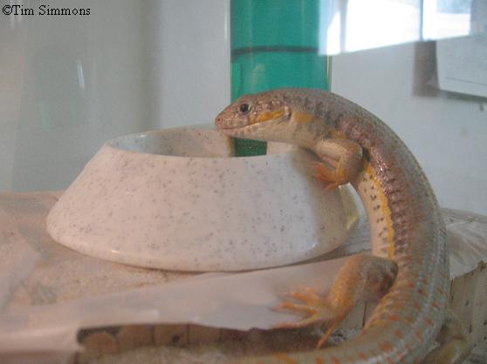

Background:
This animal is native to Northern Africa and western parts of Asia. This animal is predominantly found in the desert sands of Egypt.

Cage Environment:
This animal should be in a cage no smaller than 20 gallons (minimum of 30 gallons if paired), preferably about 55 gallons. The best substrate to use is play sand (NOT beach sand). The substrate should be about 6-7 inches in depth. To get the correct depth, you want to put a little over 3 lbs of sand for every gallon the tank holds. It is crucial that there be some sort of hide box located in the cool end of the cage along with a fresh water supply (water does not go inside hide box). Regarding heat, I suggest using a painter/plumber lamp with a 75 watt incandescent bulb (typical house hold light bulb) or even a 75 watt bulb specially designed for reptiles. If your house is warm enough, you may even be able to use a 65 watt bulb. I would also suggest an under-tank heat mat (read the directions for this device carefully-allow ventilation). The lamp and heat mat should both be placed on the designated warm side of the cage. I suggest a heat mat over a heat rock due to the fact that heat rocks have been known to burn the animals in some cases. You want to keep the cage approximately 85F-100F degrees on the warm side of the tank during the day (65F-75F in the cool end) and make sure it doesn’t drop below 65F at night in the warm end of the tank. It is important that you use a reptile UVB lamp as well. Reptiles need an optimal UVB range of 290nm – 300nm in order to produce a sufficient amount of D3. The lamp most highly recommended by reptile experts (herpetologists) is the “Zoo Med ReptiSun 5.0 UVB”. For added decor, you could purchase a live cactus or two (suitable for reptiles – check with a knowledgeable pet store or local reptile veterinarian.). Do not use a plastic cage or lid, the plastic will melt and crack easily.

Diet:
I would suggest feeding 2 dozen crickets (or as many as each animal will eat in a week) per animal each week. If the animal is juvenile (6 months – 2 years of age) or adults, I would feed it large crickets; small (pin head) crickets for the young animals (hatchlings – 6 months of age). Remember to dust the crickets with a reptile vitamin powder prior to feeding them to the animal. When you feed fruit and vegetables to the skink, remember to cut them up into small, manageable pieces to prevent choking. If you feed your skink worms, make sure to not let the worms become covered in the sand substrate (wouldn’t be good for the animal’s digestive tract. I would suggest providing the crickets with a cricket feed; this will provide your animal with added nutrition when they consume the crickets. Remember to provide your animal with a variety; proper nutrition is as important for them as it is for you. If you catch your own insects, be careful not to collect any from areas where poisons such as lawn chemicals have been applied.

Chores:
The water should be changed every day if in a dish, or every other day if it is in a water dispenser. The water dispenser should be washed out with a small quantity of hand soap and thoroughly rinsed clean of any remaining soap. The fecal matter should be scooped out once or twice each week or as needed. The sand substrate should be replaced once or twice each year. If you feed your animal any fruit or vegetables (as you should), make sure to remove any uneaten pieces within the first day or two of feeding it to the animal to prevent the growth of mold. If you feed your animal earth worms, remove any expired worms. If you supply cricket feed to the crickets, make sure you replace it every few days. Keep in mind that some crickets may drown in the water dish/dispenser and to remove the dead crickets as necessary. Remember to wash your hands well after handling any reptile or their supplies.

Health:
If your skink gets a minor cut, apply a special reptile wound medication as directed by the product. If your animal develops milky white eyes or puss around the mouth, take the animal to a veterinarian who specializes in reptiles as soon as you can. If your skink drops its tail or even a portion of it, do not be alarmed. Some lizards have a defense mechanism which allows them to drop their tail when they feel they are in danger. If your skink does drop the tail, a new one will grow back, however it will not look as nice as the first. If your animal appears to be acting unusual to you in any way, contact your veterinarian. If you have any health questions contact your veterinarian.

Supplies:
Play sand (not beach sand)
Water dish or water dispenser
Hide box (made or bought)
Cage (minimum of 20 gallons for 1 skink; minimum of 30 gallons for 2 skinks)
Screen lid
Reptile UVB Lamp (“Zoo Med ReptiSun 5.0 UVB”)
Heat lamp
Light bulb (65 watt or 75 watt)
Heat mat
Sand scoop
Cricket feed dish (optional)
Live cactus plant (optional)
Reptile vitamin powder (Zoo Med Reptivite is a good brand)
Reptile thermometer
Reptile humidity gauge (optional).

