Wisps of Straw
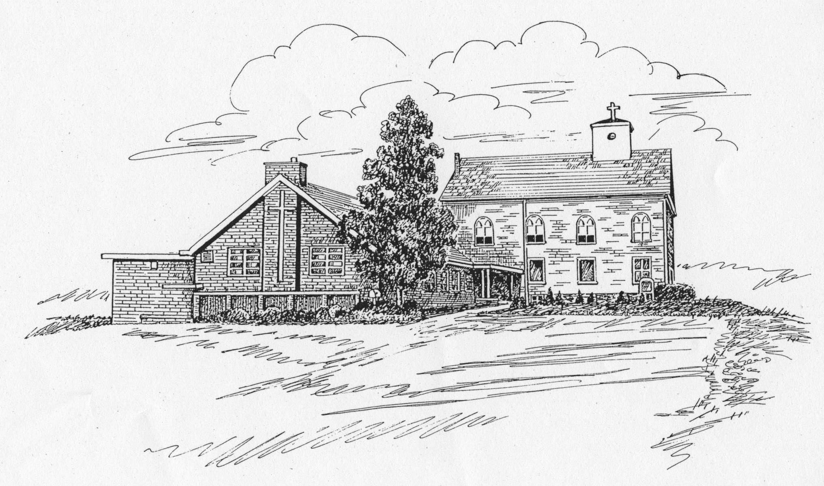
St. James Lutheran Church Newsletter
February 2010 Vice Pastor: The Rev. Glenn A. Waskow
Church Office Phone: 908-454-2864 www.strawchurch.org
“Serving Christ in Word and Deed”



Lenten and Holy Week Schedules
The most solemn weeks of the Christian year are fast approaching, but we know that the season will end, not with our Lord’s death, but with his rising gloriously from the tomb. As faithful members of his Church, we should use these forty days to prepare ourselves spiritually for the celebration of that promise of eternal life. To begin this preparation, our Ash Wednesday Service will be at 7:00 pm, February 17th.
There will be no mid-week Lenten Services at St. James, but all are invited to the 6:00 pm Soup & Supper and 7:00 pm Worship Services at St. John’s Lutheran Church, 278 Chalmers Street in Phillipsburg. There are also services at First Lutheran in Stewartsville and Grace Lutheran, Phillipsburg.
Maundy Thursday Service will be at 7:00 pm on April 1st. First Holy Communion will be celebrated at that time.
The Good Friday Service will also be held at 7:00 pm on April 2nd.
The Easter Vigil will be observed at the 6:00 pm Service on April 3rd, and Easter Sunday celebrated with Services at both 8:45 am and 10:45 am.
________________________________
We don't change the message, the message changes us.
Thrivent Financial
Helping Haiti Effort
St. James, through our membership in Thrivent Financial for Lutherans, has set up a program that enables those who wish to help the unfortunate people of Haiti have their contributions increased by up to 50%. Thrivent Financial will add $1 to every $2 its members donate, up to a total Thrivent Financial contribution of $1 million. That means a potential of $3 million or more to support relief efforts: $2 million + from its members and $1 million added by Thrivent Financial.
Please use one of the special envelopes available at various places in the church, or use a plain envelope clearly marked “Haiti Relief Fund”. Make your check payable to St. James and mark it “Haiti Relief Fund” on the memo line. Return your contribution no later than March 28th to the church office or drop it into the collection plate.
If you are a member of Thrivent Financial and wish to participate directly in this effort, visit www.thrivent.com/helpinghaiti and make a contribution until March 31st to one of the following:
Lutheran World Relief
ELCA Disaster Response
LCMS World Relief/Human Care
WELS Committee on Relief
For questions about or alternative ways to donate through this program, please call 800-236-3736. When prompted, say “directory” and enter ext. 83003.
First Holy Communion
The 5th Grade Sunday School students will meet with Pastor Waskow to prepare for their First Holy Communion from 10:00 am to 2:00 pm on Saturday, March 20th at St. John’s Lutheran Church, 278 Chalmers Street in Phillipsburg. All fifth grade students should attend, as this is the only class for students who will be receiving first Holy Communion on Maundy Thursday, April 1, at 7:00 pm. More details will be mailed to all fifth grade families as the date draws closer
Thank You
Many thanks to all who participated in the various holiday season giving programs sponsored by St. James. Our Thanksgiving food drive, as well as the Operation Santa sponsorship of a deployed Marine platoon, the Giving Tree for the Hunterdon Development Center, and our Shoe Box donations for needy children were all a credit to charitable spirit that has always characterized the people of St. James,
Scouting Events
Boy Scout Sunday will be marked on Sunday, February 7th at the 8:45 am Service.
Girl Scout Sunday will be observed on Sunday, March 7th, at the 8:45 am Service.
Congregational Meeting
The annual Congregational Meeting was held on January 24th, at 12:00 noon following a covered dish luncheon, which as always was delicious.
Upcoming work by the highway department around the exterior of the church is covered in detail on the following page.
A motion was made and carried to honor the memory of late long-time active member Ed Frey by naming the Fellowship Hall “Ed Frey Memorial Hall”.
Election of new Council members was held, and the following people will be serving in 2010:
Robert Babcock, President
Anderson Raub, Vice President
Polly Sue Avard, Council Secretary
Cheryl Pursell, Treasurer
Beth Van Blarcom, Financial Secretary
Beverly D'Apolito, Asst. Financial Sec’y
Marcia Kelly
Ron Knoble
Ken Kutzman
Jamie McLain
Carol Meixsell
George Scherer
Bill Shepherd
Steve Stocker
Lois Steible
Barbara Wynston
Janice Youpa
Contact any above member of Council if you have concerns or suggestions.
Upcoming Changes to the Exterior of St. James
By now, most everyone is probably aware of the handicap access ramp that has been constructed at the main entrance to the Sanctuary. However, there are more changes coming. Shortly after completion of the ramp we were informed that the left turn lane of Rte. 22 westbound is being lengthened to reduce hazardous back-ups into the travel lanes at the Rte. 519 traffic light during rush hour. The Property Committee has met with the NJDOT engineers and reached agreement on the extent of the work as it affects us.
The DOT will construct a retaining wall between our ramp and the widened roadway. The wall will be brick faced to blend with our exterior. Additionally (at no cost to us), our ramp will be both widened and extended to reach the second entry door, and new steps constructed to connect it to the west parking area. That parking lot will be repaved and enlarged to include a portion of the presently grassy area, allowing for several additional parking spaces. There will be new curbing adjacent to the church, and low-maintenance landscaping will be planted both there and along the wall. The present exit from the west lot to 22 west will be permanently closed for safety reasons.
It is expected that this work will begin during the coming summer. There should be no impact on any other areas of the St. James property.
Baptisms
During the past several months we have had the pleasure of welcoming three new child members to the St. James family.
The November 22nd Worship Service was the happy occasion for the Baptism of Tyler Thomas Ehrhardt, son of Patricia Ehrhardt of Phillipsburg.
December 27th marked the Baptism of John Arthur Card. John is the son of Staff Sgt. James Card and Erin Card of Gouverneur, N.Y, and is also the grandson of Barry Slack of Pohatcong.
At the January 17th Worship Service we witnessed the Baptism of Elijah Joseph La Placa. Elijah is the son of James Joseph La Placa, Jr. and Erika Leigh La Placa of Phillipsburg.
Recycle for St. James
St. James has arranged with the Funding Factory to collect empty printer ink cartridges, printer (not copier) toner cartridges, and old cell phones for responsible recycling. The church will receive cash and/or points good toward supply purchases for each cartridge and phone collected. Bins to deposit the cartridges and phones will be placed in the gathering area by the Fellowship Hall.

2009 Christmas Pageant
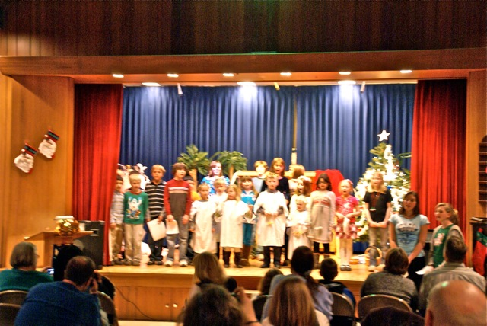
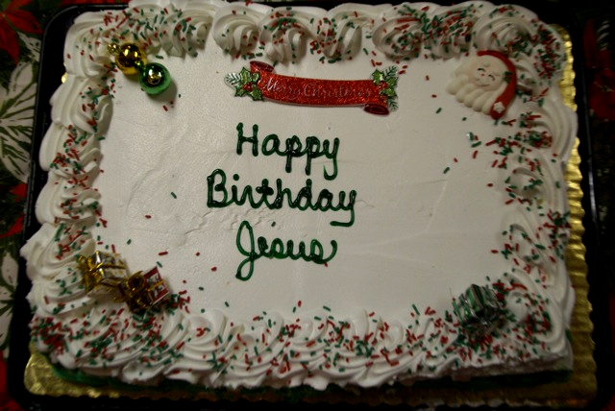
Our children graced us with their annual presentation of the familiar but always new Christmas story on Sunday, December 13th. The dedication and effort put forth by them as well as their teachers and volunteers made this year’s pageant its usual enjoyable success. Thanks also to Barbara Wynston for preserving these memories photographically.

Senior League Notes
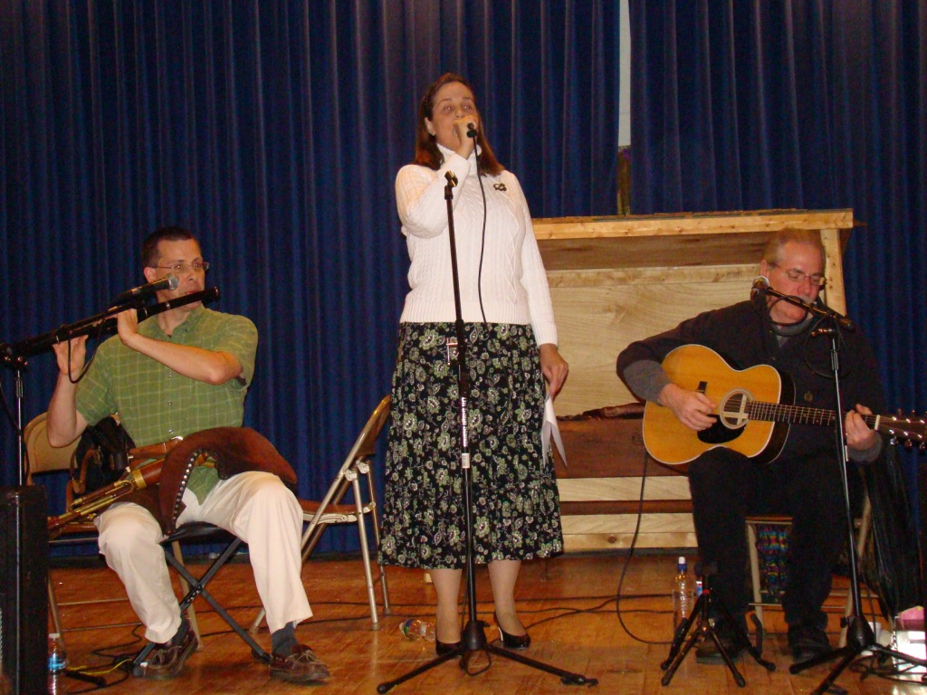
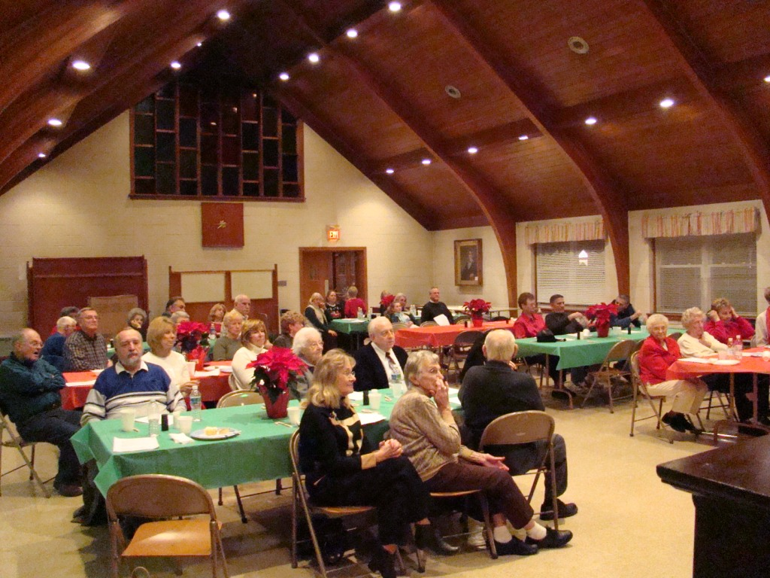
The December meeting was very well attended by both seniors and younger members of the Congregation. All had a delightful time listening to, and singing along with, Ed Saultz and his two accompanists. They presented a program of largely Christmas music that included both familiar tunes and less well-known (but beautiful) Irish airs. As is usual at these events, the food brought by the attendees was also first-rate. If anyone left hungry, it was their own fault!

