Wisps of Straw
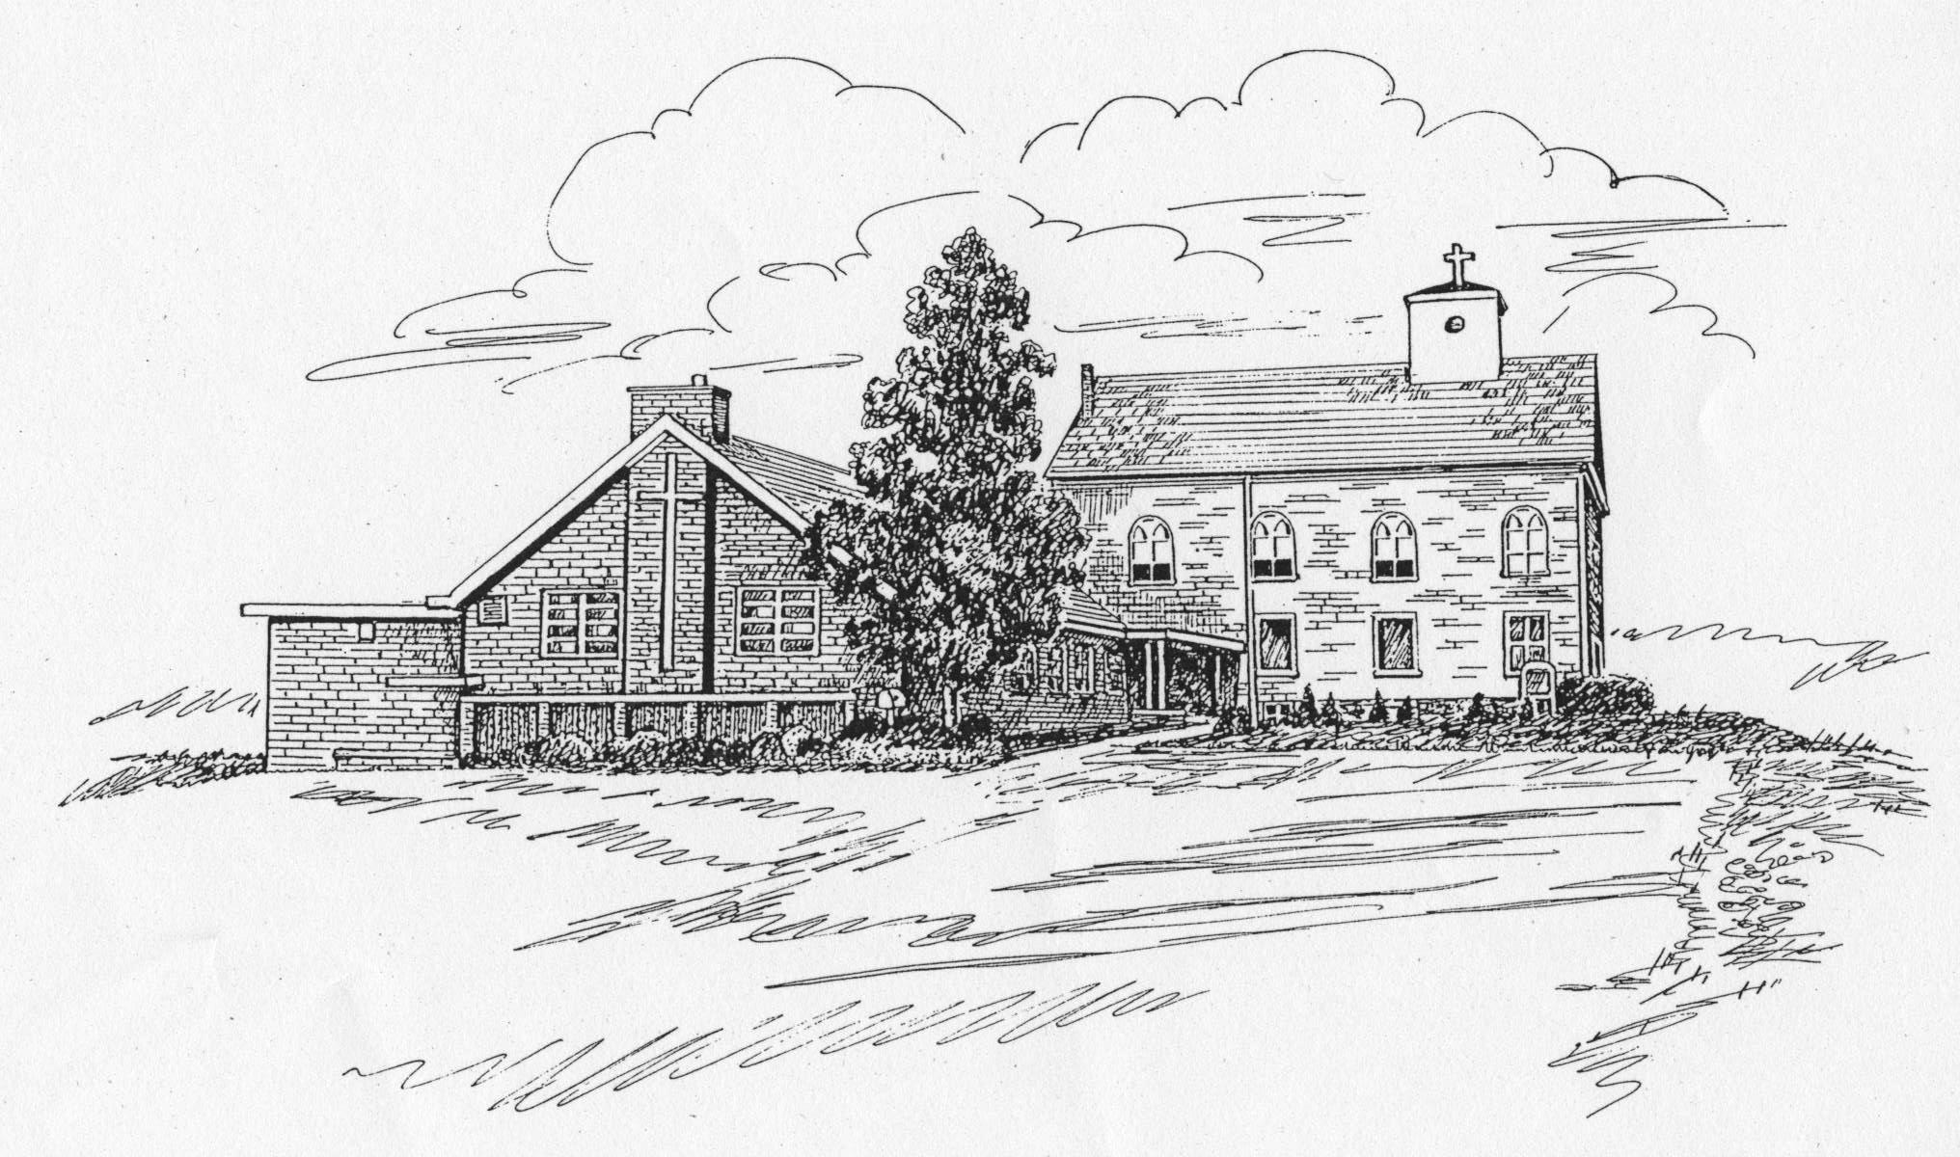
St. James Lutheran Church Newsletter
August 2009 Vice Pastor: The Rev. Glenn A. Waskow
Church Office Phone: 908-454-2864 www.strawchurch.org
“Serving Christ in Word and Deed”



Confirmation
On Sunday, June 7th, we welcomed nine young ladies and gentlemen into full membership at St. James through the rite of Confirmation. The candidates were prepared for this major step in their lives by Pastor Brunsell, and the rite was administered by Pastor Paul Brndjar.
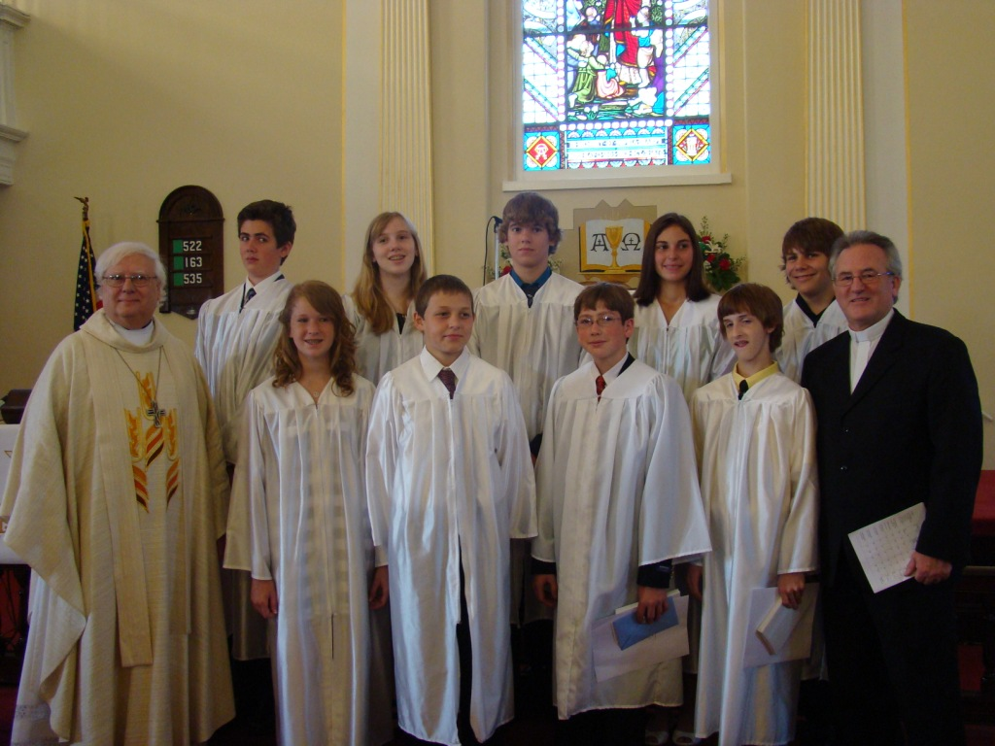
Shown here (l-r) with both Pastors are our newest members:
Back row:
Thomas Evans
Olivia Raub
Greg Lebrato
Cortney Esposito
Michael Kromar
Front row:
Brooke Bodine
Joshua Tophoney
Patrick Csiszlak
Christopher Miller
† In Memoriam †
On August 2nd our congregation lost a faithful long-time member when Erma Buss left us to join the Church Triumphant. Erma’s legacy at St. James includes 35 years of service as a Sunday School teacher, as well as having been church librarian and a member of the Meals on Wheels staff. Our prayers go out for her family, in the assurance of her eternal reward.
Baptism
On July 12th, we welcomed in Baptism Lila May Rivera, daughter of Roland and June Rivera of Stewartsville.
Fall Bus Trip
There are still some seats available for our trip to Dutch Apple Dinner Theatre for a lunch and matinee performance on Saturday, November 7th. The show is “Smoke on the Mountain”, revolving around an old-fashioned Saturday-evening hillbilly hymn sing. Given the length of the journey, we have reserved a bus with lavatory facilities. The total cost, including bus fare, show, dinner and gratuity, will range from $70.00 to about $77.00 per person, depending on how many seats are filled.
For more information, contact Christine Scherer at 908-387-0139 or by email at regalcsgs@verizon.net.
Sunday School Notes
Rally Day, the kickoff for the Sunday School year, will be held on September 13th at 12:00 noon in the Fellowship Hall. Please join us for a covered dish dinner. Registration forms will be available to sign up for Sunday School at that time.
Regular Sunday School classes will commence on September 20th after the 8:45 am Service. We are welcoming a new pre-school teacher this year, Kristen Redmond. However, additional help is still needed. In particular, we are looking for someone to serve as a teacher for the 6th grade class. If you can assist in any way in this spiritual formation of our children, please contact Susanne LaCourte at 908-995-2298 for more information.
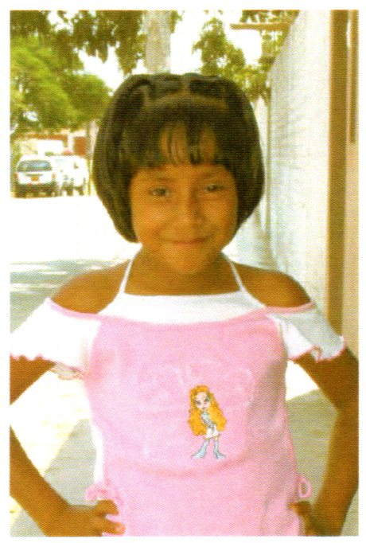
Again this year, the students will sponsor a child in Peru, nine year-old Genesis Camille Quispe Pachas. Every student is asked to bring in a $1.00 donation on the first Sunday of each month for this benevolence. The classes will write letters and color pictures to send to her as well.
________________________________
Coincidence is when God chooses to remain anonymous.
Church Office Hours
Regular office hours of Tuesdays and Thursdays, from 9:00 am to 3:00 pm, will resume after Labor Day
Memorial Plaque Fund
To honor the memories of those who have been commemorated by donations to the Memorial Fund, it is planned to erect an appropriate Memorial Plaque on the rear wall of the church. The plaque will cost about $900, and Thrivent Financial will match funds donated by the congregation. If you are able, please consider making a donation to this effort. Envelopes for the purpose are available at the church, and may be returned to the Church Office or placed in the offering plate. If you are not using this envelope, please mark your donation to designate it for the Memorial Plaque Fund.
Cub Scout Volunteers Needed
Cub Scout Pack 56 is in need of adult volunteers to serve as Pack Committee Members and Chair, Cub Master, Assistant Cub Master, and Den Leaders. Here is an opportunity to help mold the characters of our next generation of young men. Remember that a good scouting experience can lead to such things as the Eagle Scout project that will be beautifying our own church grounds in the near future.
If you can help, please contact Drew Edinger at edinger@verizon.net, or 908-209-1751.

How We Worship
This extract from the ELCA web site is a good summary for those new to the Lutheran tradition, while also serving as a review and reminder for lifelong members.

For Lutherans, worship matters. In fact, worship lies at the heart of how we understand ourselves together. While some of the approaches to worship may differ from one congregation to another, we hold certain things in common.
There is a basic pattern for worship among Lutherans. We gather. We encounter God’s Word. We share a meal at the Lord’s table. And we are sent into the world. But we do not think about worship so much in terms of what we do. Worship is fundamentally about what God is doing and our response to God’s action. Worship is an encounter with God, who saves us through the life, death and resurrection of Jesus Christ.
Think about it like this. God’s Spirit calls us together. God speaks to us through readings from the Old and New Testaments of the Bible, through preaching, prayer, and song. God feeds and nourishes us in a saving way. And God blesses us and sends us in mission to the world.
Taken together, the Word proclaimed and the sacraments – both Holy Baptism and Holy Communion - are called the means of grace. We believe that Jesus Christ is

present in these means through the power of the Holy Spirit. Sometimes we describe worship as a “gathering around the means of grace.” This is a way of saying that we trust that God is genuinely present with us in baptism, in preaching, and in sharing the bread and wine of Holy Communion. In that sense, Lutherans believe that God’s presence permeates all of Christian worship.
The cross is the central symbol that marks our worship spaces and when Lutherans worship, singing fills the air. The voices of all the people joined in song and the participation of all the people in the worship is a witness to our conviction that in worship we are being drawn in to God’s own saving story.
Affirmation of Baptism
Affirmation of Baptism Festivals gather ninth grade youth for a day of exploring what it means to "live among God’s faithful people…and strive for justice and peace in all the earth." This year the events will be held on the Lutheran Seminary Philadelphia campus on Saturday, October 24th, and on the Gettysburg campus on Saturday, November 14th.
Registration can either be done online at www.theologicaleducationwithyouth.com or by calling the Coordinator, Sherry Rippman, at 717-338-3005. The fee is $25.00, which includes lunch and snacks. Additional information is also available at the above link.
VBS Wrap-up



Our VBS was a huge success. We had 70 children join us to hear about God’s Love through the Lord’s Prayer. This is the largest number we have seen in many years. The children had a wonderful time. We learned new songs, met new friends, and enjoyed snacks and games together. At the end of the week, the children put on a wonderful performance explaining the entire week’s lessons and sang songs they learned that week. Each day a safari animal represented a core value from The Lord’s Prayer.
On Monday, a lion represented how God listens to us and we should listen to him.
“Our Father who art in Heaven, hallowed by thy Name.
Thy Kingom come, Thy Will be done on earth as it is in Heaven.”
On Tuesda y, the giraffe helped us learn how God provides.
“Give us this day our daily bread”
On Wednesday, the zebra helped us discover forgiveness.
“Forgive us our trespasses as we forgive those who trespass against us.”
On Thursday, the hippo helped us learn about God’s protection.
“And Lead us not into temptation, but deliver us from evil.”
On Friday, the elephant helped us discover how God Rules!
“For Thine is the Kingdom, and the power, and the glory forever and ever. Amen.”
Thank you to all the adults and teens who volunteered this week. You were amazing! Your efforts made our Kingdom of the Son Prayer Safari the success it was. The generous donations from the congregation were hugely appreciated by the children (and volunteers). Props were donated by the Free Evangelical Church in Easton and Bethlehem Presbyterian Church in Pittsown, NJ. The sound system was on loan from Cub Scout Pack 61 and the DVD player was borrowed from Mr. Brian Cenci. Thank you to them as well for helping keep the teachings seen and heard.
Senior League News
Senior League meetings will resume after the summer break with a games night on Wednesday, September 2nd, at 6:00 pm. Meetings are held in the Fellowship Hall on the first Wednesday of the month and include a light supper. Please contact Carol Meixsell at 908-454-6734 if you plan to attend.
The June meeting featured a program of Irish music and lore, presented by Ed Saultz. His repertoire contains many beloved tunes, traditional Irish as well as Irish-American. Ed also shared his wealth of knowledge about the background of this music as it relates to the Irish experience, both in the homeland and as immigrants to our shores.

From a Friend
Dear Friend,
How are you? I just had to send a note to tell you how much I care for you.
I saw you yesterday as you were talking with your friends. I waited all day hoping you would want to talk with me, too. I gave you a sunset to close your day and a cool breeze to rest you – and I waited. You never came. It hurt me – but I still love you because I am your friend.
I saw you sleeping last night and longed to touch your brow, so I spilled moonlight on your face. Again I waited, wanting to rush down so we could talk. I have so many gifts for you! You rushed off to work, and my tears were in the rain that fell on you.
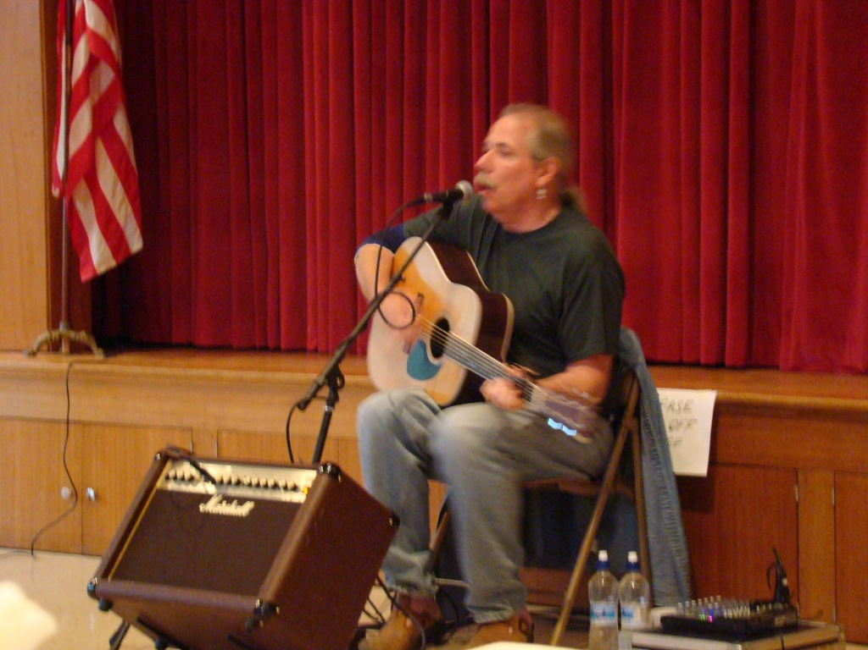
If you would only listen to me! I love you! I try to tell you in blue skies and in the quiet green grass. I whisper it in leaves on the trees and breathe it in colors of the flowers, shout it to you in the mountain streams, and give the birds love songs to sing. I clothe you with warm sunshine and perfume the air with nature’s scents. My love for you is deeper than the ocean, and bigger than the biggest need in your heart!
Ask me! Talk with me! Please don’t forget me. I have so much to share with you!
I won’t hassle you any further. It is your decision. I have chosen you, and I will wait – because I love you.
Your Friend,
Jesus

