Wisps of Straw
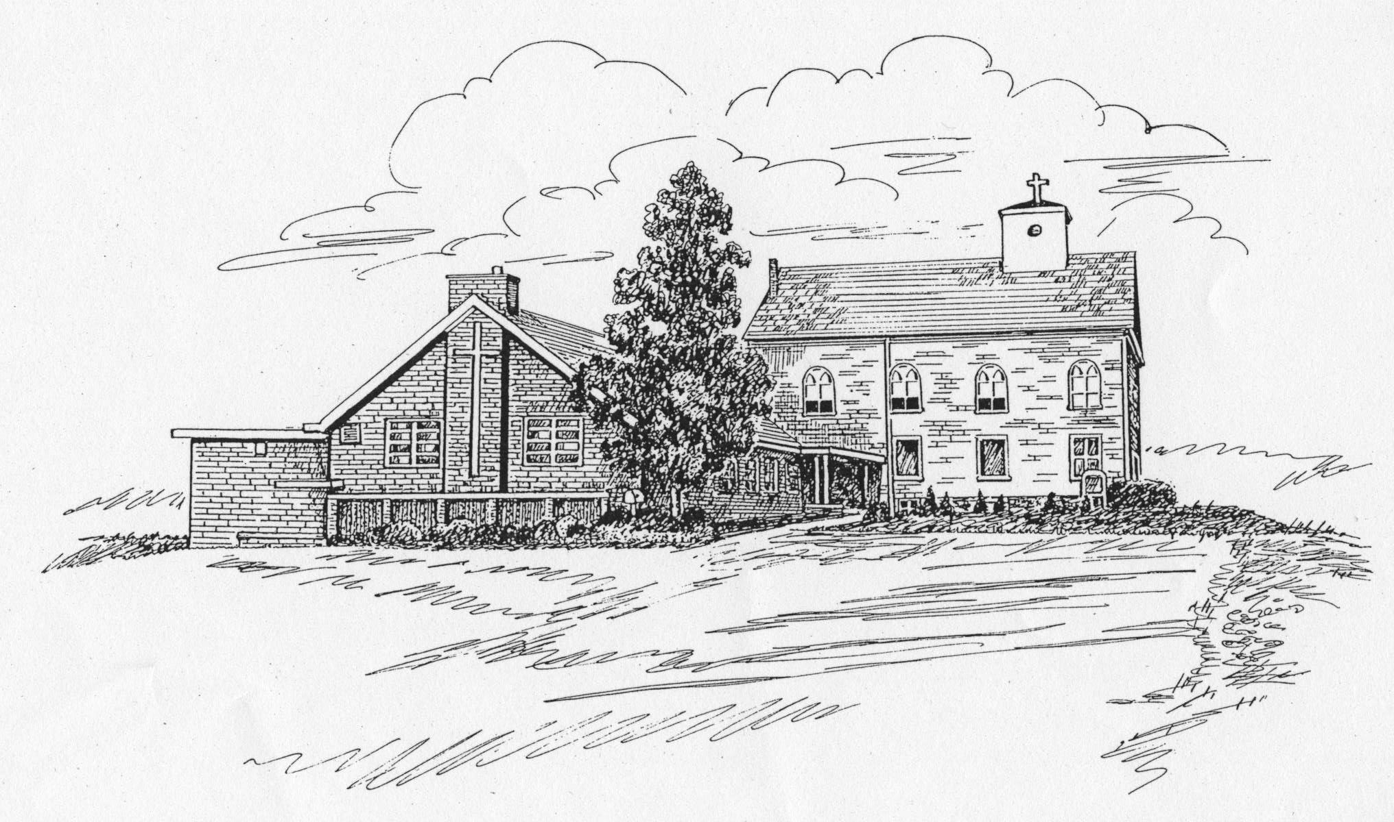
St. James Lutheran Church Newsletter
February 2009 Vice Pastor: The Rev. Richard Brunsell
Church Office Phone: 908-454-2864 www.strawchurch.org
“Serving Christ in Word and Deed”



Lenten Information
Soon we Christians will begin our observance of the solemn and penitential season that prepares us for the commemoration of our Lord’s suffering, death and glorious Resurrection. At St. James, we will have an Ash Wednesday Service at 7:00 pm, February 25th, with the Rev. Paul Brndjar as our Supply Pastor.
There will be no mid-week Lenten services at St. James, but all are invited to the 6:00 pm Soup & Supper and 7:00 pm Worship Services at St. John’s Lutheran Church, 278 Chalmers Street in Phillipsburg. Also, on Ash Wednesday St. John’s is having Services with Holy Communion at 12:00 noon.
Scout Spaghetti Supper
Our own Boy Scout Troop 56 is holding a Spaghetti Supper on Saturday, February 21st from 4:00 to 7:30 pm in the Fellowship Hall. This is an all-you-can eat event. Adult tickets are $6.00 each and children (students) are $4.00; 5 years and under are free. Come join us for Saturday night Worship Services and leave the cooking to the Boy Scouts.
Offering Envelopes
Offering envelopes for 2009 are in the Fellowship Hall. If you have not already done so, please take a moment following Worship to pick up your box. Thank you.
First Holy Communion
The 5th Grade Sunday School Students will meet with Pastor Brunsell to prepare for their First Holy Communion. Dates for the classes will be sent out as soon as they are confirmed. The students will receive their First Holy Communion on Maundy Thursday, April 9th.
Church Records Update
The church has obtained a new computer program to consolidate all congregation records in one more easily accessible database. If each household could take the time to complete one of the forms located outside the Fellowship Hall and place them in the Comments box, it would be greatly appreciated. This new program will do much for our church, but it can only be as good as the information we put into it.
Vacation Bible School
Although summer seems very far away right now, we are beginning to plan our Vacation Bible School for mid summer. If you can help, please contact Beth Van Blarcom. We need adult and teen volunteers to help make this year's VBS a success.

Opportunity may knock once, but temptation bangs on your front door forever.
Congregation Meeting News
The annual Congregational Meeting was held on January 25th, at 12:00 noon following a covered dish luncheon. Our thanks go to all the great cooks in the St. James family, who really outdid themselves.
Council President Bob Babcock expressed his appreciation of all those members whose efforts have helped us in so many ways throughout the year.
The Property Committee is researching the next phase of the project to provide handicapped access to the church. An outside ramp replacing the sidewalk and stairs to the main doors appears the most practical and cost-effective. Portions of those stairs are deteriorating and would require major repair or replacement in any event, so that cost would be avoided.
Election of new Council members was held, and the following people will be serving:
Robert Babcock, President
Anderson Raub, Vice President
Polly Sue Avard, Council Secretary
Cheryl Pursell, Treasurer
Beth Van Blarcom, Financial Secretary
Beverly D'Apolito, Asst. Financial Secretary
Mike Kolba
Lois Steible
Ron Knoble
Steve Stocker
Barbara Wynston
Bill Shepherd
Ken Kutzman
Carol Meixsell
George Scherer
Michael Redmond
Contact any above member of Council if you have concerns or suggestions.
Meals on Wheels
Can you spare 90 minutes once a month? That’s all it takes to bring meals to the homebound. Two-person teams deliver the meals. Stay-at-home Moms, this is a great way to teach charity to young children. Please contact Holly Chemidlin if you can help.
Trip Announcement
Following the success of our Radio City trip in November, we are planning another outing this spring, a trip to the Hunterdon Hills Playhouse to see “Over the River and Through the Woods” sometime in mid-May. Cost for both show and dinner would be $50.50 per person for a group of 20 or more. Because of the short distance involved, we feel that driving or car pooling would be more cost-effective than chartering a bus. If you are interested, contact Chris Scherer ASAP but no later than March 1st at 908-387-0139 or regalcsgs@verizon.net.
An Appeal for Help
Catholic Charities food pantry in Phillipsburg has been a partner with the Scouting for Food program for many years, helping distribute food to those in need. The pantry is looking for one or two low-cost upright freezers for perishable food storage. If you can help, please contact Ed Socci of Cub Pack 50 by phone at 908-235-8800, or email ed.socci@pepsi.com. Many thanks in advance for your help.
Sunday School Christmas Program
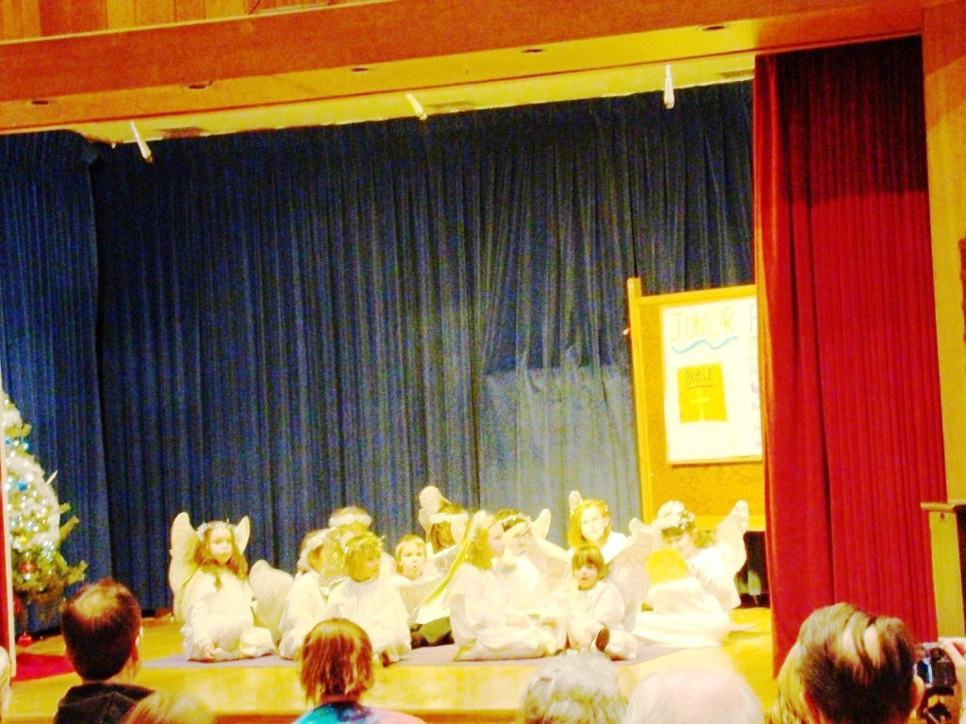
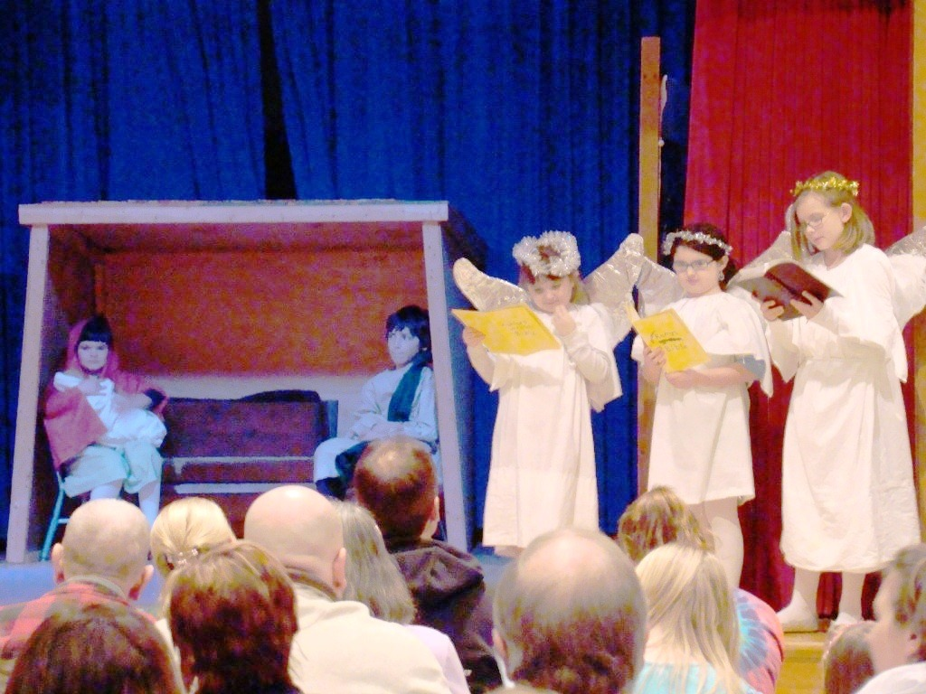
The Sunday School children staged their annual Christmas Program in the Fellowship Hall on Sunday, December 14th. Congratulations to them all for a presentation that was both entertaining and inspirational. Thanks also go to the staff and volunteers that helped them bring this to us.
