Wisps of Straw
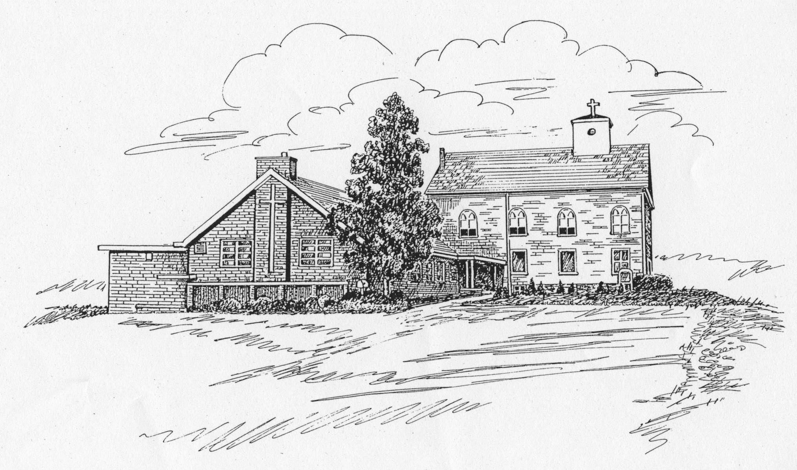
St. James Lutheran Church Newsletter
July 2008 Pastor: The Rev. Dr. Jane Gaeta
Church Office Phone: 908-454-2864 www.strawchurch.org
“Serving Christ in Word and Deed”


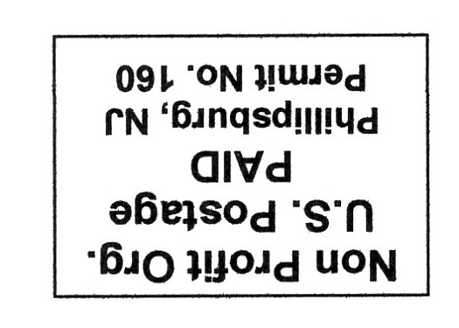
The Pastor’s Letter
Dear Members and Friends of St. James,
Paul writes in the first chapter of his letter to the Philippians:
I thank my God every time I remember you, constantly praying with joy in every one of my prayers for all of you, because of your sharing in the Gospel from the first day until now. I am confident of this, that the One who began a good work among you will bring it to completion by the day of Jesus Christ.
During the past thirteen months, we have begun some amazing work with youth, seniors, families and outreach to those in need - all founded on Bible Study and a new Daily Prayer ministry. God has blessed this congregation in Jesus' name! It is with much emotion that I leave as your stated supply Pastor. Nevertheless, I am certain that God will continue to bless you with the strength and the grace to do great things in the name of Jesus!
I thank God for blessing me through you, confident that the One who began a good work among you will bring it to completion by the day of Jesus Christ.
God's joy and peace,
Pastor Jane Gaeta

From the Editor
I am certain that I speak for every member of the St. James family in expressing our heartfelt thanks to Pastor Gaeta for the caring and inspirational leadership she has shown us over the past thirteen months. She has been more than generous with her time, and has truly embraced the congregation as her own over this period. While she will certainly be missed, there is no doubt that she leaves us a stronger and more vibrant Christian community that will long be the better for her time with us.
Pastor, thank you from the bottom of our hearts for all you have done.

God calls us to worship. God is the focus of worship.

Worship Times
We will continue to have a 6:00 pm Worship on Saturday evenings through the summer season. Sunday Worship will likewise remain as is, at 8:45 am.
Holiday Bus Trip

Social Ministry and Senior League are jointly considering a bus trip to Manhattan on a weekday early in November. Our destination will be the Radio City Music Hall, to take in the annual Christmas Spectacular. With a group of at least 25, we will be able to get show tickets for $37.00. Bus costs will depend on the number of people going, but should be in the range of $25.00 to $30.00.
We would be stopping for a meal at each person’s own cost on the return trip, possibly at Cracker Barrel.
There will be a sheet on the church bulletin board (over the coffee table in the hallway) for those who are interested, or you may contact Chris Scherer at 908-387-0139 (regalcsgs@verizon.net) or Shirley Johnson at 908-454-5748 (sjcj2@verizon.net). The coach seating is limited to 33 people, so it will have to be first come, first served.
Vacation Bible School
Vacation Bible School is scheduled for July 7th to 11th. VBS is open to all children ages 4 and up. If you can assist in any way, please contact Sandie Takacs at 908-479-1946.
Fall Quilt Group
Is anyone interested in learning to quilt? I would like to start a church quilt group, and thought we might be called the "Straw Church Quilters". We will begin by making baby quilts for babies who are baptized at St. James. Material and lessons will be supplied to get us started. We could meet for two hours on Saturday afternoons at the church, either twice a month or whatever is preferred. Anyone who is interested, please call Beverly D'Apolito at 908-454-9442 or speak to me on Sunday.
Fighting Hunger One Click at a Time

This information bears repeating from the last Wisps of Straw. Just by logging on to http://www.thehungersite.com/ we can help hungry people the world over. This is made possible by sponsors who advertise on the site, and finance food donations with every hit on the “Click Here to Give” button.
Additional donations are also made by these sponsors when any product of theirs is actually sold through the site.
It is not necessary to register, so bookmark the site and visit it whenever you log onto the Internet!
.
Cub Scout News
The Cub Scouts (Pack 56) of St James Lutheran Church have had a busy year. In August the boys had the opportunity to participate in Day Camp and Resident Camp programs sponsored by the Minsi Trails Council. During the first part of the year we started with outdoor activities such as Camping with Troop 56 & Troop 63 and Hiking at Hawk Mountain.
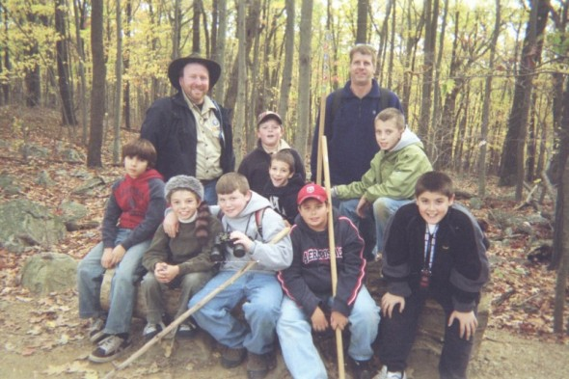
We then turned our attention to others in the fall by participating in our annual food drive “Scouting for Food”, took time to sing and bring holiday cheer for the residents of Clymer Village, and adopted a needy family through NORWESCAP (raising money to provide clothing and toys for them). We also collected toys for the annual Order of the Arrow toy drive and ended with caring for our wild animals by making feeders that were hung on our scout tree at Warren Glen Park.
The winter months were filled with activities and learning. Several of the boys took advantage of overnight events at the DaVinci Science Center where they learned Nature, Astronomy & Geology. We assisted with the church service on Scout Sunday, held our yearly Pinewood Derby, camped in at a climbing gym, and attended Scout Day Basketball at Lehigh University. In addition, our boys participated in the activities at the Yukon Gold rush, went skiing and snow tubing, and winter camped with Troop 56.
In the spring we turned to outdoor activities, which included community service such as the Musconetcong River Clean Up and Beaver weekend to get our summer camps ready for the season. We participated in our JAMBO where over 6000 scouts, parents and leaders converged on Kutztown University for a weekend of camping, activities and entertainment.
We celebrated our achievements through the year at our Blue and Gold Dinner where seven of our boys completed their Arrow of Light and crossed over to our Boy Scout Troop.
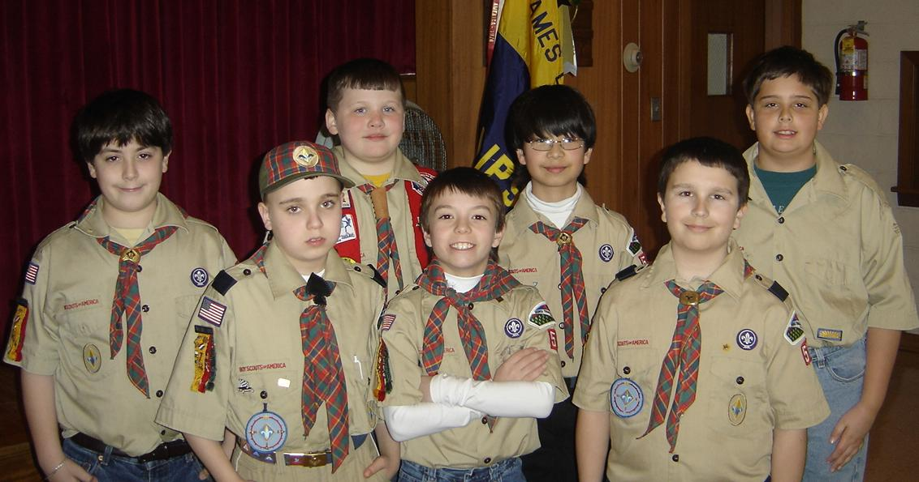
Our Wolf and Bear Dens saw the boys earn their ranks along with many special awards such as Emergency Preparedness and World Conservation.
Even though our weekly meetings are ending for the summer, we have many activities planned including a fishing derby, Residence and Day Camps, District Family Camping at Weona Park, a Dorney Park outing, the Camel Beach outing and hiking in the Delaware Water Gap.
Looking to next year we have already recruited eight new scouts and one new leader. We are always looking to grow our ranks and welcome adult volunteers to help run our program. If any church member wants to assist or get involved with our Cub Scouts, please contact the Cub Master, Drew Edinger, at 908-454-3646.
Senior League News
On June 4th, the Senior League held its last meeting before suspending them for the summer season. It was a fun-filled occasion that included games and Bingo. Pizza was on the menu, as were all the “fixins” for making delicious sundaes. A good time was had by all.
We would like to extend a big Thank You to all our local merchants and friends who so generously helped to make this evening a success.

Bon-Ton Beauty Shop
Carol Meixsell
Domino’s Pizza
Floral Workshop
Friendly’s
Helen’s Florist
Manhattan Bagel
Panera Bread
Pastor Gaeta
Perkins Family Restaurant
Piazza Farms & Greenhouse
Pizza Hut
Rita’s Ice
Stop & Shop
Tender Touch Car Wash
Tess Johnson
Wal-Mart

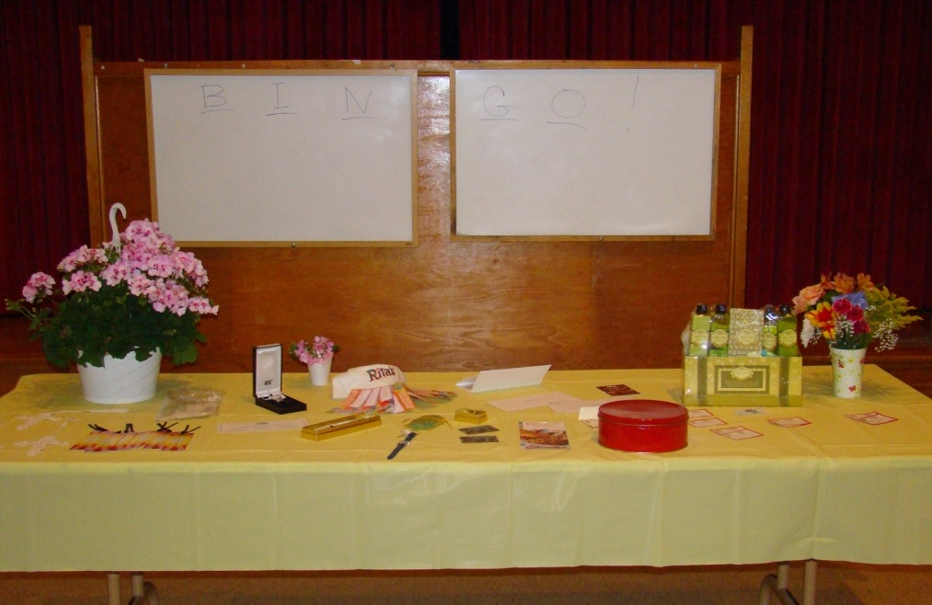
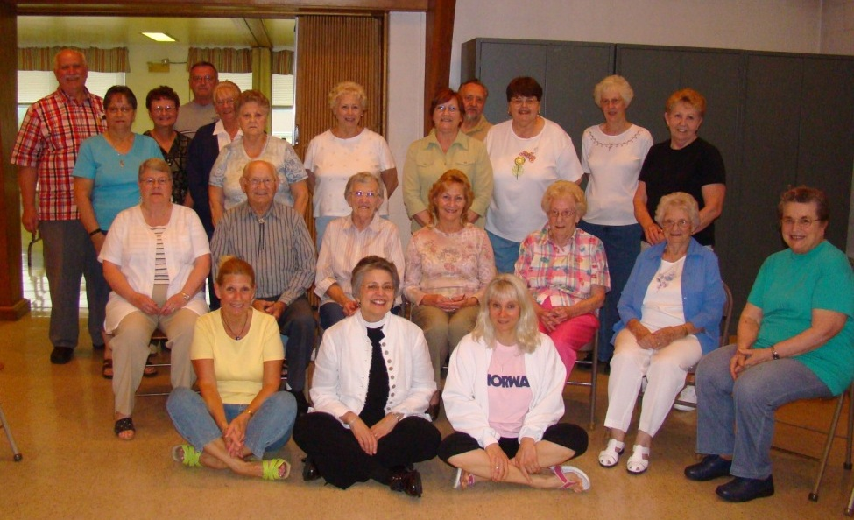

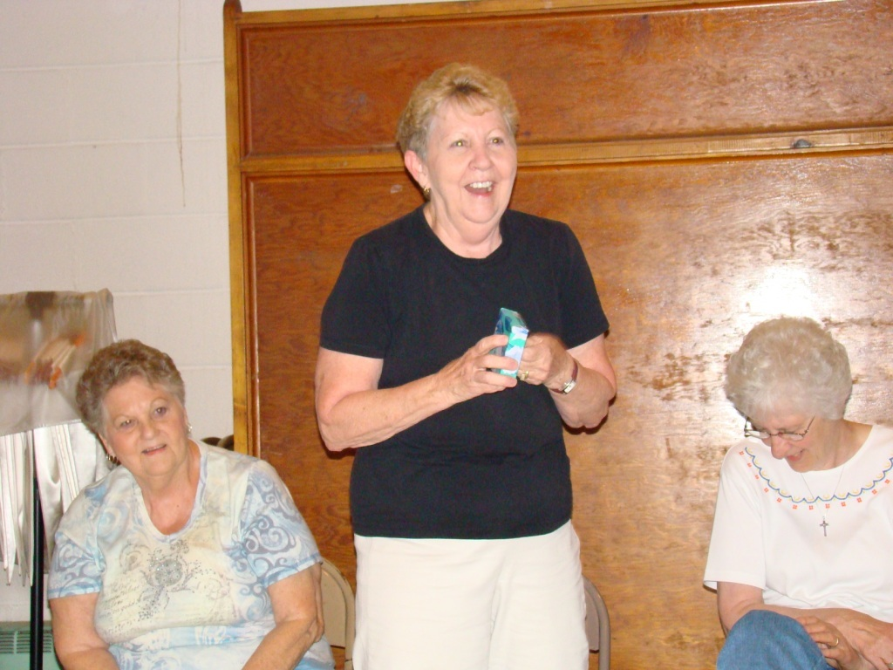
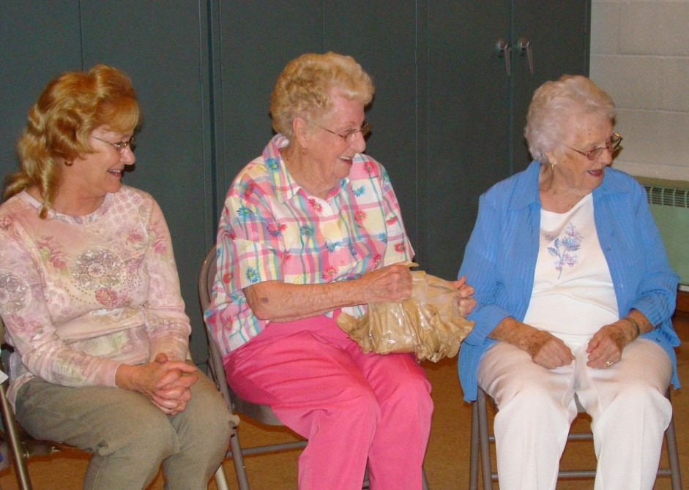

The Senior League will resume regular meetings in the fall. These meetings are in the Fellowship Hall on the first Wednesday of the month from 6:00 to 7:30 pm. All members over 50 are invited. A light supper is provided, and there are always interesting and enjoyable programs. Please call Carol Meixsell at 908-454-6734 if you plan to attend.

From the New Jersey Synod
During the last year, our Synod has launched an initiative called Mission on the Move (MOM). It is a part of changing the culture of this Synod, to engage it in God’s mission in this territory, and to make us a church that is sent, not settled.
From the Word and Sacrament center of our life, Christ calls us to follow him into the world. The Holy Spirit propels and guides us on our way, leading us back at least weekly to the gathered community for refreshment, renewal, and remembering what God has done and what we are to do. Then and always, the Spirit leads us back out again into the world. Such is the mission-rhythm of the Christian life of faith.
The 185 congregations of this Synod follow this pattern each week in a variety of ways and contexts. For some, the connection of worship and mission in the world seems natural, giving meaning and life to the local faith community. For others, there is a great disconnect between the gathering and sending. Many churches seem to rise or fall somewhere in between: at some points (or with some members) connecting energetically and creatively the encounter with God’s Word and the call to be gospel for the sake of the world; at other times being totally inwardly focused on the joys and ills of “my” church.
The greatest strategic mission resource God provides for the Evangelical Lutheran Church in America in New Jersey is the 185 congregations – called, gathered, enlightened, made holy, and kept in true faith by the Holy Spirit.
What does this mean? It means that we must constantly and prayerfully be in conversation about our part in God’s mission for the sake of the world and especially how and to what and to where the Risen Christ may be leading us as church together.
Our shared witness to the Gospel is strongest when these 185 congregations are vital, healthy, growing, and engaged in the world. So we commit ourselves to Christ and to one another.
ELCA Information
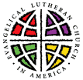
There are two worthwhile new ELCA publications available to borrow in the church office. The first is Stories of Faith in Action | 2008. In concise, inspiring magazine format, it shows how the mission dollars donated by people like us are used to spread Christ’s message as well as His love throughout the world.
The second publication speaks to one of our current concerns at home. Called to be a Public Church is filled with information on fulfilling our civic duties as an informed electorate, as well as guidelines as to what is and is not permissible activity within a tax-exempt entity such as a church. There are also a series of Issue Briefs that provide background information and questions on many of the problems facing the U.S. and the world today.

