Wisps of Straw
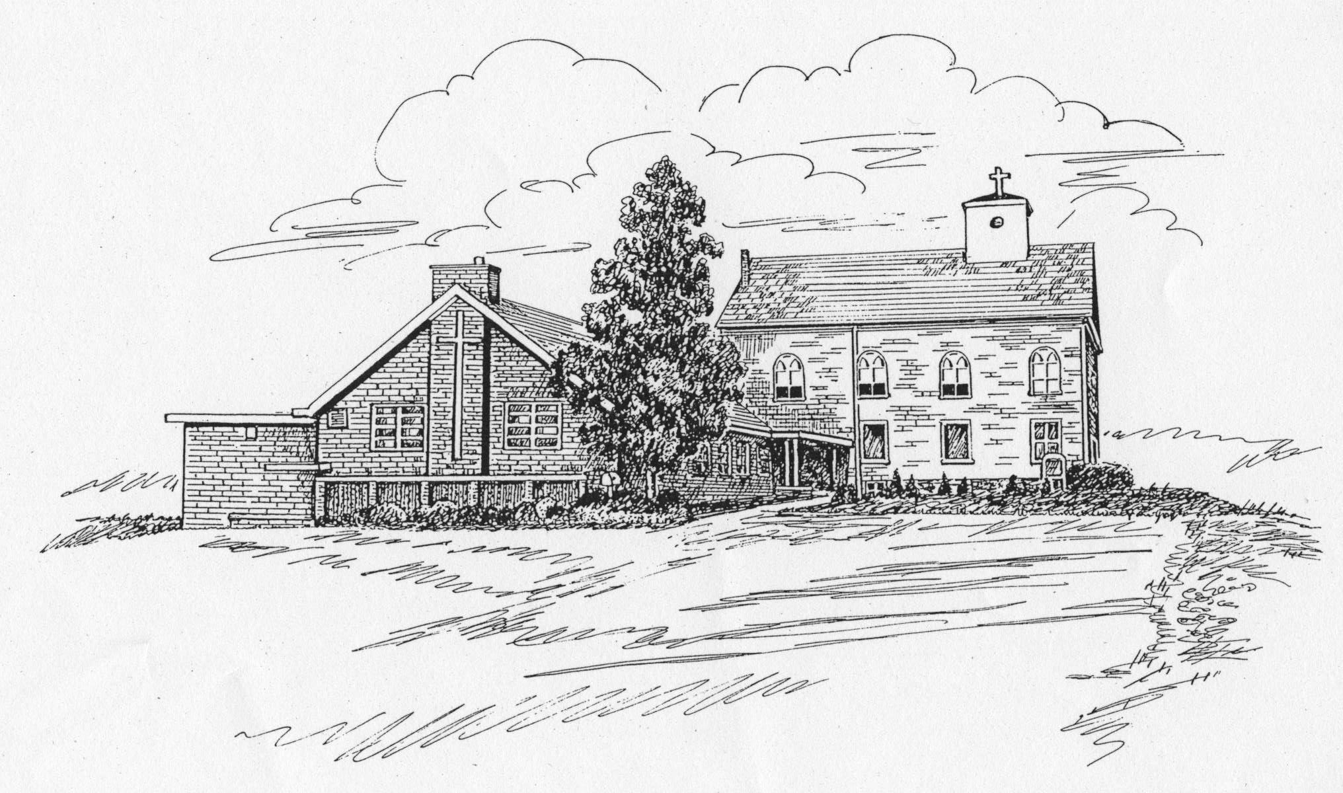
St. James Lutheran Church Newsletter
May 2008 Pastor: The Rev. Dr. Jane Gaeta
Church Office Phone: 908-454-2864 www.strawchurch.org
“Serving Christ in Word and Deed”



The Pastor’s Letter
Dear People of St. James,
Christ is Risen! He is Risen Indeed! Alleluia!!
This is the Queen of seasons! The great feast of the church! A fifty day celebration of rejoicing!
Death has been put to death, humanity has been restored, and even the face of the earth is renewed with flowering trees, daffodils, tulips and the promise of ever so much more!
The Easter Cross stands victorious in our Sanctuary. The Paschal Candle remains lit.
So let us continue to celebrate! No less than fifty people contributed to our Holy Week and Easter celebrations. Thank you! The word liturgy (what we do at worship) means 'the work of the people' which it most certainly was - and continues to be.
Invite your friends, your neighbors, folks you haven't seen in a while to join in the celebration!
We have been richly blessed - to be a blessing!
Christ is Risen! He is Risen Indeed! Alleluia!!
God's peace and joy,
Pastor Gaeta
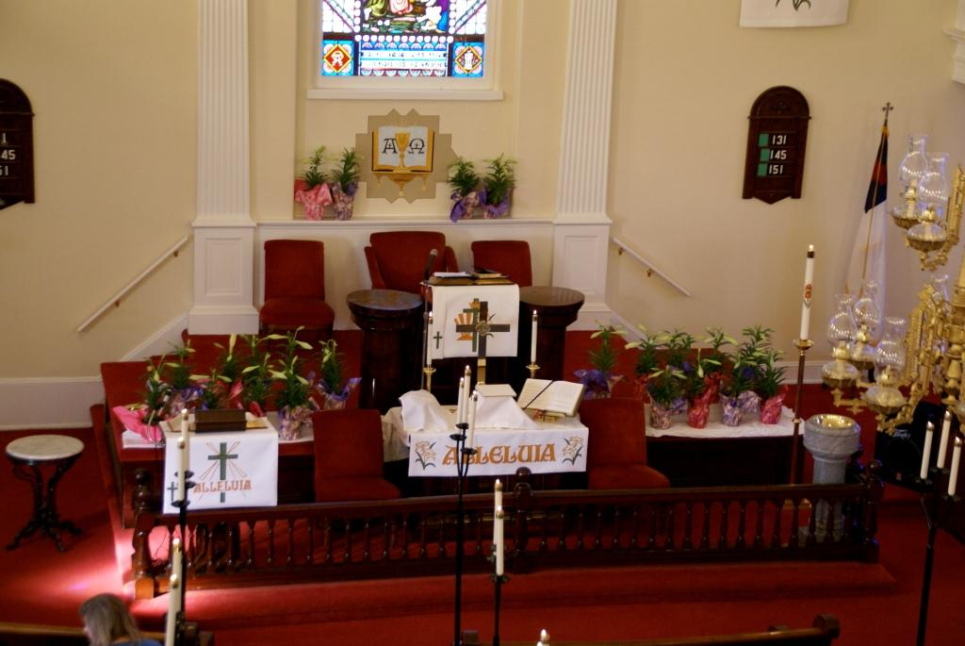
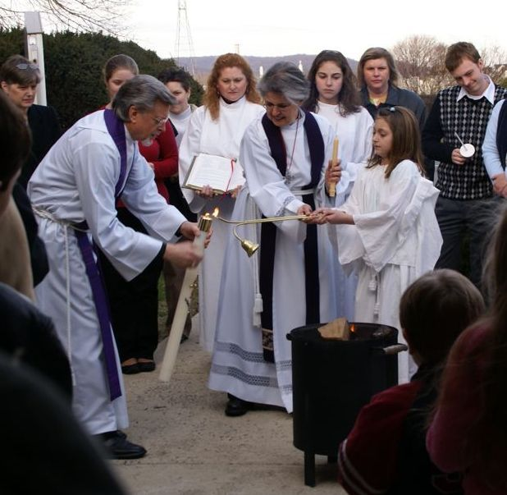

God calls us to worship. God is the focus of worship.

In Memoriam
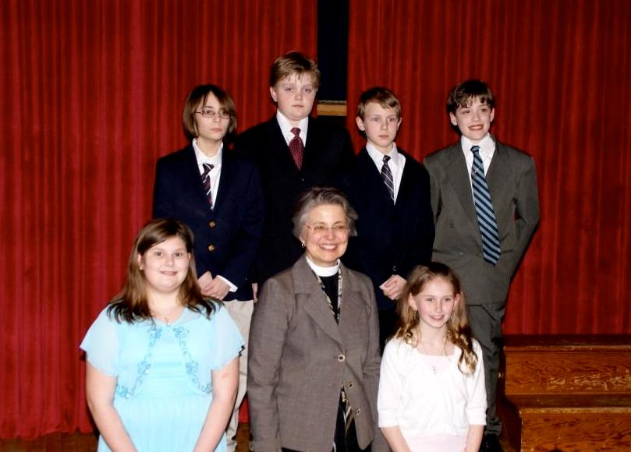
Clara Louise (Ache) Curran 1915 - 2008
Clara Louise was a long-time member of St. James, and a Sunday School teacher for many years. She had moved to Connecticut to be near family during her later years, and entered the Church Triumphant this past January 30th. Her ashes were interred at Phillipsburg Cemetery on April 12th.
Messages of condolence may be sent to her son: Tim Curran
20 Ardsley Lane
Ellington, CT 06029
Baptisms
Liam Carl Bittenmaster, son of Mr. and Mrs. Carl Bittenmaster, on March 22nd.
Hailey Nicole Taiana, daughter of Mr. and Mrs. Raymond Taiana III, on April 19th.
Scouting News
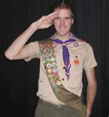
Congratulations to Eric Conner and Mike Martin of Troop 56 on earning the rank of Eagle Scout, and to Brandon Maris on earning the 2007 Scout of the Year award.
Credits
Thanks to Barbara Wynston and Beth van Blarcom for the photographs in this issue.
First Communion
We welcomed the following Fifth Grade students as they received their First Holy Communion on Maundy Thursday:
Meghan Chemidlin
Jason Holman
Matthew King
Sean LaCourte
Lauren Orchulli
Douglas Wrede.
New Members
The following new members were welcomed during the Easter Vigil on March 22nd:
Kathryn Raub
Barbara Wynston and her children, Ashley and Douglas Wrede.
Saturday Evening Worship
If you can't make it to Worship some Sunday morning, consider coming Saturday evening. Worship is upbeat, informal and a joy! Also, if your neighbors can't come on Sunday, tell them about Saturday worship.

Sanctuary Restoration & Beautification
As you may recall, there was a discussion at the congregational meeting this past January regarding a painting project in the Sanctuary. Church Council studied photographs of the altar area from the early through the late 1900s. It was discovered that the Alpha and Omega painting below the stained glass window at the altar had been in existence much longer than anyone ever thought, as it was discovered to be under the paper wall covering. It has now been restored to its original appearance.
The second phase of returning our church to its original glory has also been completed. This consisted of accenting the arch around the stained glass window at the altar, as well as painting the medallion from which the chandelier hangs in the center of the church. These changes also go back to the original appearance of the church so long ago. There will now be a pause for us to reflect upon these beautiful changes as we worship over the next months and make no additional changes at this time.
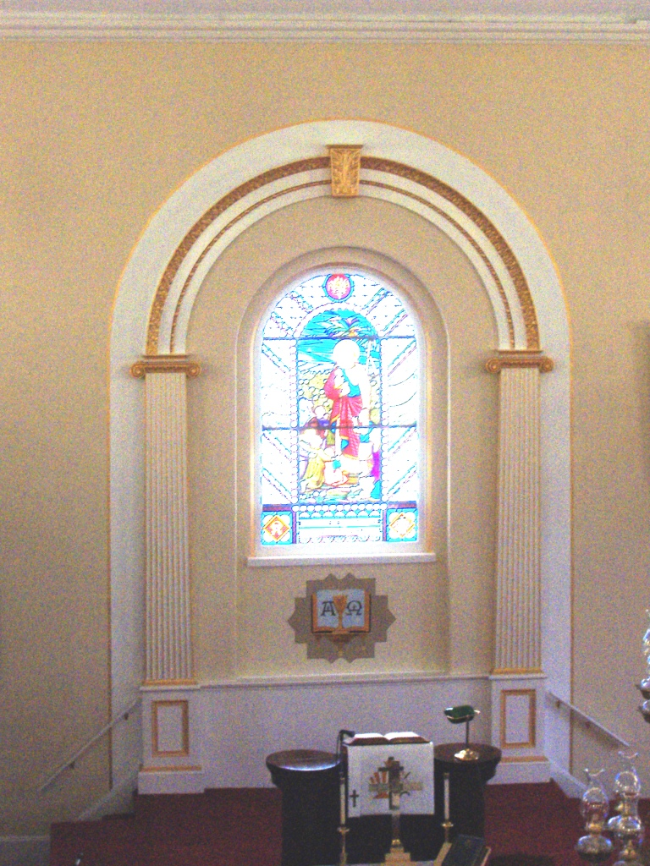
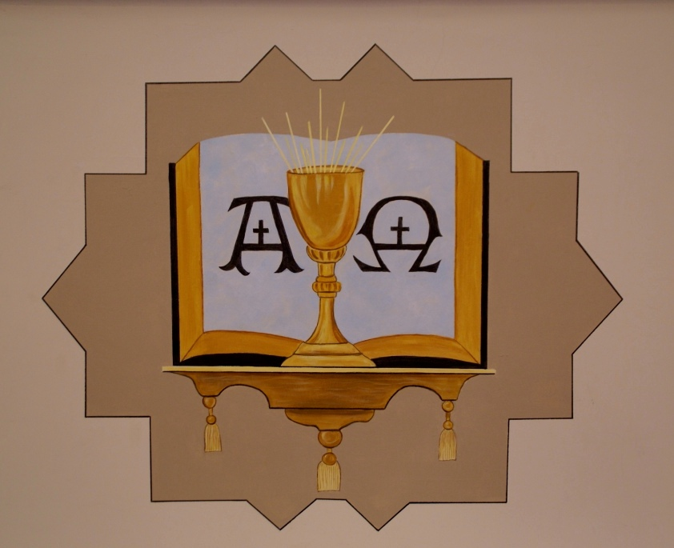
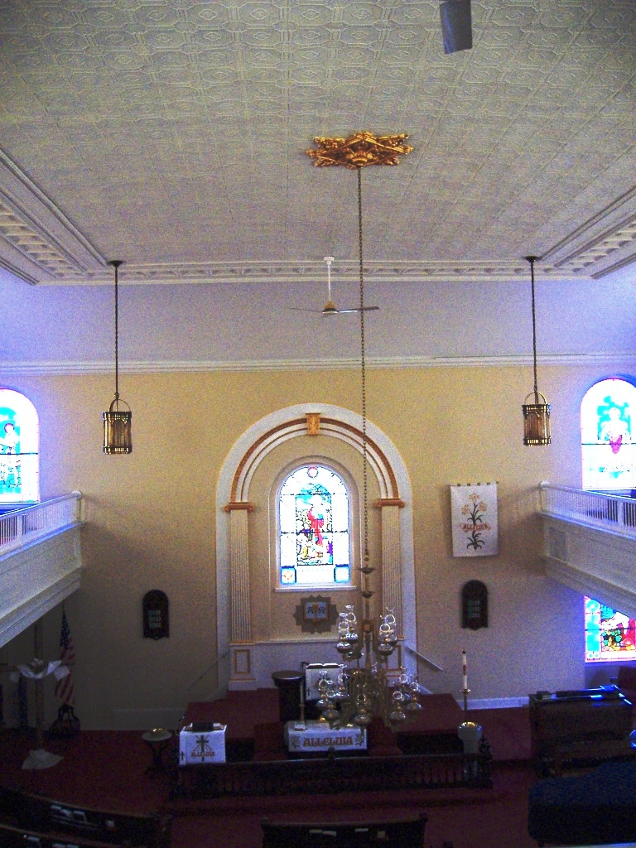
Our heartfelt thanks go to a member of the St. James family who has been so passionate about this project, providing a large donation toward the work. We are asking other members to provide the remainder of the funds for the project, which has a balance of approximately $1,000. If you can contribute to this restoration, please enclose your donation in an envelope marked “painting project” (or simply note “painting project” on your check) and either place it in the offering plate or mail it to the Church Office.
We thank Sobrinski Painting artists, Judy and Frank, and all those who shared their God-given talents with us to restore St. James to its original glory.

Benevolence Project
Links of Love and Heifer International
The Sunday School children are selling “Links of Love” each Sunday in the Fellowship Hall following Worship. The proceeds will go to Heifer International. Our goal this year is to purchase the Gift Ark of animals at $5,000 with the help of matching funds from Thrivent. This goal is an ambitious one, therefore we are modifying the Links of Love - each link color available will represent a different monetary value.
As of April 13th we collected $454, and Thrivent will match up to $800. Links of Love sales will continue in the Fellowship Hall immediately after Worship, every Sunday through the end of May. With God’s help and yours, we can achieve our goal. If you can assist in any way, it will be greatly appreciated. Contact Susanne LaCourte at 908-995-2298.
Vacation Bible School
Vacation Bible School is scheduled for July 7th to 11th. VBS is open to all children ages 4 and up. If you can assist in any way, please contact Sandie Takacs at 908-479-1946.

Senior League News
At the April 2nd meeting, a speaker from Warren Hospital gave a presentation on Alzheimer’s Disease. She covered a variety of topics ranging from recognizing the symptoms to providing care and utilizing available community resources.
For those interested, there will be a further presentation by:
Amy Matthews, Alzheimer’s Association
Wednesday, May 14th at 6:30 pm
The Comfort Zone
Hillcrest Professional Plaza
755 Memorial Pkwy, Bldg. 302-B
Phillipsburg, NJ
This presentation is oriented toward relatives and caregivers. Participants will learn communications techniques to assist with responding to behaviors, recognition difficulties, and anxious or agitated feelings.
The Comfort Zone, operated by Warren Hospital, is the first and only Adult Day Care Center in Warren County. It provides medical and social services in a group setting for disabled and/or elderly adults in the community.
The Senior League meets in the Fellowship Hall on the first Wednesday of the month from 6:00 to 7:30 pm. All members over 50 are invited. A light supper is provided, and a speaker makes the session informative as well as enjoyable. Please call Carol Meixsell at 908-454-6734 if you plan to attend.
A Worthwhile Web Site
Seldom are we able to do good with little effort and no expense. However, such an opportunity exists on the web at The Hunger Site: http://www.thehungersite.com/
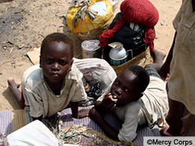
Simply by clicking on the “Click Here to Give” button you can provide food for the needy world-wide. The reason this is possible is that the donations are actually made by the sponsors who advertise the products sold on the site – similarly, of course, to the way our “free” TV and radio programs are funded. Additional donations are also made by these sponsors when any product is actually sold through the site.
There are links on the home page to related sites for Breast Cancer (free mammograms), Child Health, Literacy (free books), Rain Forest, and Animal Rescue. All these operate on the same principle.
It is not necessary to register, so bookmark the site and visit it whenever you log onto the Internet!
Blood Drive
Grace Lutheran Church in conjunction with Miller Keystone Blood Bank will be hosting a blood drive on Tuesday, June 24th. Hours of donation and a contact to sign up to donate will be provided in the weekly bulletin closer to the scheduled date.
New Eyes for the Needy
We are currently collecting used eyeglasses to help those in need. Please place your unwanted eyeglasses in the collection bin near the Fellowship Hall.
Youth Group Effort
Youth Group is collecting trial size toiletries to benefit the Warren County Interfaith Hospitality Network. Primarily deodorant, shampoo, and combs are needed. A donation box is located near the Fellowship Hall.
ELCA News
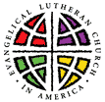
For several years the ELCA has been working to prepare a Social Statement on Human Sexuality. A draft of this work is now available on the web site at: http://www.elca.org/faithfuljourney/
It is recommended that the information be read carefully and in the spirit of Christian charity, both as to content and what it does not address. Note also the dates listed for Synod hearings.
CPR Certified Members
We are updating our list of members who are CPR certified. If you have a current AHA or Red Cross CPR certification, please contact the church office to have your name added to the list.

