The Rules of Chess
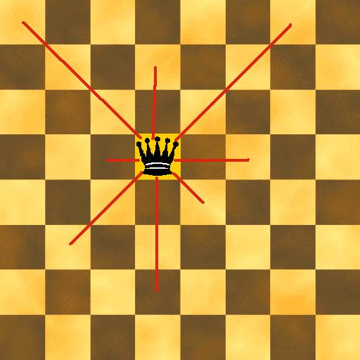  Queen | 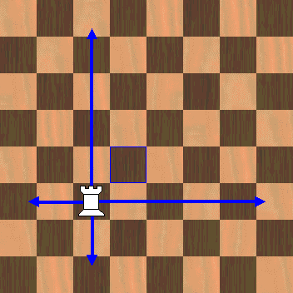  Rook | - The chessboard is placed so that the corner in the right is white.  - The player with the White pieces always moves first.  - A pawn on reaching the last rank will be immediately exchanged for a Queen, Rook, Bishop, or Knight. It may check or checkmate as part of the same move.  - Each move must be made with only one hand, including castling.  - A piece that is touched must be moved unless moving this piece would place the King in check. This is called the "touch-move rule". | - If an opponent's piece is touched then it must be captured if possible. If this is not possible then play continues as if that piece had not been touched.  - A person may adjust a piece on the chessboard on her move by saying "I adjust".  - All play should be conducted with respect for the opponent. A player should not distract or annoy her opponent in any way.
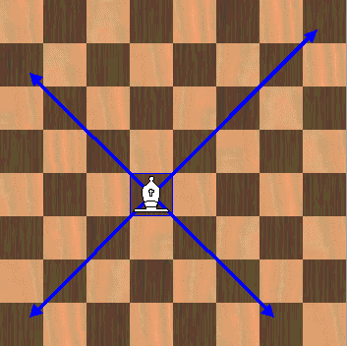  Bishop | 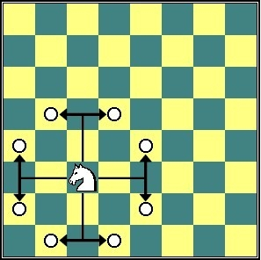  Knight | Castling  Castling is a special move in which the player can move two pieces at one time. Castling can only be done once, and only with the king and the rook. It may be done with either rook.  - There must be no pieces in between the Rook and the King.  - Neither the King nor the Rook may have been moved yet.  - The King may not be in check.  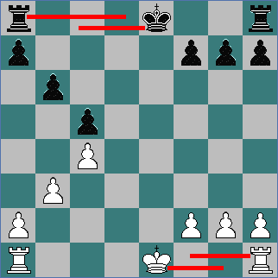  - The King may not cross squares that are attacked by opponent's pieces.  - The King must be moved first.
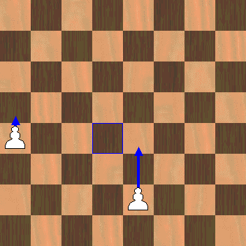  Pawn’s ordinary and first moves | 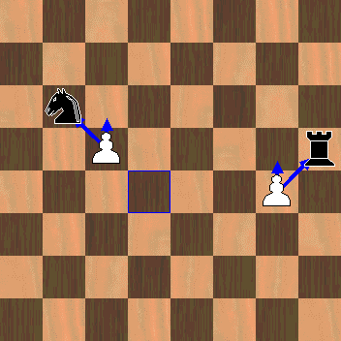  Pawn’s attack | The Draw  Six ways in which nobody wins.  1 Perpetual Check – one side is checked over and over but not mated.  2 Stalemate – a player has no legal moves but the King is not in check.  3 Insufficient mating material - neither side has enough pieces left to make checkmate:  - Just the two Kings on the board.  - King & Bishop against a King  - King & Knight against a King  - King & two Knights against a King  4 Threefold Repetition – when both players repeat the same move three times.  5 Fifty Moves, No Progress – no captures or a pawn move within 50 moves  6 Agreement – both players agree to call it a draw.
Strategies for Chess
Your Opening Strategy: Dominate the Center  1st move: get out the king’s pawn so that the bishop can get out.  2nd move: Get a knight out toward center. Try to keep knights off the edge.  3rd Move: Get a bishop out so that he attacks a center square.  4th Move: unless you must defend a piece, castle to protect your king and bring out your rook.  Don’t go grabbing pawns in the opening, unless they are center pawns.  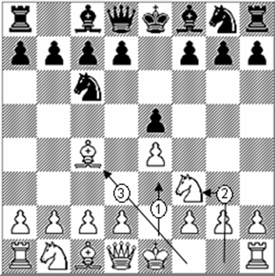Bring out your rooks, either to the center or to open files  Keep your queen safe! Don’t bring her out too early. |  |  | Rooks love open files.  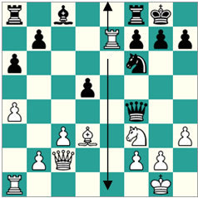  A file is a line of squares between you and your opponent (rather than a row, which is side to side). An open file is one that no longer has any pawns on it. In the diagram, white has moved the rook onto the open file before black was able to. White now controls this file. White’s next move should be to create a battery. |  |  | Create a Battery  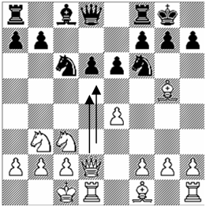 One of the most powerful plays is to have two long-range pieces back each other up. Above, the queen and rook are both on the same file. The queen can now capture the d6 pawn without fear. Black’s queen better move off the d file or she’ll be next. Two rooks can also create a battery. On a diagonal, a bishop and a queen can create a battery.
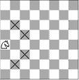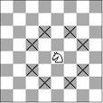  Knights love the center.  The knight on the left is on the rim and can only move to four squares. The knight in the center of the board can move to eight. Chess players say, “A Knight on the Rim is Dim.” | 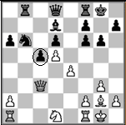  The Passed Pawn  A pawn which is no longer blocked by the opponent’s pawns is a danger. Here, black’s pawn is on its way to promotion – it has passed white’s defenses. |  |  | 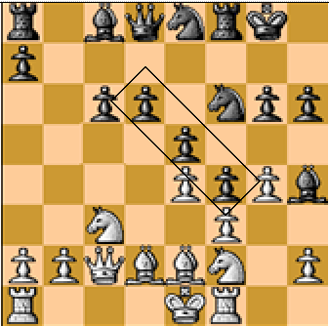Pawn Chain  Black’s pawn structure is strong because it is built as a diagonal, each protected by the one behind it. This makes it difficult for white to achieve a passed pawn. Black protects the one in the rear – the base pawn – with the queen and knight. |  |  | 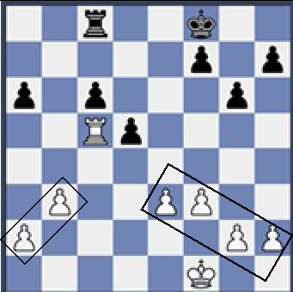Pawn Islands  White’s pawn structure is broken into two pawn islands. It is possible for pawns in the same island to protect each other and to form barriers to black. The gap between pawn islands is a weakness.
The Pin  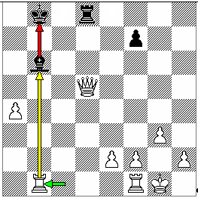Black’s bishop is pinned down. If black were to move the bishop, the king would be in check. White’s queen is now free to take black’s rook because the bishop can no longer protect it. |  | The Overworked Piece  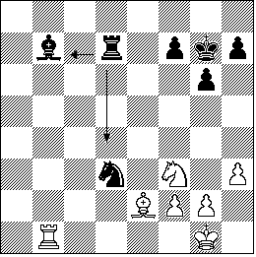Black is trying to use the rook to defend both the knight and the bishop. If white is willing to sacrifice the bishop, white can take a knight and a bishop (W bishop takes B knight; B rook takes W bishop; W rook takes B bishop). |  |  | 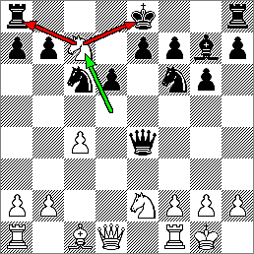  The Fork  It is called a fork when a player attacks more than one piece at a time. Here, white uses the knight to attack the king and the rook at the same time. Black must save the king, and so loses the rook.

