Jeremy “Jem” Finch chapters 4, 6, 7  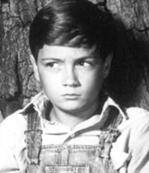 | “Scout” Jean Louise Finch  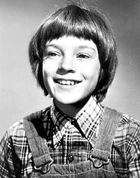
Dill Harris chapters 1, 4, & 6  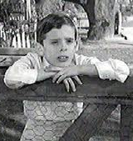 | Atticus Finch chapter 10  
Boo Radley chapters 2-7 | Calpurnia chapters 3, 10, 12  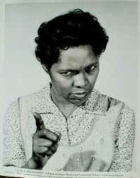
Boo Radley chapters 2-7 | Mrs. Stephanie Crawford  
Mrs. Henry Lafeyette Dubose chapter 11
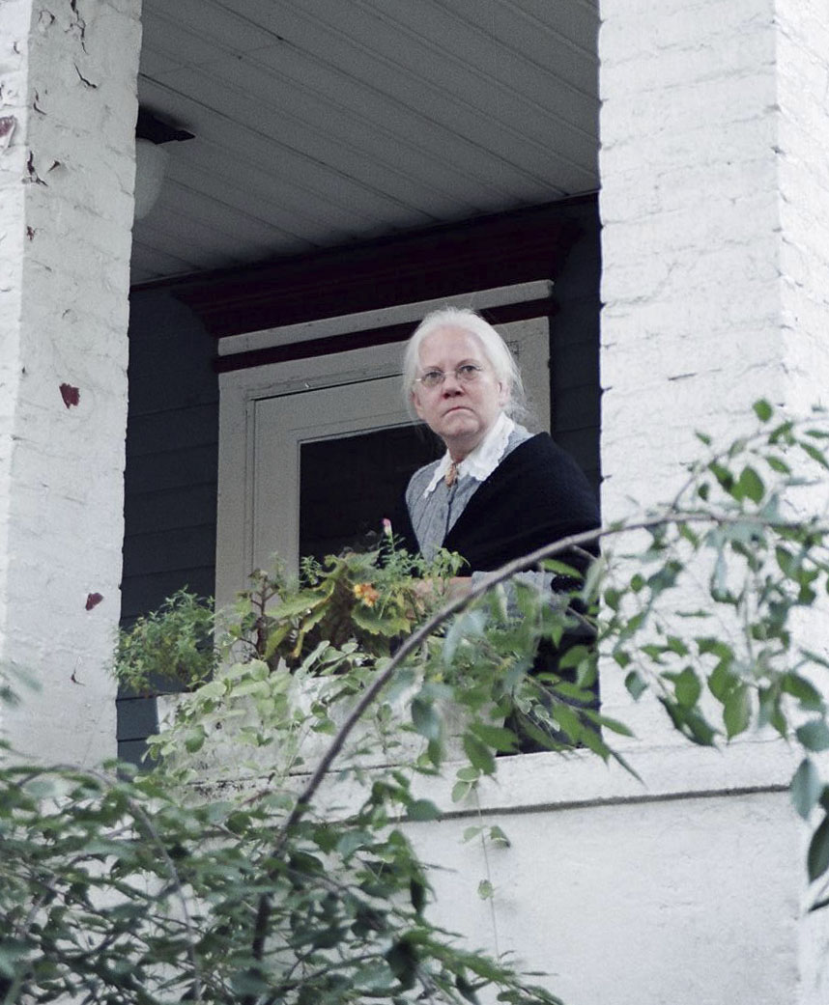
Miss Maudie Atkinson chapter 5
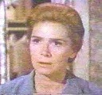
Sheriff Heck Tate   | Tom Robinson  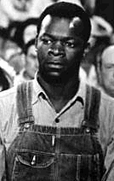
Bob Ewell  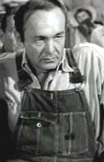 | Mayella Ewell  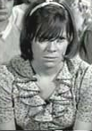

Mrs. Henry Lafayette Dubose  Ch 11 |  | ⇨ | Mr. Dick Avery  Ch 6 & 8 |  | The two borders of the children’s lives are the crazy man’s house and the house of the strictest old woman who ever lived (page 6). As you read the book, think about how in other ways they live between these two extremes.
Downtown,
Cecil Jacob’s,
Post Office,
the courthouse
Miss Rachel Haverford  Ch 8  (Dill’s Aunt) |  | Downtown,  Cecil Jacob’s,  Post Office,  the courthouse
 |  | ⇦ South North ⇨
Atticus Finch |  | ⇦ South North ⇨ | Miss Maudie Atkinson  Ch 5 & 8
 |  | ⇦ South North ⇨ | Miss Stephanie Crawford  Source of children’s “knowledge” of the Radleys (11-12)
 | The Radley Place  (Boo)  Ch 1, 4, 6, 7 |  |  | To First  Purchase & Ewell’s
 |  |  |  | ⇩
School

