The Origins of the Lipkas

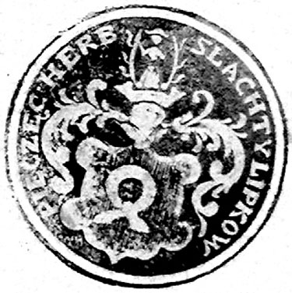
The first references to Tatars in Lithuania come down to us from the beginning of the 14th century, however, it is only in the reign of Grand Duke Witold that we can speak of their settlement - Lithuanian Tatars count 1397 as the year of their arrival in Lithuania. These were, initially, the survivors of the clan of Khan of the White and Golden Hordes, Tokhtamysz who had lost out in a dynastic struggle and who, together with his family, had sought political asylum in Lithuania.
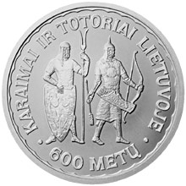
Lithuanian coin issued in 1997 to commemorate the 6ooth anniversary of the settlement of the Lipka Tatars.

Witold saw in these warlike Tatars an excellent opportunity to strengthen his own position and to defend the state. He not only allowed the Tatars to settle in Lithuania, but also allocated them estates and titles of nobility, in return for which the Tatars had to fulfil obligatory service in the army and as diplomatic couriers. It was only in the 18th century that this obligatory service was finally relaxed. Companies of Lipka Tatar light cavalry for a long time constituted one of the foundations of the military power of the Commonwealth. The Lithuanian Tatars, from the very beginning of their residence in Lithuania were known as the Lipkas. By the 17th century the term Lipka Tatar began to appear in the official documents of the Polish-Lithuanian Commonwealth. Jan Tuczkowski, Polish Information Centre in Lithuania.
Heraldic Seal of the Lipkas
Inscription: Heraldic Seal of the Noble Lipkas - From the State Archive in Siedlice
Knightly seals with heraldic inscriptions were in use on Polish lands from the middle-ages; however, these were first and foremost the personal signs of individuals from particular family lines. The seal of the Lipkas of Lipki has a unique character in that it is the collective seal of an entire community that shares a common noble ancestry from a single family line. Seals similar to the specimen from Lipki are found extremely rarely In the example of the seal from Lipki we see a manifestation of the sense of common identity of the entire population of the community.

The nobles from this rural community bear the Nałęcz Arms, known from the earliest days of the Commonwealth. In the 18th century representatives of the Lipka families from Lipki settled in the village of Tuczna in the district of Biała Podlaska. This locality was also inhabited by Lipka Tatars settled by King Jan III Sobieski towards the end of the 17th century – the Lipkas famous from the pages of the Trilogy of Henryk Sienkiewicz.
Grzegorz Welik ©2003
Lipka Tatars in Poland
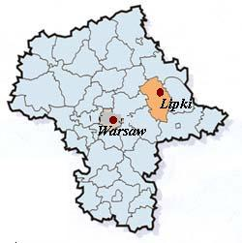
"The earliest references to Tatar followers of Islam in Poland – known from those days onwards as the Lipkas - come to us from the Chronicles of Jan Długosz for the year 1397, and this date is taken as the beginning of Tatar settlement. At first the Tatars served in the armies of the Polish Crown. With subsequent changes in the form of government they served in the armies of the Polish Lithuanian Commonwealth. They united their fate with that of Poland. From the Battle of Grunwald onwards they have participated in every significant military campaign."
Embassy of the Polish Republic in Yemen

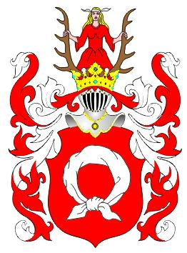
Nałęcz Arms of the Lipkas of Lipki

References to the Lipkas of Lipki can be found in the Historical Geography of the Lands of Old Poland by Zygmunt Gloger. "The largest of all the settlements in the lands of Drohiczyn, the village of Lipki had 72 landowners of noble status, the great majority of these being representatives of the Lipka family.”
The Lipkas of Old Lipki
The village of Old Lipki belongs to the Stoczek Municipality of the Węgrów district of the eastern half of the Mazovia Voivodship. The earliest references to the village of Lipki come from the year 1368, during a time of mainly forced Polonisation of the region, lead by the Dukes of Mazovia. Lipkas bearing the Nałęcz Arms of Lipki from the district of Drohiczyn appear in all the volumes on Polish Heraldry.
According to all the available historical evidence it appears that, in spite of the many legends relating to their Tatar past, the Lipkas of Lipki lived the lifestyle of Country Gentry typical of the nobility of the Podlasie. Evidence of their Podlasian patriotism is given by their participation in the Kościuszko Insurrection, the November Uprising (the Battles of Stoczek and Iganie) and the January Uprising.
The special traditions of the nobility continued to influence everyday life in Lipki right up to the Second World War. Over the course of recent decades this ancient village is more and more being transformed into a summer resort.
Maria Dąbrowska - Diaries

