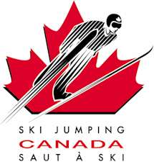 Competitor License Application 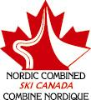
May 1, 2003 – April 30, 2004
Nordic Combined Ski Canada
Ski Jumping Canada

Athlete Information

Athlete Name: ______________________ Birth Date: ____________________

Address: ______________________ Telephone: ____________________

______________________ Alberta/Ontario ___________________
Heath Care #
______________________

Parent or Legal Guardian

Parent Name: ______________________ Home Phone: ____________________

Address: ______________________ Work Phone: ____________________

______________________ EMail: ____________________

______________________

Competitor License (Choose one category):

_____ Trial Competitor – Valid for 1 day only on K30 or smaller hills - $5.00

_____ Domestic Competitor – Nordic Combined and Ski Jumping activities - $20.00
(good for Canada and USA club competitions)

_____ International Competitor – Nordic Combined and Ski Jumping activities - $100.00
(includes Out-of-Country Accident Insurance that is mandatory for FIS Competitions)

In consideration of the Canadian Ski and Snowboard Association (CSSA), Nordic Combined Ski Canada (NCSC) and Ski Jumping Canada (SJC) accepting my entry into CSSA/NCSC/SJC activities, the undersigned hereby for myself, my heirs, executors, administration and assigns, release and forever discharges the CSSA/NCSC/SJC, its servants, agents, sponsors, employees and volunteers from any and all claims, demands, damages, actions or causes of action arising out of or in consequence of any loss, injury or damage to my person or property incurred while attending or participating in CSSA/NCSC/SJC. Without limiting the generality of the foregoing, I further release any and all recourses that I may or hereafter have resulting from any decisions of the CSSA/NCSC/SJC.

Athlete Signature: ___________________ Date: _________________

Parent/Guardian Signature: ___________________ Club: _________________

