The Story of Human Progress
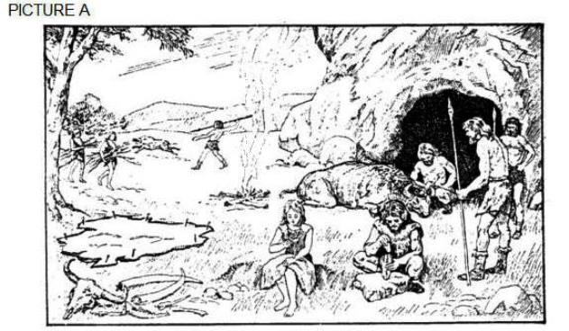
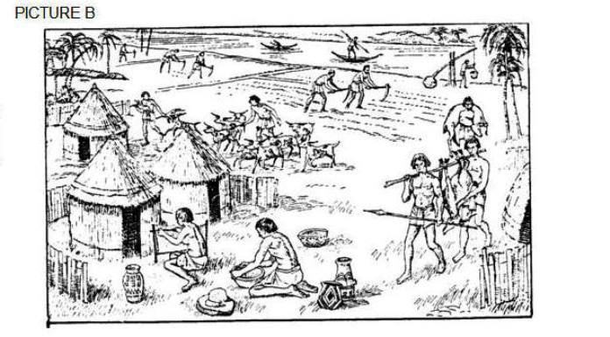
Picture B
Picture A

Refer to the details seen in the pictures A and B and you own knowledge in answering this question:
Using pictures A and B and your own knowledge, explain how did the lives of people changed from
the days of the early humans, to the time when people were living together in the ancient societies?
In answering this question, try and use all of the following words to help you:
- Nomadic
- Hunters and gatherers
…many discoveries over time….
- Domestication of animals
- Farming
- Irrigation e.g.Shaduuf
…with farming there was a big increase in food production…
… everyone no longer need to spend their time hunting and gathering…
…with more time many people could specialise in their own interests…
…people could develop new skills, crafts and occupations…
- Specialisation of labour
- The key features of ancient societies were:
(city/towns, social classes,
Government, laws,
education, religion,
trade.)
To answer the question there is too much to explain in one paragraph.
Use several paragraphs and structure your answer like an essay.
This link will remind you how to structure an essay.
The pictures will provide details and information you can include in your paragraphs.

