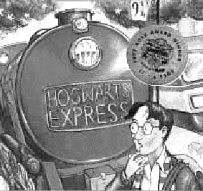 |   1) Where do the Dursley’s live?  2) What do you call non-wizards?  3) What is the name of the bank in Diagon Alley?  4) What does uncle Vernon’s Company make?  5) What is Hagrid’s job?  6) Who is Mrs. Norris?  7) What happened to Harry at the zoo?  8) What is the wizarding newspaper called?  9) Where does the train for Hogwarts leave from?  10) Where do you get wizard cards from?  Free resource from http://www.teachit.co.uk © 2000
.
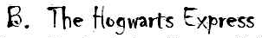
1) It is time to board the Hogwarts Express. Describe what it was like to enter Platform 9-3/4.
Use some of these words to make your descriptions fun to write and
more interesting to read. ( For this link see the on-line study-guide )
2) You are on the Hogwars Express and the goodie cart has just stopped at your compartment. Which treat would you like to buy? There are Chocolate Frogs, Bernie Bott Every Flavor Beans, Licorice Wands, Droobls Best Blowing Gum, Caldron Cakes, Pumpkin Pasties, Cockroach Clusters, Levitating Sherbet Balls, Ice Mice, Pepper Imps, and Jelly Slugs. Now make up a new treat, and describe what happens when you eat it.
3) The conductor of Hogwarts Express has just stopped by your compartment and introduced himself. Describe the conductor and your conversation.
4) You just entered a compartment on the Hogwarts Express and there are two other students there that you have never met. Who are they? Where are they from? Are their parents Muggles or Wizards? Describe what they look like and their personalities.
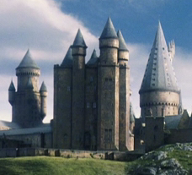
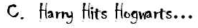 (Draw this chart in your book)
1) What would be a suitable name for the teacher of Astronomy?
2) How often does Harry have Herbology?
3) When are Flying Lessons?
SUBJECT | TEACHER
Herbology | (…and then complete the chart.).
 | Professor Binns
Charms
 | Professor Mc Gonnagall
Defence Against the Dark Arts
 | Professor Snape
Flying Lessons

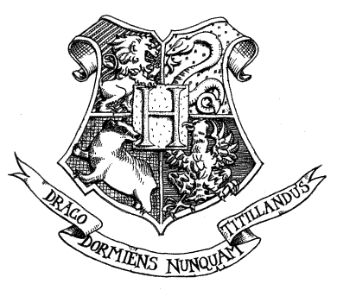 | 4) When is Astronomy?  5) Who is the ‘Tiny Little Wizard’?  6) Which boring lesson is taught by a ghost?  7) What did Prof. Mc Gonagall change her desk into?  8) Where are Potions lessons?  9) What is a Bezoar?  10) Name three ingredients in the potion to cure boils?  11) In one paragraph describe the main setting of the novel.
 
Characters (and real-life people) each have their own personality traits.
Think about which of the following character traits listed below, you could use to describe yourself?
Use the words from these lists when writing about the different characters you've read about in Harry Potter.
1) Find on the Internet or draw a picture of one character from Harry Potter, and
paste it in the middle of a new page. (Pick a different character to the ones listed in Part G. below)
2) Then around the picture write all of the words that describe this character.
3) Also write out some dialogue from the book that shows the personality of your character.
Don't stop with these lists though; can you think of more terms to describe your characters?
- Honest  - Light-hearted  - Leader  - Expert  - Brave  - Insecure  - Mischievous  - Demanding  - Thoughtful  - Keen  - Happy  - Disagreeable  - Simple  - Fancy  - Plain  - Clever  - Studious  - Strange | - Excited  - Studious  - Inventive  - Creative  - Thrilling  - Independent  - Intelligent  - Compassionate  - Gentle  - Proud  - Wild  - Messy  - Neat  - Joyful  - Strong  - Confident  - Frightened  - Odd | - Bright  - Courageous  - Serious  - Funny  - Humorous  - Sad  - Poor  - Rich  - Tall  - Dark  - Light  - Handsome  - Pretty  - Ugly  - Selfish  - Nasty  - Weak  - Different | - Unselfish  - Self-confident  - Respectful  - Considerate  - Imaginative  - Busy  - Patriotic  - Fun-loving  - Popular  - Successful  - Responsible  - Lazy  - Dreamer  - Helpful  - Simple-minded  - Mean  - Aggressive  - Lonely | - Humble  - Friendly  - Short  - Adventurous  - Hard-working  - Timid  - Shy  - Bold  - Daring  - Dainty  - Pitiful  - Cooperative  - Lovable  - Prim  - Proper  - Greedy  - Sneaky  - Dull | - Ambitious  - Able  - Quiet  - Curious  - Reserved  - Pleasing  - Bossy  - Witty  - Fighter  - Tireless  - Energetic  - Cheerful  - Smart  - Impulsive  - Loyal  - Sporty  - Popular  - Smart
http://www.teachervision.fen.com/writing/resource/2669.html
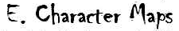
A character map shows the relationships between the different characters in a novel.
1) Make a Google 'image' search with the words 'character map', and look at the different examples of character maps you can find on the Internet.
2) On a double page (or an A3 size piece of paper) design your own character map for the book 'Harry Potter and

the Philosophers Stone'.
- Start by writing Harry Potter in the middle of the double page. Then draw arrows to all of the different characters with which he is related or connected in some way. Along the lines joining different characters, write the connection, with such relationship words like: Friend, guardian, father, teacher, fellow student, teacher, son, sister.....
(You could use MS Word and the 'Autoshapes', or if you are designing your character map in you book, use a pencil so you can make corrections as you go.)

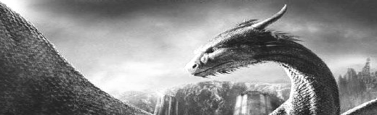 | 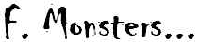
.
Revise the monsters mentioned in the book, and read about the creatures listed at this site:
http://www.geocities.com/hogwarts_online_school/monster.html
1) Invent your own monster or creature. Describe such things as its size and appearance,
where it lives and what it eats, how it behaves and any special powers it might have.
2) Then draw and colour a picture of your monster or creature.

.
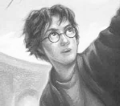 | Harry Potter:  pages 20, 22, 25,30  42-45, 91. | Dudley Dursley:  pages 19, 20, 28, 29. | 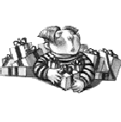
 | Vernon & Petunia Dursley:  pages 7, 8, 19, 20,  22, 23, 28, 34. | Fred & George Weasley:  pages 67, 70, 71, 75,  89, 95, 125, 149.
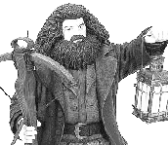 | Hagrid:  pages 16, 17, 39, 41,  47, 48, 83, 104. | Albus Bumledore:  pages 12, 14, 16, 77,  91, 95, 156-157. | .  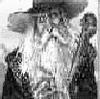

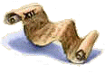 | .  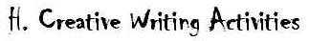
  - Diaries : Imagine you are a new student at Hogwarts – write a series of diary entries about your first days or weeks at your strange new school. OR Write diary entries for some of the other characters. You could choose Harry or Ron or Draco Malfoy, Dumledore or Snape for more of a challenge.
  - The Daily Prophet: Write a story suitable for inclusion in the best-selling Wizard newspaper, “The Daily Prophet”. Google an ‘image’ search with the words ‘The Daily Prophet’, to get some ideas on how to present the article. Include an illustration.
  - Play-scripts: Take an episode from the novel and dramatise it in the form of a short play-script. (Optional: Perform it with some friends to your class, or record it as a radio play with sound effects.)
  - Illustration: The novel has been published with nearly twenty different covers so far. Design a new cover for a new edition of the text. Open this site to see the earlier cover designs:
http://www.scholastic.com/harrypotter/books/covers/art3.htm
Also write and design a new ‘blurb’ for he back cover as well.
Free resource from http://www.teachit.co.uk © 2000

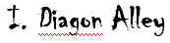
Flourish & Blotts
  1) Which book is Harry very keen
  to read? Why?
  2) Name two books Harry has to
  buy for Hogwarts?
  Invent more books that could buy
  in Flourish & Blotts.
  1) Describe the Goblin standing
  outside Gringotts.
  2) What did Harry see near the
  underground lake?
  3) Describe the item Hagrid collects
  from the underground vault.
. | Madame Malkin’s  Robe Shop
  1) How long have Ollivander’s been
  making wands?
  2) Why does Harry’s neck tingle?
  3) Describe Harry’s wand.
  4) How much does the wand cost?
  1) What does Madam Malkin look
  Like?
  2) What impression do you get of
  the boy Harry meets here?
  Give reasons.
  3) What does the boy want to
  smuggle into Hogwarts?

