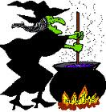
- List four of the ingredients that get put into the Witch’s stew.

- Does this poem have a clear repeating rhythm? Also how many beats or syllables are there in the different lines to make the rhyming pattern?

- Write out in your book a definition of the term alliteration. Write out three lines from the poem where the poet has used this figure of speech.

- Write in your book a definition of the term onomatopoeia. Write out three examples from the poem.

- Why do you think that the poet has used these techniques? (Use the words “poet’s purpose” in your answer).
- For what audience do you think this poem was written? Explain why.

Put the above heading on a new page in your book and then answer the following questions.
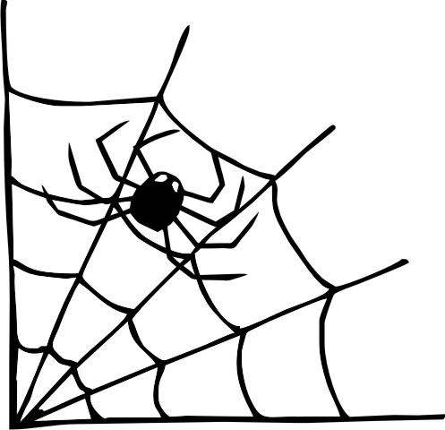

Witches Stew
Bubble, blubber, squirm and gloop,
Boiling broth of bat's tail soup.
Wobble, slobber, liquid goo,
Add the sole of one old shoe.
Spooky shadows dance around,
Of frogs and rats and snarling hounds.
Steam swirls rising to the roof,
Add one small ear and one old tooth.
Gnarly, scratchy, tickle and itch,
Stir round and round to make it rich.
Mushy, sticky, sizzle and stew,
They're making mischief just for you!
©2002 Gareth Lancaster
Write the following in your book:
Two types of poetry are Rhyming Couplets and Free Verse.
A Rhyming Couplet is a poem where the two lines rhyme with each other and a whole poem is made up couplets where each pair of lines rhyme with each other.
Free Verse is the type of poetry where the words do not need to rhyme, and there is no need for any formal structure. For example, you do not need to use proper sentences.
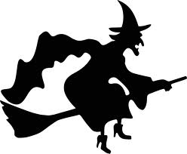

7. Is Witches Stew by Gareth Lancaster an example of
Free Verse or is it a Rhyming Couplet?
Explain your reasons.
:

Word Bank
Bewitch, menacing, bats, mesmerizing, terrifying, cunning, midnight, charms, sorcery, apparition, spirit, moan, haunt, gloomy, moon, menacing, hair-rasing, cackle, chilling, cats, scream, incantations (magic spells), wand, hiss, attic, spiders, cobwebs, secret, cauldron, passageway, broom, scaly, brew, bubble, cloak, ………
YOUR TURN!!
Use any of the words in the word bank, plus any words that you can think of to write a funny free verse poem about magic, witches or fairies.

