Page 1
HOW TO USE AND QUOTE SUPPORTING DOCUMENT SOURCES
IN SHORT ANSWERS AND ESSAYS
(….for both primary and secondary sources documents.)
At the start of World War One, aircraft were very basic and crude. They were few in number and fragile in design. One British general made the comment that “the airplane is useless for the purposes of war”, and the French General Marshal Foch believed that “aviation is good sport, but for the army it is useless.”
You will need to be able to do this in your assessment tasks and exams to get good marks.
Follow these 3 simple rules:
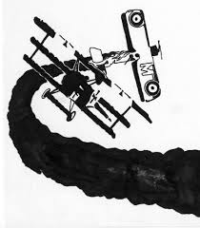
1. Never write out long slabs of quoted text in an answer or essay.
- Just quote two or three words from the document you are using and blend these
words into one of your own sentences.
For example:
QUESTION: In accounts of WW1 the view is often given that the life of a fighter pilot was extremely demanding and dangerous; also that the life expectancy of the pilots was shorter than in any other area of the fighting forces. In what way do the sources provided support this claim?
ANSWER: There is evidence in the sources that support this claim in a number of ways. The accounts of the fighting between the planes show how dangerous it could be for the pilots with little protection from bullets in their open cockpits. One French pilot described how with his machine gun bullets he “swept the cockpit” of a German plane, destroying their motor and hitting “the two fliers.” He then described how he killed the pilot with his “first burst” and that the copilot or observer, though still alive, fell from “the overturned plane,” which then fell to the earth “like a gigantic torch”. (Source A: Rene Fonch describes firing at a German plane.)
2. Notice how you should name in brackets the source document or author you are quoting at the end of the paragraph.
- If you don’t do that, you can mention the document or author in your paragraph.
For example:
….The number of planes reported in the sources as being destroyed in this type of aerial combat also supports the claim that the fighter pilots would have had a short life expectancy.
As is noted in Source B, one very talented air fighter or ‘ace’, Captain Ball, in eleven days in 1917, flew twenty-six flights and was able to destroy “eleven hostile aeroplanes” and force two “down out of control.” This pilot went on to destroy a total of “forty-three German aeroplanes” and one observation balloon. The dangers fighter pilots encountered in this type of fighting is also evident in Source B. According to the London Gazette article, despite this pilot’s obvious skills, Ball’s plane was often “badly damaged” and once “so seriously” that the control wires had been “shot away”. Therefore, the sources do support the claim that…
3. Never use the word “Quote” in your answer or essay. A better way to introduce some quoted evidence is to use the word ‘noted’ or the words ‘according to’.
ACTIVITIES:
a) Circle with a red pen the examples shown where these words in the above paragraph.
Page 2
b) In the following answer, insert the words ‘noted’ or ‘according to’, where you think they would be appropriate.
QUESTION: Despite the brutal aerial fighting that the two sides inflicted on each other, is there any evidence in the sources that a spirit of comradeship was displayed between the opposing forces?
ANSWER: There is evidence in the sources to suggest that a spirit of comradeship did exist between the opposing air forces. __________________ Billy Bishop, a Canadian airman, the English and their allies had a “wonderful arrangement” with the German air forces. (Source C) Bishop _________ that if an English plane was shot down “behind enemy lines”, then a German plane would come back over to “drop a message” to tell if their pilot was “killed or wounded”, and they “would do the same for them”. Therefore this shows that there was a spirit of….
c) In the following three sources highlight the words that were quoted in the above answers.
SOURCE A - Rene Fonch, a French pilot describes firing on a German plane:
I aimed at the middle of the motor, and my fire swept the cockpit, spraying the motor and the two fliers…The pilot, who had probably been killed by my first burst, slumped into his seat clinging to his controls, and the plane went into a spin…..I saw the observer, still alive, fall from the overturned plane after a vain effort to hang on…his body passed only a few yards from my left wing, his arms still open in a desperate clutch, a sight I will never forget. My tracer bullets had set the enemy plane afire, and it was rapidly falling towards earth like a gigantic torch, preceded by the body of the observer.

SOURCE B - The London Gazette, 8 June 1917:
…during the period of the 25th of April to the 6th of May, 1917, Captain Bell took part in twenty-six combats in the air, and destroyed eleven hostile aeroplanes, drove two down out of control…. Several times his aeroplane was badly damaged, once so seriously that but for the most delicate handling his machine would have collapsed, as nearly all the control wires had been shot away…. In all, Captain Ball has destroyed forty-three German aeroplanes and one balloon…

SOURCE C – Billy Bishop, a Canadian airman describing their relationship with the German Flying Corp:
…during the period of the 25th of April to the 6th of May, 1917, Captain Bell took part in twenty-six combats in the air, and destroyed eleven hostile aeroplanes, drove two down out of control…. Several times his aeroplane was badly damaged, once so seriously that but for the most delicate handling his machine would have collapsed, as nearly all the control wires had been shot away…. In all, Captain Ball has destroyed forty-three German aeroplanes and one balloon…

d) In your book write out the above 3 rules on How to Use and Quote Sources in Short Answers and Essays.
e) Read and discuss the following sources and then answer the five questions that follow them.
Page 3
IN ANSWERING THE FOLLOWING QUESTIONS USE THE THREE QUIDELINE RULES FOR
HOW TO USE AND QUOTE SOURCES IN SHORT ANSWERS AND ESSAYS.
Air Warfare During WWI : 1914-1918
SOURCE A
As a result of this attitude airplanes in WWI were initially mainly used for reconnaissance; for example, feeding back information on the enemy trench lines for artillery strikes and recording German troops movements. The pilot would fly the plane and bring along an observer to study and photograph troop movements on the ground.
John Ray, The First World War
SOURCE B
Sholto Douglas was a British observer in the early days of the war. Here is his description of a meeting with German airmen as they flew over the battle trenches below:
The first time I ever encountered a German machine in the air, both the pilot and myself were completely unarmed….we were taking photographs of the trench system of the north of Neuve Chapelle when I suddenly espied a German two-seater about 100 yards away and just above us. We waved a hand to the enemy and continued with our task. The enemy did likewise. At the time this did not appear to me in any way ridiculous…

SOURCE C
The first major engagement of the war - the Battle of Mons was on August 23, 1914. It was at Mons, a small industrial town in southern Belgium, where the advancing British Army collided with the Germans as they marched towards France.
From their vantage point above the battlefield, the British observers flying with the pilots could see that the Germans were moving their forces to surround the unsuspecting British army. Alerted, the British high command ordered an immediate retreat into France. As embarrassing as the withdrawal was for the British, the move saved the army. A few days later, French aerial observers noted a shift in the movement of the German army that exposed its side flanks to attack. The resulting battle of the Marne (September 5 - 12), halted the German drive into France and saved Paris.

Terraine, John. Mons, The Retreat to Victory
SOURCE D
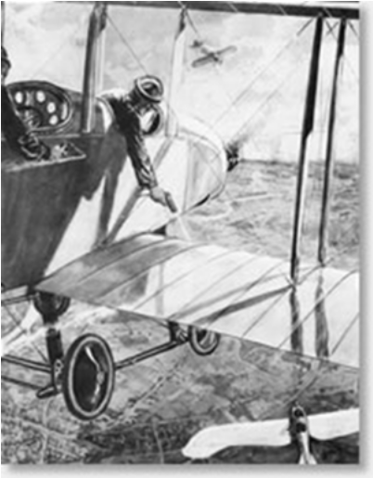

Illustrated London News - Aerial Warfare,
1914 British observers fire on a German Taube reconnaissance plane.

SOURCE E Page 4
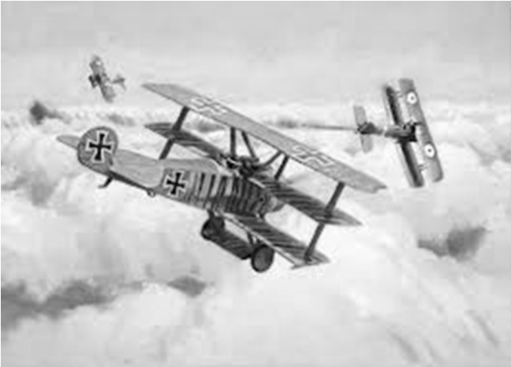
The Fokker Dr.1 proved to be an excellent and manoeuvrable dog fighting machine and it quickly became the favoured aircraft of the top German pilots, including Werner Voss and Goering and - of course - von Richthofen, whose aircraft was painted red in his ‘Red Baron' style.

SOURCE F
Early in World War One bomb aiming was crude in the extreme. The pilot – or co-pilot if the aircraft carried two people – simply dropped a small bomb over the side of the aircraft in the general direction of a target. If a bomb dropped anywhere near a target it was through good luck more than anything else.
Learning History Site: Aircraft of WW1
(http://www.historylearningsite.co.uk/aircraft_world_war_one.htm)
SOURCE G
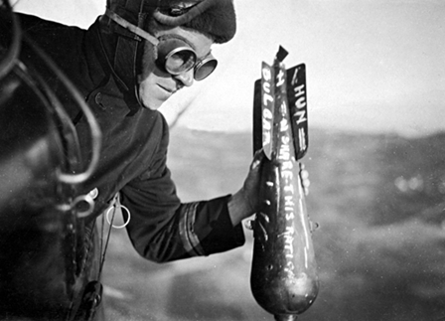

A British airman drops a bomb, complete with written messages, on the enemy.
SOURCE H
By the end of the war aircraft that could be recognised as long-range bombers had been developed. Much larger than fighters, their task was very specific – to carry to a target as many bombs as was feasible and to drop them on targets with a degree of accuracy. The Germans had the Gotha bomber while the British had the Handley Page bomber. While the deliberate targeting of civilians was not a new military tactic, bombers made an aerial attack possible. Also a nation’s means of war production – mainly factories – could also be attacked from the air. Such a consideration would have been impossible in 1914. By 1918, it was a reality.

Ezra Bowen, Knights of the Air (1980)

Page
SOURCE I
.
HOW TO USE PICTORIAL SOURCES IN SHORT ANSWERS AND ESSAYS:
When you use pictorial sources in your answers, don’t just mention the source, but point out some detail in the picture.
For Example:
As can be seen in Source I, not only the size and design of the bombing aircrafts greatly increased during the war, but also the size and destructive power of the bombs. As can be seen in the foreground of the photograph, Source I, by the end of the war, some of the bombs dropped were more than twice the size of the pilots flying the plane.
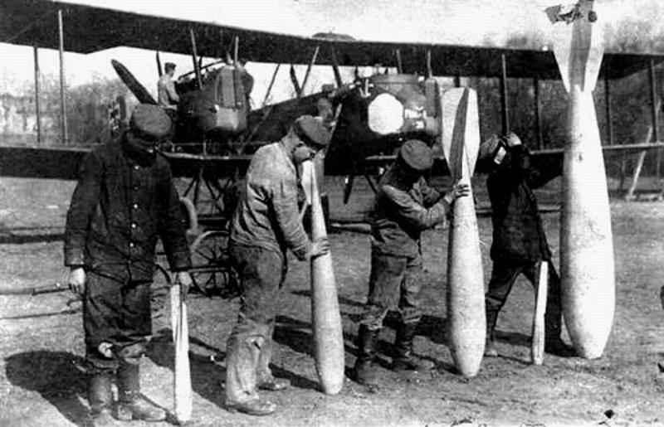
Page 5
1918 Bomber. The largest bombers had four engines as well as the bomb carrying racks with a release lever inside the cockpit
SOURCE J
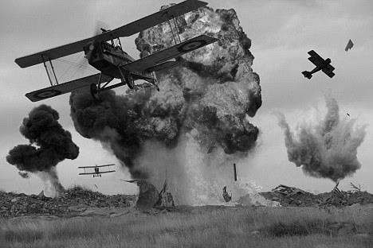

A bombing run on the trenches during the war on the western front.
SOURCE K
Dogfighting first emerged in World War I. Aircraft were initially used as mobile observation vehicles, and early pilots gave little thought to aerial combat. Enemy pilots at first simply exchanged waves, or shook their fists at each other. Due to weight restrictions, only small weapons could be carried on board. Intrepid pilots decided to interfere with enemy reconnaissance by improvised means, including throwing bricks, grenades and sometimes rope, which they hoped would entangle the enemy plane's propeller. Soon after an airplane was shot down by a hand gun from another plane, machine guns were mounted to the airplane, and the era of air combat ‘dog-fighting’ began.
For some time the biggest problem was mounting a machine gun onto an aircraft so that it could be fired forward and aimed by pointing the nose of the aircraft directly at the enemy without shooting off your propeller blades! Anthony Fokker, a Dutch designer who built aircraft for the Germans, solved this problem in 1915 by connecting the trigger of an MG 08 Maxim machine gun to the timing of the engine. By synchronising a gears mechanism on a plane called the Fokker E1, his design enabled the machine gun bullets to safely pass between the revolving propeller blades, thus creating the first synchronized, forward firing fighter plane.

John Terraine, White Heat: The New Warfare 1914-18
SOURCE L Page 6
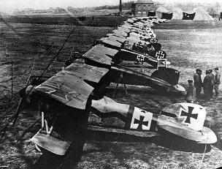

SOURCE M
British Front Line Air Strength
Year Nos. of men Aircraft
1914 1,429 63
1918 291,175 22,000

German fighter planes lined up ready for takeoff 1916
SOURCE N
“It would be impossible to describe the action of such a battle. A pilot in the seconds between his own engagements, might see a Hun diving vertically, a British SE5 on his tail, on the tail of the SE5 another Hun, and above him another British plane. These four, plunging headlong at 200 miles an hour, guns crackling, red tracers screaming, suddenly break up. The lowest Hun plunges flaming to his death…his victor staggers, suddenly pulls out in a great loop, turns on his belly, swoops and spins out of control into a dizzying spiral down to the earth and his end. The third German zooms veering… his victory run lasts perhaps ten seconds before the sharp rattle of another attack. The two machines now approach head-on at break neck speed, tracers whistling through each other’s planes…who will last longest? 200 yards, 100, then 50 then neither hit, they fling their machines sideways, bank, circle, each striving to bring his gun on the others tail, each glaring through goggle eyes, calculating, straining, wheeling, grim, bent only on death or dying…”

Cecil Lewis (WWI British pilot) QUESTIONS:
Make each of your answers one good paragraph in length. (5-8 lines)
We will be reading and discussing good answers in class and mark each question out of 10.
Before you begin, first:
a) write in your book the notes on How to Use Pictorial Sources in Short Answers and Essays.
b) Revise the notes you have on how to write a good TEEL paragraph answer.
c) Re-read the notes on page 1 about how to use sources in answering questions and your
answers to the five activities (a-e) that followed.
- Explain how Source C provides evidence that the French general Marshal Foch (see top of page1) was wrong in his opinion of how useful the aeroplane would be as a weapon to help them in the war.
.
- Using Sources B, K and N, explain how the fighting in the air escalated and changed during the war.
.
- Using the sources explain how the technological improvements that were made to aircraft during WWI made them far more dangerous and effective weapons.
.
- How is the information in Source K corroborated (supported) by Source B, the illustration that was published in the 1914 London Illustrated News (Source D)?
.
- Using the sources, explain how the role of the aircraft changed during the First World War.
(The ‘role’ means what the aircraft were used for, the different functions they served.)

