How to use and quote from sources in short answers and essays.
.


- You know by now not to use the term: ‘I think …”
 Instead use terms such as: ‘There is evidence to suggest that….’
or ‘It could be argued that…..’
- When quoting from document sources never quote or write out long quotes of several lines of text.
 Instead just quote two or three words and blend these words into one of your own sentences.

- When blending these words into one of your own sentences, never use the word ‘Quote:’!
 Instead use terms like the following:
‘According to Source A, there were many “…………….. …….……….” active at this time.
Or
There is evidence to suggest that there were many “……………… …………….” active at this time. (Source A)
REMEMBER: Mention your Source in your sentence or name it in brackets at the end your sentence.
Also always underline the Source so that the examiner notices when you use it!
Don’t repeat using the same word too often, instead of ‘According to….’ You can use the term:
As noted in Source A, there were many “…………….. …….……….” active at this time.
- If you are told who wrote the Source, you can use the author’s name instead:
According to Taylor, there were many “…………….. …….……….” active at this time. (Source A)
Or
Taylor noted that there were many “…………….. …….……….” active at this time. (Source A)
- If you are not given sources you can quote from in the question or exam, then use the name of an historian that you remember from your point form notes when you were studying for the exam.
For example:
According to Redford, there were many “…………….. …….……….” active at this time.
Or
Redford noted that there were many “…………….. …….……….” active at this time.
(If he or she is a well-known historian, you do not need to give the name of their reference book.)
- If you can’t remember the actual words the historian used, don’t guess or make it up!
     Instead you can paraphrase, or write what they said using your own words.
When doing this you can still mention the author’s name in your sentence.
For example:
‘Redford argued that….’(then put what he said in your own words)
, or ‘According to Redford…….’, or ‘Redford claimed that….’

You have read the rules, now it is time to try playing the game!
a. Your teacher will give you some Sources and two or three questions.
 As you answer the questions, use a pencil and tick each of the above boxes as you use that rule.
b. Before you begin, write out in your book all of the words in bold on page one,
as well as the three words in bold at the bottom of this page.
c. At the very end, give yourself a mark out of 10 – one for each of the nine boxes ticked and 1 for neatness!
REMEMBER: to use T.E.E.L when answering your questions – note below where your quotes or use of sources
should go in your paragraphs or answer.
Quickly revise T.E.E.L. below:

...if this paragraph is answering a short answer question, or writing the introduction to an essay.
If it is just a paragraph in the body of an essay, in your Topic sentence just restate one of the points of your argument that you made in your introduction.
T – Topic Sentence – briefly answers the question and
uses some of the main words from the question
E – Expand with Extra details (information)
E – Evidence to support what you say – with a quote
from a source or an example
L – Link your last sentence links back to the question.
- Briefly restate the point of your answer or paragraph
and use some of the main words from the question

A TEEL Paragraph
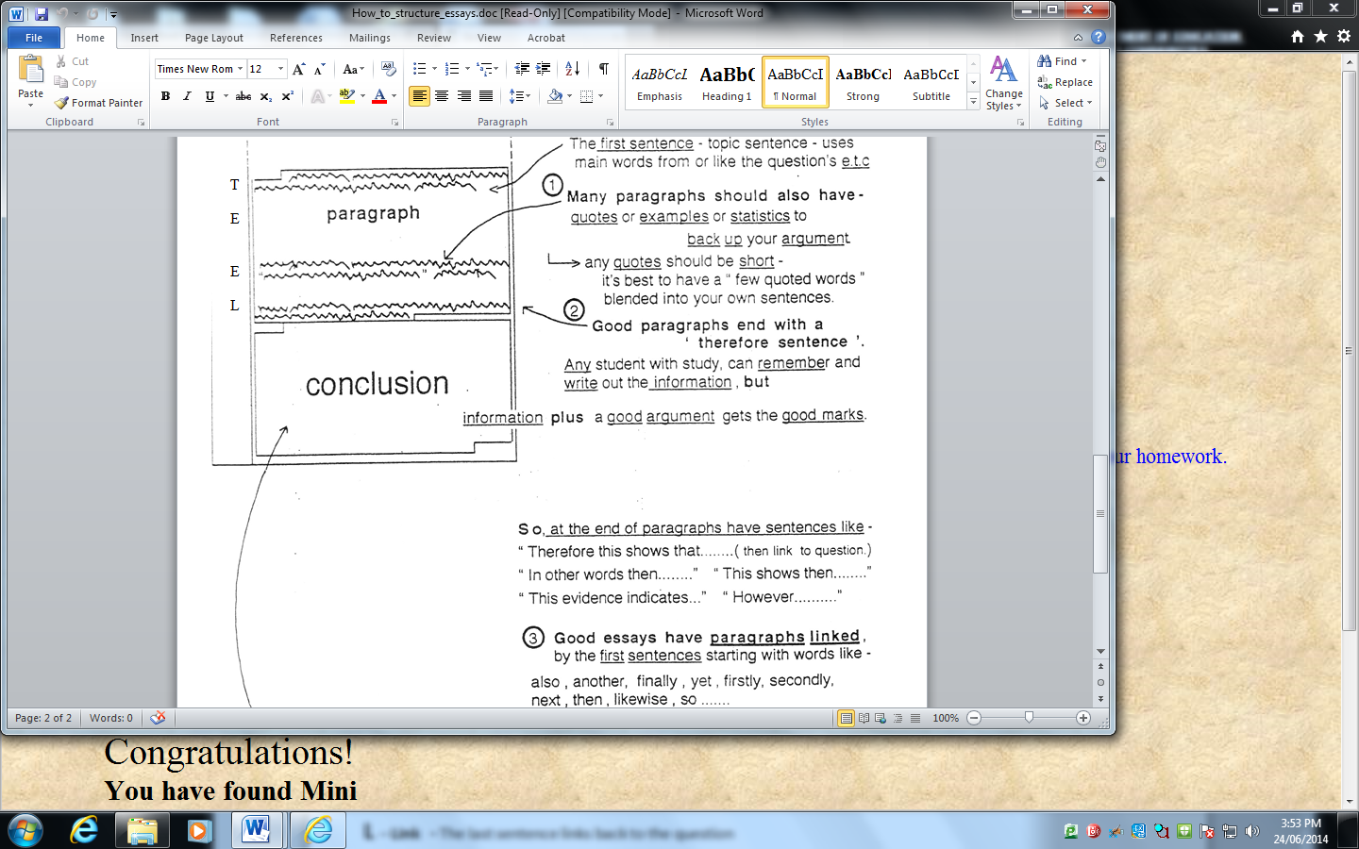
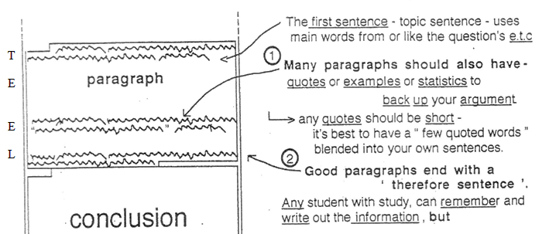
Supporting
Evidence
(then link back to the question)
Link or
Expand with extra details here…..

‘Therefore’ is a great word to start your link sentence with. (Use ‘In conclusion…’ if ending an essay.)
You should use ’therefore’ at least once in every essay or short answer.
Other great argument words that examiners like to see are: ‘However,…’ and ‘For example….’

