The Witch’s Daughter
by Nina Bawden  Chapter 1  1. How did the boys in the town act when they saw  Perdita near the jetty?  2. Why didn’t Mr. Smith want a child living in the house  with him at Luinpool?  Chapter 2  3. Why did ‘Frog Face’ think Perdita needed a ‘good whipping’? 4. What did ‘Frog Face’ give Perdita?  Chapter 3  5. What was Mr Hoggart looking for on the Island of Skua?  6. What did Tim find in Carlin’s cave? |  | 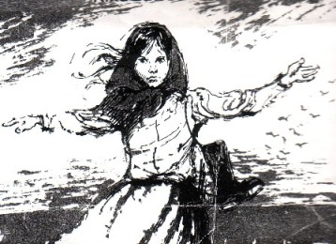
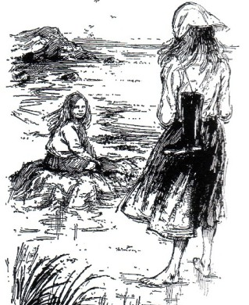 | Chapter 4  7. Why did Janey scream from the upstairs bedroom and then start shaking?  8. Where was Mr. Hoggart taken to in the helicopter?  Chapter 5  9. What did ‘Toffee Papers’ steal from Tim?  10. Where did Mr. Smith tell Perdita he was going to take her?  Chapter 6  11. What did Perdita want Janey to teach her?  12. What does Tim think of Perdita’s ‘special Powers’?  Chapter 7  13. What had happened to Perdita’s parents?  Chapter 8.  14. What did Janey discover about Tim’s ruby?  15. Did Tim’s father think Tim needed more imagination or evidence?
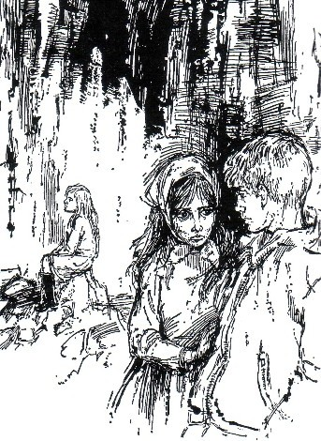
Chapter 9
16. What was the real name of the character known as ‘Toffee Papers’,
‘Frog Face’ and Mr Jones?
17. What did Perdita take from
Mr.Smiths suitcase?
Chapter 10
18. Who carried the hurricane lamp
into the cave?
19. How did Mr. Jones trap the
children in the cave?
Chapter 11
20. How did the children find their
way out of the cave?
Chapter 12
21.Who helped the exhausted children in the rain get back to the Hotel after they got out of the cave?
www.interactive-learning.com.au
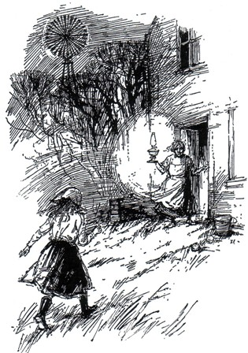
Chapter 13
22. Who tried to sneak into the hotel and was watching the policeman
through the window?
23. What did Janey like to collect?
Chapter 14
24. Why did Mr.Campbell and Mr Smith go lobster fishing if they didn’t
like lobsters?
Chapter 15 25.Who was in the boat then it crashed onto the rocks?
Chapter 16 26. What did Janey find in the sheep’s skull?
Chapter 17 27.What did Perdita give Janey as a goodbye present?

