T.E.E.L. Paragraphs – Draw and write the following in your book
T – Topic Sentence – uses some of the
main words from the question
E – Expand with Extra details (information)
E – Evidence to support what you say – with a quote
from a source or an example
L – Link - The last sentence links back to the question

A TEEL Paragraph
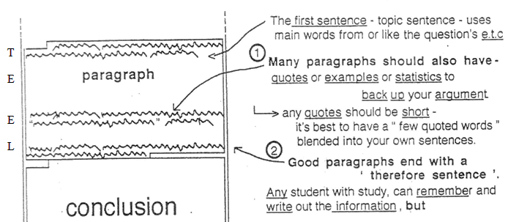
(Evidence)
link or
Expand with extra details here…..

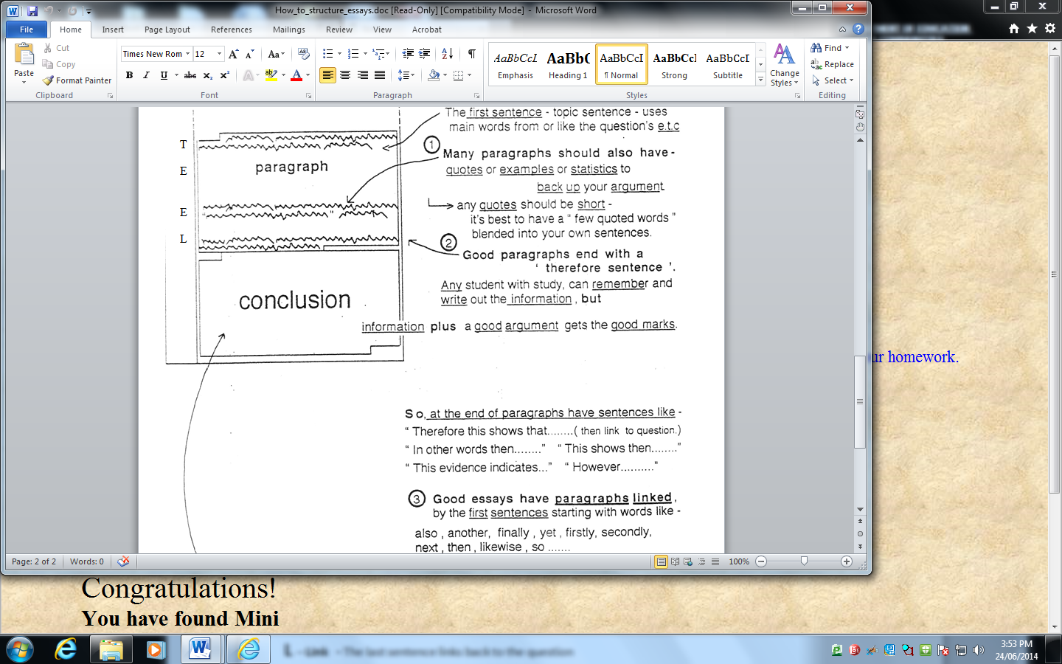

(then link back to the question)

