Medieval Realms
The Norman Conquest (Modified from a resource by Mr. Moorhouse)
When Edward the Confessor died Harold Godwinson, Earl of Wessex, was crowned King. Harold was a leading Saxon lord and had plenty of experience as a warrior and as a governor, so for him to be crowned in the absence of a royal heir to the throne was not too surprising.
Within 10 months though, Harold was killed in Battle, the crown was in the hands of a foreigner and Saxon England was at an end.
You are going to try and establish (work out) why this happened.
Source A
“finally Edward sent Harold himself to Normandy so that he
could swear to me in my presence what his father …had sworn
to me here… through his own hands he made himself my vassal
and with his own hand he gave me a firm pledge concerning the
kingdom of England.”
Written by William of Poitiers
William of Poitiers was a biographer of William of Normandy, the source is written as though the Duke was speaking.
(A biographer records a person’s life story.)
(In other words, according to William, Harold had promised to be an obedient follower of William, and had promised that William could become king.)
QUESTION 4a1
What reasons did William of Normandy have to be upset by Harold’s accession to the English throne?
(‘by Harold’s accession to the English throne’, means ‘by Harold becoming King on the English throne.’)
Source B
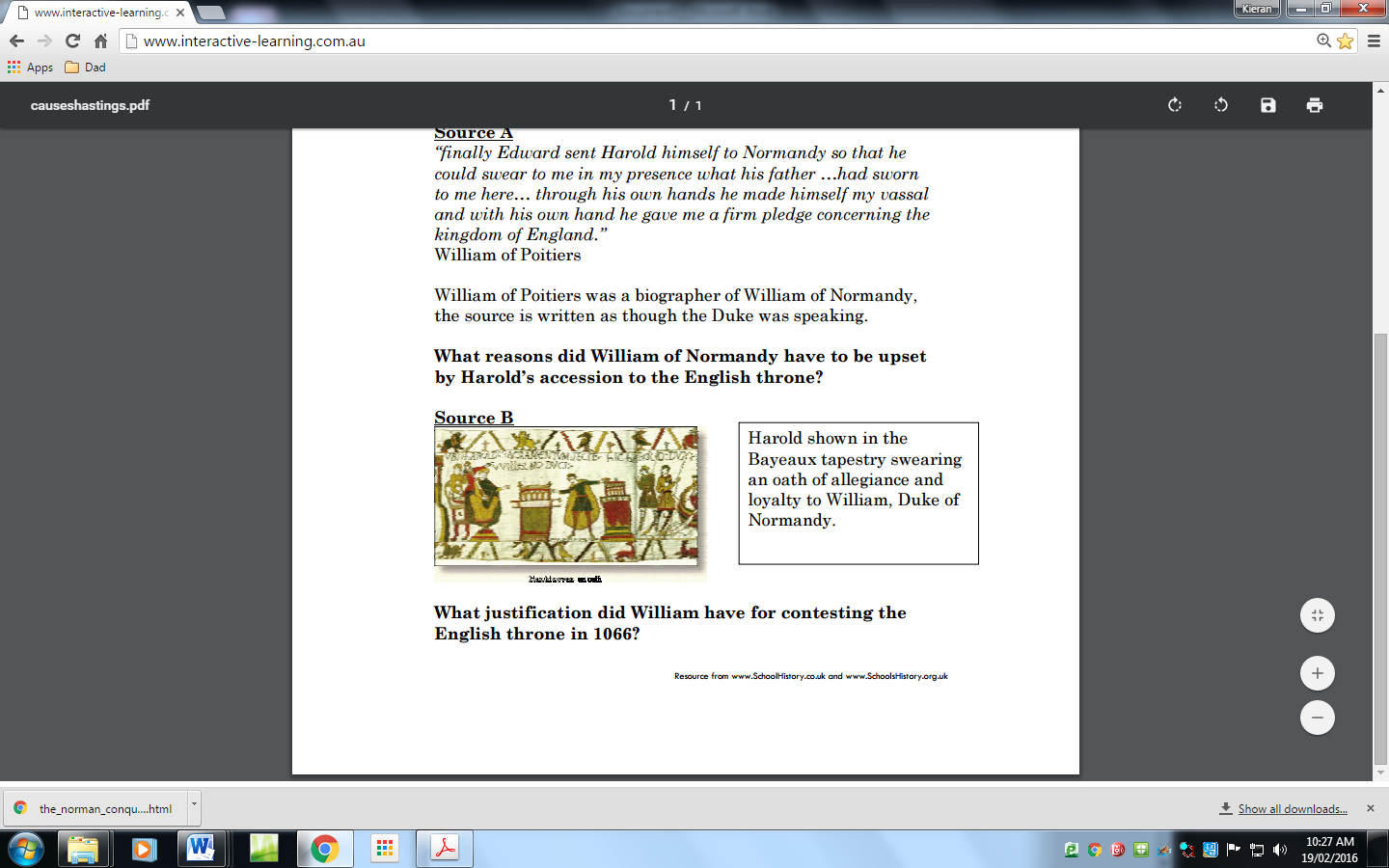
QUESTION 4a2
What justification did William have for contesting the English throne in 1066?
(In other words, why did William think it was fair to argue that he should be the new king on the English Throne and not Harold.)
(Modified from a resource by www.SchoolHistory.co.uk and www.SchoolHistory.ogr.uk)

