Source A – The code of the Samurai by Yuzan Daidoji 1600
One who is a samurai must before all things keep constantly in mind by day and night, from the morning when he takes up his chopsticks to eat his New Years breakfast to Old Years night when he pays his yearly bills, the fact that he has to die. That is his chief business. If he is always mindful of this, he will be able to live in accordance with the paths of loyalty and duty, will avoid evils and difficulties, keep himself free from disease and disaster and be able to enjoy a long life. He will also be a fine person with many admirable qualities… he must commit himself to everlasting service to his daimyo lord or give unending devotion to his relatives…..

How to use and quote sources in history
It’s easy!!! Just follow these 3 simple rules;
1. Never write out long slabs of quoted text in an answer.
(Just quote 2 or 3 words from the source and blend these words into your own sentences.)
For example:
Question: Using Source A explain the main qualities expected from a Samurai.
The main qualities expected of a Samurai was to be “loyal” to his “daimyo lord” and provide “everlasting service”. A Samurai was also required to think about his death constantly. According to Daiboji in Source A this would help him “be a fine person” and help him perform his duties such as giving “unending devotion to his relatives”.
*Now highlight in source A the words that were quoted in this answer.
2. Mention the source you are using in your answer, or put the name of the source you use at the end of your paragraph. (This avoids plagiarism)
For example:
Source A provides evidence on the qualities of a samurai. Yuuzan Daidoji noted that a Samurai should be “loyal” and give “everlasting service” to his Daimyo lord and devote himself “to his relatives”. (Source A)
3. Never use the word “quote” in your answer. A better way to introduce some quoted evidence is to use the words “noted” or “stated”
For example:
Question: Using Source A explain the main qualities expected of a Samurai.
Daidoji noted that the main qualities a samurai should have is to stay on the “paths of loyalty and duty”. Yuzan Daidoji stated that a Samurai would be able to maintain these “admirable qualities” if he saw his own life as less important, and was prepared to make his own death his “chief business” and was “always mindful of this”.
Source 1 Yamaga Sokō, a philosopher and expert in military strategies who lived during the mid sixteenth century.
The business of the samurai is to reflect on his own position in life, to give loyal service to his master if he has one….. To devote himself to duty above all…. He must live up to the best samurai traditions of good form. This is particularly true in connection with training in the arts of war and with the manufacture and use of armour and horse (trappings).

Source 2 Okuba Tadataka, a Japanese warrior from the Edo period.
As long as it is my duty towards my lord, I would like to die in battle in front of his eyes. If I die in my home, it be a death without significance."

Source 3
Extract from “Samurai Weaponry” by Jeffrey Hays
Swords traditionally have been the favourite weapon of samurai. Samurai carried two hardened steel swords---the katana (long sword) for fighting and the wakizashi (a 12-inch short sword) for protection and suicide. Worn at the waists, these swords served as both weapons and symbols of samurai authority. The swords of high-ranking samurai were decorated with elaborate engravings of dragons and other beasts. Swords in Japan have long been symbols of power and honour and seen as works of art.
Only samurai could carry both of swords. It was against the law for the peasant class to use one…Other samurai battle weapons included the giant battle axe, a two pronged spear, and bows and arrows. Some samurai foot soldiers used both long bows and short bows.
.

Source 4
Extract from “Retroactive” by Maureen Anderson, Ian Keese and Anne Low
They were the top ranking class in society beneath the Daimyo… In earlier times they were solely warriors, but as Japan became more peaceful under the Tokugawa, their role in administration also became important. In their training, skills in reading, writing and poetry and ceremonial behaviour were now as important as training in archery, horse riding and sword fighting.

An artists impression of the attack on Lord Kira’s Edo mansion from the Tale of The 47 Ronin.
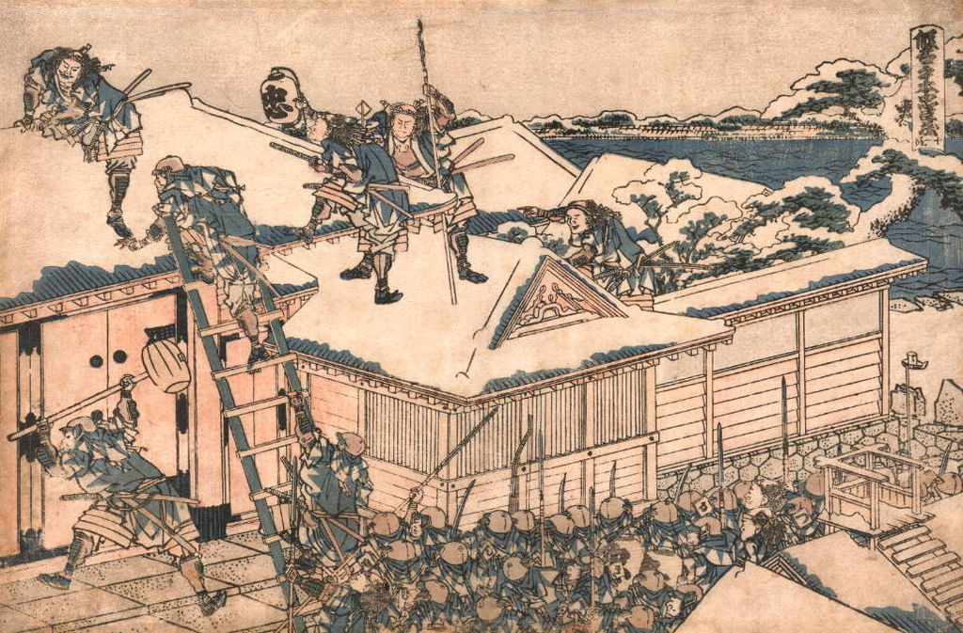

Source 5
Extract from “Samurai Training” by Jeffrey Hays
Samurai were the sons of samurai and they were taught from an early age to obey their mother, father, and daimyo. When they grew older they were trained by Zen Buddhist masters in meditation and Zen ideas of harmony with nature. They were also taught about painting, calligraphy, nature poetry, mythological literature, flower arranging, and the tea ceremony… They were expected to be proficient in the martial arts of aikido and kendo as well as swordsmanship and archery.
An individual didn't become a full-fledged samurai until he wandered around the countryside begging as a pilgrim for around two years to learn humility. When this was completed they achieved samurai status and received a salary from his daimyo paid from taxes (usually rice) raised from the local townspeople.

Source 7
Extract from “Samurai Training” by Jeffrey Hays
Samurai were the sons of samurai and they were taught from an early age to obey their mother, father, and daimyo. When they grew older they were trained by Zen Buddhist masters in meditation and Zen ideas of harmony with nature. They were also taught about painting, calligraphy, nature poetry, mythological literature, flower arranging, and the tea ceremony… They were expected to be proficient in the martial arts of aikido and kendo as well as swordsmanship and archery.
An individual didn't become a full-fledged samurai until he wandered around the countryside begging as a pilgrim for around two years to learn humility. When this was completed they achieved samurai status and received a salary from his daimyo paid from taxes (usually rice) raised from the local townspeople.
Source 7
Extract from “Samurai Training” by Jeffrey Hays
Samurai were the sons of samurai and they were taught from an early age to obey their mother, father, and daimyo. When they grew older they were trained by Zen Buddhist masters in meditation and Zen ideas of harmony with nature. They were also taught about painting, calligraphy, nature poetry, mythological literature, flower arranging, and the tea ceremony… They were expected to be proficient in the martial arts of aikido and kendo as well as swordsmanship and archery.
An individual didn't become a full-fledged samurai until he wandered around the countryside begging as a pilgrim for around two years to learn humility. When this was completed they achieved samurai status and received a salary from his daimyo paid from taxes (usually rice) raised from the local townspeople.
Source 7
Extract from “Samurai Training” by Jeffrey Hays
Samurai were the sons of samurai and they were taught from an early age to obey their mother, father, and daimyo. When they grew older they were trained by Zen Buddhist masters in meditation and Zen ideas of harmony with nature. They were also taught about painting, calligraphy, nature poetry, mythological literature, flower arranging, and the tea ceremony… They were expected to be proficient in the martial arts of aikido and kendo as well as swordsmanship and archery.
An individual didn't become a full-fledged samurai until he wandered around the countryside begging as a pilgrim for around two years to learn humility. When this was completed they achieved samurai status and received a salary from his daimyo paid from taxes (usually rice) raised from the local townspeople.

Japan Samurai Sources Worksheet
Answer the following questions using the method outlined in the 3 rules.
(Also remember that in history you must always use full sentences.)
- According to sources 1 and 2 what are the most important duties of a Samurai warrior?
_______________________________________________________________________________________________________________________________________________________________________________________________________________________________________________________________________________________________________________________________________________________________________________________________________________________________________________________________________________________________________________________________________________________________________________________________________________________________________________________________________________________________________________________________________________________________________________________
- Using source 4 explain how the role of the samurai changed during the Tokugawa period.
_______________________________________________________________________________________________________________________________________________________________________________________________________________________________________________________________________________________________________________________________________________________________________________________________________________________________________________________________________________________________________________________________________________________________________________________________________________________________________________________________________________________________________________________________________________________________________________________
3. Using source 3 describe the types of weapons used by the Samurai.
_______________________________________________________________________________________________________________________________________________________________________________________________________________________________________________________________________________________________________________________________________________________________________________________________________________________________________________________________________________________________________________________________________________________________________________________________________________________________________________________________________________________________________________________________________________________________________________________
4. According to source 3 why were peasants not allowed to carry or use Swords?
_______________________________________________________________________________________________________________________________________________________________________________________________________________________________________________________________________________________________________________________________________________________________________________________________________________________________________________________________________________________________________________________________________________________________________________________________________________________________________________________________________________________________________________________________________________________________________________________
5. According to sources 4 and 5 what training and skills were required for the samurai?
_______________________________________________________________________________________________________________________________________________________________________________________________________________________________________________________________________________________________________________________________________________________________________________________________________________________________________________________________________________________________________________________________________________________________________________________________________________________________________________________________________________________________________________________________________________________________________________________

