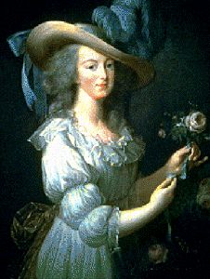
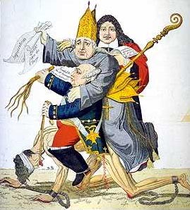
A. ________________________________________________
.B. _____________________________________________________
______________________________________________________

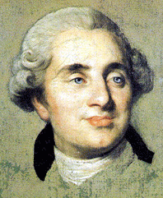
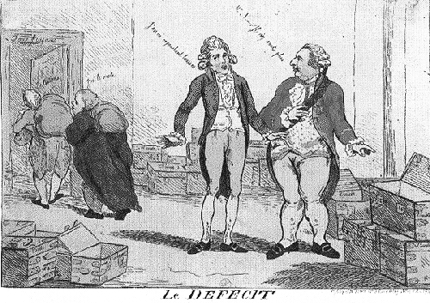
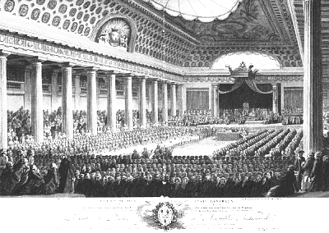
__________________________________________________ C.
_____________________________________________________
______________________________________________________
______________________________________________________
D. _______________________________________________________
_______________________________________________________
_______________________________________________________
E. ____________________________________
_________________________________________________ F.
__________________________________________________
__________________________________________________
__________________________________________________
G. ________________________________________
___________________________________________
___________________________________________
___________________________________________

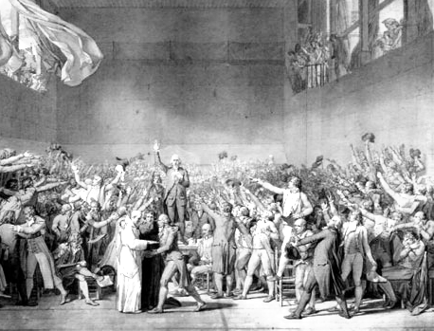

_________________________________________ H.
_________________________________________
_________________________________________
__________________________________________
page1
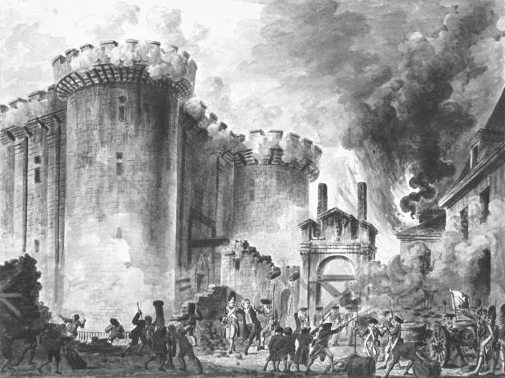
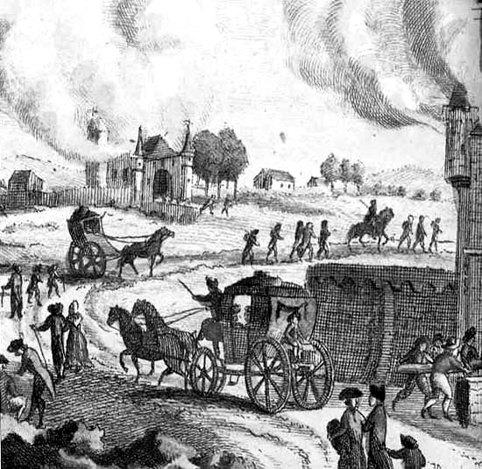
I. _______________________________________________
_______________________________________________
_______________________________________________
_______________________________________________
___________________________________________________ J
____________________________________________________
____________________________________________________
____________________________________________________
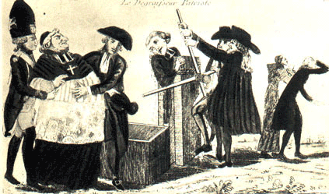
K. ________________________________________________
________________________________________________
________________________________________________
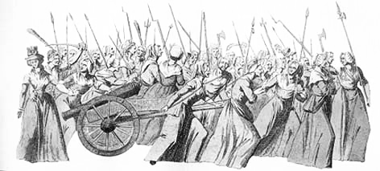

_________________________________________ L.
__________________________________________
__________________________________________
__________________________________________

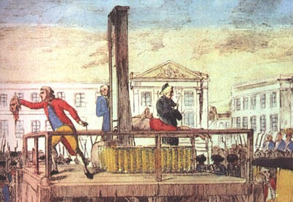
M. ______________________________________________
_______________________________________________
_______________________________________________
_______________________________________________

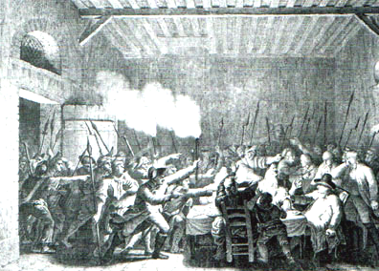
___________________________________________ N.
_____________________________________________
_____________________________________________
_____________________________________________

page 2
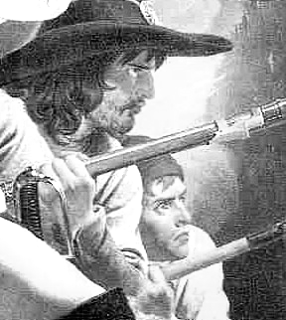
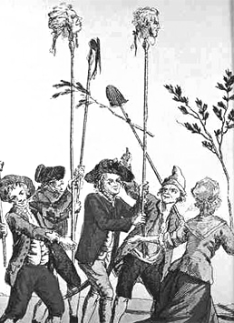
O. __________________________________________
__________________________________________
__________________________________________
______________________________________ P.
________________________________________
________________________________________
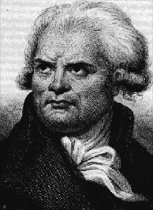


Q. ________________________________________________________
_________________________________________________________
_________________________________________________________

_______________________________________________________ R.
_______________________________________________________
_______________________________________________________
_______________________________________________________
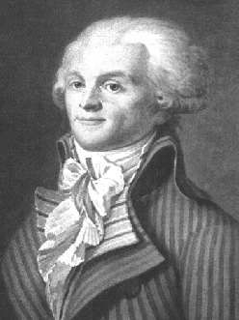
S. ____________________________________________________
_____________________________________________________
_____________________________________________________
_____________________________________________________

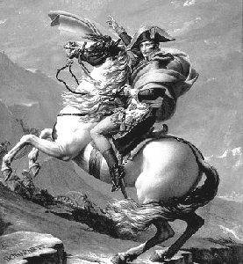
______________________________________________________ T.
______________________________________________________
______________________________________________________
______________________________________________________
______________________________________________________
______________________________________________________
page 3 www.interactive-learning.com.au

