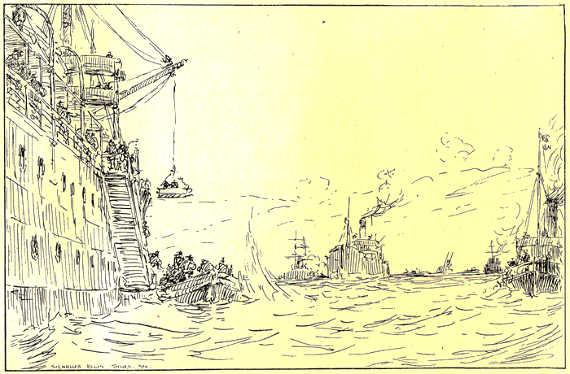
The Gallipoli Campaign
http://www.abc.net.au/innovation/gallipoli/
A. Time Line: (10 marks)
From the above site, on a new A4 page construct
a timeline of the different main battles that
Australians were involved in on the Gallipoli peninsula.
- Also, for each battle include 3-4 key points about the battle.
B. Fact Finding: (5 marks each)
- Describe the initial landing of the ANZAC troops at Gallipoli. (1 paragraph – your own words!)
- Also include a sketch or photograph.
- Describe the different tactics and weapons that the Turkish forces used, to prevent the allied forces from achieving their objectives in the Gallipoli campaign.
- In one paragraph, describe the evacuation form Gallipoli. Include in this an explanation of the tactics the Anzacs used to hide the evacuation from the Turkish forces. (Include a diagram or photograph)
- Provide a sketch or photograph and a brief description, for each of the different weapons that the ANZACs used at Gallipoli.
C. Opinion/ Argument: (10 marks)
Examine the ‘Profiles ‘ section in this same site (http://www.abc.net.au/innovation/gallipoli/ )From the list of Turkish soldiers profiled, select the one individual Turkish soldier for which it could be argued, made the most effective contribution in the Turkish war effort against the Allied invasion on the Gallipoli peninsula.
D. Research Task: (10 marks)
Do some wider research about the British and French Contribution to the Gallipoli Campaign.
Then draw and fill in a chart similar to the following:
The Gallipoli Campaign | Number of Troops: | Casualties: | Name of Regiments: | Name and Location of the battles:
British
French
A good site for research:
http://www.iwm.org.uk/upload/package/2/gallipoli/index.htm (Total Marks – 50 )

