The Change in Australia's Relationship with Britain and the USA During the War.
a) On a new page, write the above heading. Then make point form notes from the following two pages, but only points that you don’t already have in your workbook.
World War II - Australia meets the world - a new approach in foreign policy
Source A
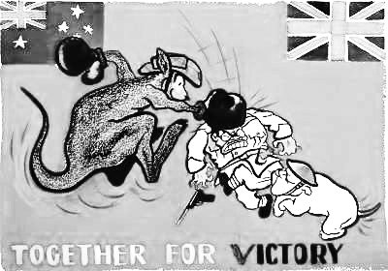
Make up your own questions and activities, for questions b), c), and e). Don’t answer them, but make them interesting and target the key point. e.g. Design another cartoon that explains/ shows…
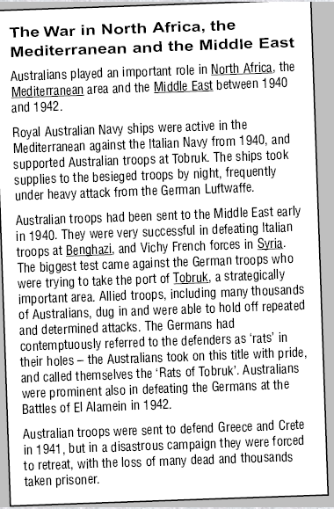
War in the Pacific caused a new direction in foreign policy
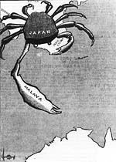 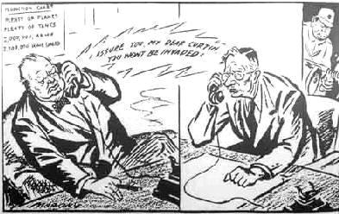
Source B Source c "I assure you my dear Curtin, you won't be invaded"
d) Who are these three characters shown in the cartoon (Source c ) meant to represent?
What is the point the cartoon is trying to make?
In October 1941, John Curtin became Prime Minister of Australia. Curtin refused to see Australia as a colonial outpost serving only British interests. When the American base at Pearl Harbour was bombed by the Japanese, without warning, on 7 December 1941, John Curtin had been prime minister for only 2 months. He immediately turned his attention to engaging the Americans in our defence and began negotiating with British Prime Minister Churchill for our troops to be sent home from the Middle East. Churchill wanted the Australian troops to stay helping the British in North Africa and the Middle East. But an atmosphere of crisis was created with the fall of the British fortress island of Singapore to the Japanese and the bombing of Darwin in February 1942.
b)

c)
The outbreak of war in 1939 had little initial impact on Australia but as German troops conquered more and more countries in Europe in 1940, Menzies called for an 'all in' war effort. By 1941 Australia had over 100,000 soldiers serving in Europe and the Middle. More than 10,000 men from the RAAF were also in Europe.
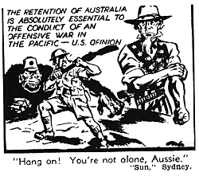
"Australia's Big Fear, and realization. The Japanese attack on Pearl Harbour finally confirmed Australia’s big fear: to be isolated and white in an Asia at war. When Singapore fell to the Japanese on 15 February 1942, 15,000 of the 130,000 captured troops were Australian. The country was faced with the fact that a distant and beleaguered Britain could be no real assistance against an imminent Japanese invasion. Japanese planes bombed Darwin on 19 Feb and Broome on 3 March 1942. Australia faced the very real threat of invasion by Japanese troops! The Australian war cabinet then outraged Churchill by diverting the 7th Australian Division from the defence of Burma to the New Guinea and Pacific regions.
If it is true that the Australian nation was born at Gallipoli, it is no less true that with the fall of Singapore – Australia finally came of age."
Source D
e)

