Practice Formal Letter – Use the following sources and persuasive language.
The Background:
The body of a man has been found in a peat marsh or bog in Tollund Fen in Denmark. The man has a rope noose twisted around his neck. The local Police Superintendent at Tollund Fen Police Station, is convinced that the man was recently murdered and wants to start a murder investigation.
You are a visiting young archaeologist and have just been shown some documents and ancient local artefacts. You think that the sources you have been shown, prove that the man found dead in Tollund Fen, was not a recent murder victim.
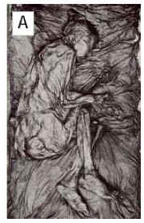
Your Letter:
Write a formal letter to the Police Superintendent trying to persuade him that the body they found was not the result of a recent murder. Use evidence from the sources to convince him that there was not a recent murder, and that a murder investigation would be a waste of time
Use the layout and features of a business or formal letter when writing your letter to the Police Superintendent. Also read this page, it will help you use the sources and structure your letter.
Sources Collected by Archaeologists with the help of Local University Scientists:
Source A shows the body found in a peat bog on Tollund Fen in Denmark. A peat bog is where partly decayed vegetation, like tightly woven grass and tree roots, build up over a long time period. A type of acid that builds up in the peat kills bacteria. The peat is known to preserve bodies that would normally rot away.
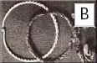
The man lay on his right side as if he was asleep. He wore no clothes, except for a pointed skin cap and a smooth hide belt. His hair was cut short. Round his neck was a twisted rope noose. It was drawn tight around his neck and throat.
These items (Source B) were not found on the Tollund man but are similar to what was found around his neck. The items are a rope noose and a neck ring. Iron Age people buried metal neck rings in the ground for a sacrifice offering to the Spring Goddess. In return they hoped for good crops.
This noose was around the neck of another Iron Age man who was found buried in nearby Borre Fen in Denmark. His last meal had been a vegetable soup made from only Spring seeds. Next to the noose in the picture is a metal neck ring that has been twisted, and looks like the rope noose. The Iron Age people used to bury these in the bogs as sacrificial offerings to the Spring Goddess.
The iron age was between 700 BC and 300 AD.
SOURCE C
SCIENTIFIC REPORT on the body found in the marsh in Tollund Fen in Denmark
Age : The heart and organs were healthy. The wisdom teeth had just grown. These appear in people around 20 years of age.
Stomach: The man had eaten soup at least 12 hours before he died. The soup was made up of seeds that were connected only with the Spring
Date of Death: When he died and they dug his grave to bury him, some plants were trapped in the peat around his body. The plants were about 2000 years old, from the time of the Iron Age.
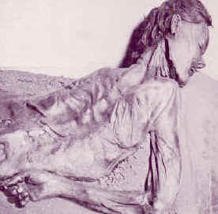
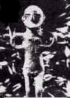
SOURCE D
An Earth Goddess of Spring
statue found in a local bog.
SOURCE D
This man was found buried in another nearby bog at Grauballe, which is also in Denmark. He had no noose around his neck, but his throat had been cut from ear to ear.
Scientists discovered that he had been buried 1650 years ago. His last meal, eaten shortly before his death, had also been a vegetable soup made from only Spring seeds.
Here is a description of the religious customs of seven North German tribes, such as the Aviones, the Anglii. These tribes worshipped Mother Earth, the Goddess of Spring and growing crops. Each spring they celebrated the birth of new life and crops.
These North German tribes lived in the area which is now modern Denmark.
SOURCE F
"There is nothing unusual about these tribes except their worship of Mother Earth, the Goddess of Spring. They believe that each spring she rides through the tribes. A chariot carries a statue of the Goddess in a procession. After this the chariot and her robes.....are washed clean in a hidden lake. This task is done by slaves who are then..." killed.
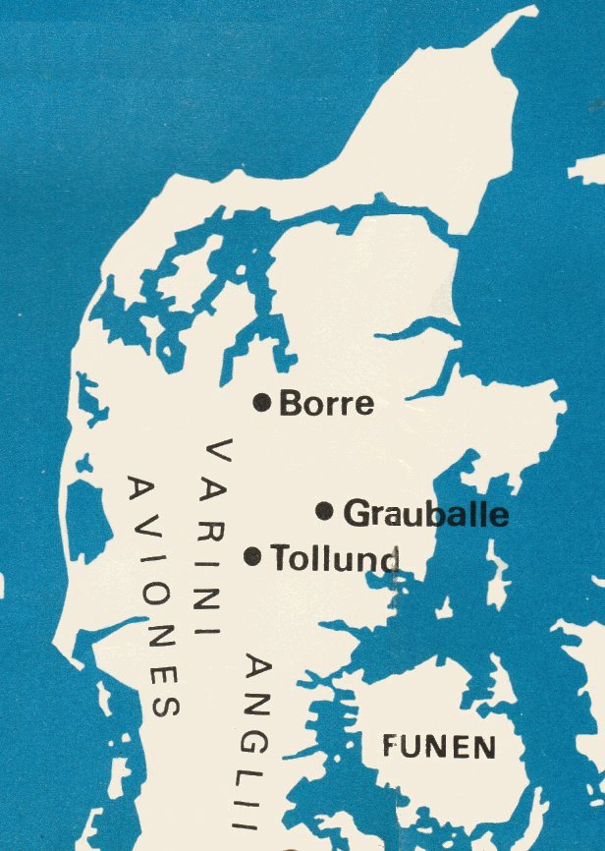
(Written in 97-98 AD by Cornelius Tacitus, a Roman, in his book about the German tribes.)
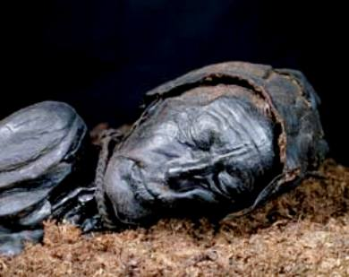
A close up photograph of the man found buried
in Tollund Fen in Denmark
Map showing the north German tribes, that were living where now
is modern day Denmark. Also Tollund, Grauballe and Borre Fens.
Some of the above material is from a unit by Ms Boughey http://www.schoolhistory.co.uk/year7links/history/tollund_man_updated.pdf

