In memoriam: Matthew Carrington's death in a hazing incident four years ago remembered on Sunday
By SARAH KINGSBURY-Staff Writer
Posted: 02/03/2009 12:00:00 AM PST

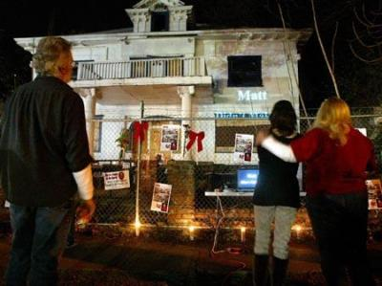
Bill Vahl (left to right), Debbie Smith, and Bobbie Vahl watch a PowerPoint dedication projected...
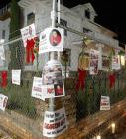
CHICO — It's been four years since Matthew Carrington died — long enough for a new cycle of Chico State University freshmen to wonder about the boarded-up house surrounded by a chain link fence on West Fourth Street.
A lot has changed since Feb. 2, 2005, when Carrington stopped breathing after his brain swelled from water intoxication, during a bizarre hazing ritual while pledging the unofficial Chi Tau fraternity.
The seven fraternity members who were sentenced to jail have since been released. Carrington's mother, Debbie Smith, successfully lobbied state politicians to pass legislation to enhance hazing penalties. And the house, which has stood empty since that night, now has a new owner.
Every year Smith, her husband Greg and their 18-year-old son Travis drive to Chico to hold a candlelight vigil at 10:30 p.m. on Feb. 1. This is the estimated time that the third day of the fraternity's "Hell Week" began and the last time Carrington entered the house alive.
On Sunday, a dozen friends and family members from the Bay Area gathered in front of the house and covered the fence with ribbons, flowers and posters and lined the sidewalk with candles. They stood in pairs and held each other as they watched a video of Carrington's life projected onto the front of the house.
No one from the university or the community attended. A few groups of young people passed nearby talking loudly and laughing. A man from across the street wandered out and watched the video for a moment before returning inside.
Smith worries that her son will be forgotten.
"If they forget about him, they'll forget what happened to him and it will happen again," she said, remembering the morning when she found out something had happened to her 21-year-old son, "I don't want someone else to get that phone call."
Through her grief, Smith has become something of a spokeswoman for the prevention of hazing, which is part of the reason why she holds a vigil in front of the house every year. She said she increasingly encounters more people on her annual return who have never heard of Matthew Carrington, strengthening her resolve to show up every February to remind them.
"I think, my gosh, am I going to be 70 years old and coming here lighting candles? And yeah, I can see myself doing that," she said.
Next year the family might encounter a different scene. After four years as a boarded up and abandoned reminder on a south campus street, the former fraternity house has finally been sold.
The new owners wish to remain anonymous until the sale is complete, but they confirmed to the Enterprise-Record Monday that the site will house a center that will benefit students.
Smith said she isn't angry at the seven members of Chi Th au who pled guilty to hazing charges and received varying lengths of jail time for their involvement in Carrington's death. All the men apologized to her for the incident, and after they began serving their sentences at the Butte County Jail, she said to went to visit them.
Smith still talks to Gabriel Maestretti, who spent a year in jail for involuntary manslaughter, about twice a year, and occasionally asks him to join her at a speaking engagement. As part of his plea bargain, Maestretti agreed to help educate the public about the dangers of hazing.
"I know the intent of the boys was never to kill Matt," she said. "They actually really, really liked him."
Staff writer Sarah Kingsbury can be reached at 896-7761 or skingsbury@chicoer.com.
Family Remembers Matthew Carrington - CBS 12 Action News

