ActiveResource.org PeaceResource.com TheWordsmithCollection.org WritingResource.org
WANTED
George W. Bush
To print more of these posters visit sites on margin
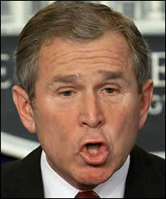 | 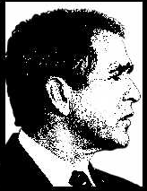
FOR CRIMES AGAINST HUMANITY & THE PLANET
Beware if you meet this man! He suffers from delusions that he is the “democratically-elected” President of the world. *He is guilty of civil and constitutional violations of US law & international war crimes. Do not approach. He is nuclear-armed and dangerous. Act responsibly and contact the nearest police station or your representative.
*Mr. Bush admitted to violating the law when he authorized illegal domestic spying and bypassed the special court. The Attorney General of the United States testified to Congress that Bush personally prohibited Justice Department staff from investigating the illegal spying. Mr. Bush admitted to “renditions” which included torture, rape, & murder. The Constitution is the supreme law of the land. When Mr. Bush is allowed to selectively ignore civil and constitutional law and our right to a fair trial suspended, freedom is lost. We need not become a dictatorship to catch terrorists. Nor does an undeclared war suspend the Constitution.
To print more of these posters visit sites on margin
AlternativeNewsResource.org ComputerResource.org InternationalPeaceresources.org UnionResource.org

