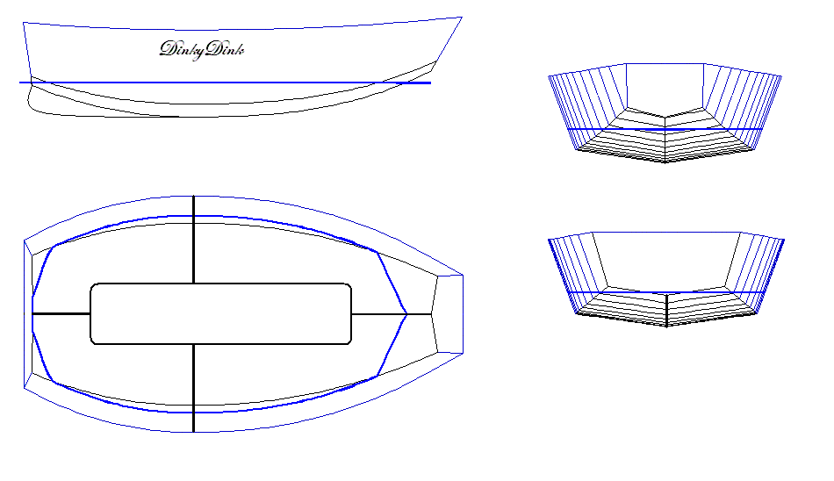
DinkyDink Plans
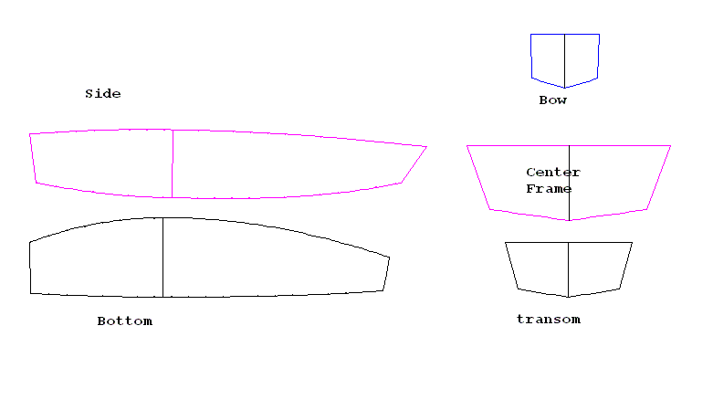

Bottom Panel Half
Station | X | Y | X2 | Y2
1 | 1/4 | 3/4 | 0 | 11 5/16
2 | 4 | 9/16 | 4 | 12 9/16
3 | 11 11/16 | 1/4 | 11 7/16 | 14 1/2
4 | 18 5/8 | 1/16 | 18 5/8 | 15 11/16
5 | 25 3/4 | 0 | 25 3/4 | 16 5/16
6 | 32 13/16 | 0 | 32 13/16 | 16 3/16
7 | 39 15/16 | 1/16 | 38 1/2 | 16
8 | 47 | 1/8 | 45 11/16 | 15 1/4
9 | 54 3/16 | 5/16 | 53 | 14
10 | 61 1/2 | 9/16 | 60 1/2 | 12 5/16
11 | 69 1/8 | 1 | 68 1/4 | 10 1/8
12 | 72 15/16 | 1 1/4 | 74 3/16 | 8 3/16
Side Panel
Station | X | Y | X2 | Y2
1 | 1 3/8 | 3 1/4 | 0 | 13 5/16
2 | 5 5/8 | 2 1/2 | 5 5/8 | 13 3/4
3 | 13 1/8 | 1 7/16 | 13 1/8 | 14
4 | 20 3/8 | 5/8 | 20 3/8 | 14 1/4
5 | 27 3/4 | 1/4 | 27 3/4 | 14 1/4
6 | 34 5/8 | 1/16 | 34 5/8 | 14 1/8
7 | 41 3/4 | 0 | 41 3/4 | 13 7/8
8 | 48 7/8 | 1/16 | 48 7/8 | 13 5/8
9 | 56 1/8 | 7/16 | 56 3/8 | 13 1/8
10 | 63 3/4 | 1 1/8 | 63 3/4 | 12 1/2
11 | 71 1/2 | 2 1/4 | 71 1/2 | 11 3/4
12 | 76 5/8 | 3 1/4 | 82 | 10 5/8
Rear Transom Half |  |  |  | Frame Half Dimensions
Station | X | Y | Station | X | Y
1 | 0 | 0 | 1 | 0 | 0
2 | 1 9/16 | 10 7/16 | 2 | 2 | 16 1/16
3 | 11 5/16 | 13 3/16 | 3 | 15 1/4 | 20 3/4
Front Transom Half |  |  |  | Skeg Curve Coords
Station | X | Y | Station | X | Y
1 | 0 | 0 | 1 | 0 | 5 5/8
2 | 2 1/16 | 6 3/4 | 2 | 7 1/16 | 3 1/16
3 | 11 3/16 | 6 7/8 | 3 | 14 3/16 | 1 5/16
 |  |  | 4 | 21 1/4 | 5/16
 |  |  | 5 | 28 5/16 | 0

Above are the offsets for the plywood panels.

Bill of materials:
- 2 sheets ¼” plywood (more if you want to use a mold to form the boat)
- 8 1x2 furring strips
- 1”x 8”x 12’ board for seat, frame, knees and seat end supports.
- 40 ft of 3-4” fiberglass tape (more if you haven’t used it before)
- 1 ½ quarts of epoxy (2:1ratio)
- 100 4” wire ties or a roll of wire
- Sandpaper, paint, roller or brushes,

When plotting the panels, start from the lower left corner of the ply or from X and Y lines drawn on the sheets of ply. The lines in the Bottom and Side panels are the Max Beam Stations. The station for the Side panel is X=31”, X2=31 1/4” and for the bottom is X=29 5/16”, X2=29 5/16” .Mark these when laying out your panels so you can locate your frame and mold if using one. The transoms and the center mold are shown full, but the offsets are only for half of the panel. X and Y are for the bottom line and X2 and Y2 are for the top line. Join the end points with a straight line. The bow and stern transoms are shown with flat tops but any kind of shape could be cut into the ply above the shear line. The Skeg Curve Coordinates, when plotted, should follow the curve of the bottom from the point X= 28 5/16 (the lowest point of the boat) to the bottom rear of the transom. Running a straight line from X=0, Y=0 to the point X=28 5/16, Y=0 will give you a shape somewhat like the picture below. From there you can shape the bottom and end of the skeg as you please, keeping the curve intact so you can fit it to the bottom of the boat, in a slot cut out in the keel strip. The keel strip is cut on an 8° bevel to match the bottom and one piece reversed to install (see picture on next page).

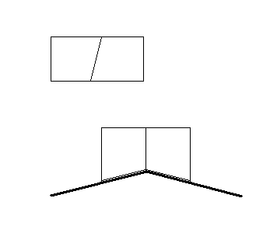

Beveling and installation of Keel Strip.

Construction is of standard stitch and glue techniques. Framing is light on the front and rear transoms, just to stiffen the flat panels up a bit. All framing can be installed on the assembled hull. If desired, you can use a center mold to bend the panels around as you stitch the boat together, but it is not necessary. The offsets for the center frame have been adjusted for ¼” ply, but may need some further tweaking. Remember, it is better to have a some gap to fill with epoxy as this makes a stronger joint. Trust to the shape of the panels to give the proper shape of the boat and all you will have to do is spread the beam to the correct width. The actual frame shape will vary with your choice of seating arrangements. A longitudinal (lengthwise) bench seat is what I would recommend as this allows you to adjust your position forward and back to help balance the boat. Couple this with multiple oarlock positions and you should have a decent comfort and stability zone. For this, a frame that is low across the middle and that runs up the side to support the sides at max beam would be best, somewhat like the pictures on the next page. The easiest way to do this is with a frame, seat and supports made with 1X pine or fir boards.
All joints should be filleted for strength. The angle of the side panels, from vertical, is 20° so the arms of your frame should be the same. The Vee in the bottom’s angle is 8° per side, from horizontal. Use the offsets for the mold to get an accurate shape.

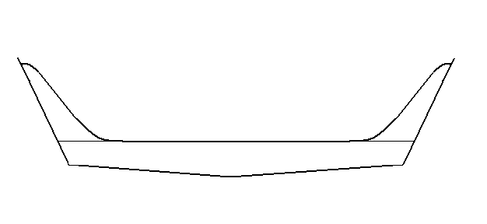
Suggested frame shape.

Suggested Longitudinal Seat and supports.

Stitching:

To assemble the boat, cut out all your parts to form the boat “kit”. If you are going to use the mold, you will need to frame it to brace it from bending. For the skeg, determine the shape and cut two pieces to laminate together, making a ½” thick piece. Laminate it by wetting the joining sides with epoxy and then smoothing some thickened epoxy over that, then clamping the piece together and letting it cure. Clean any ooze off after the epoxy has cured, then glass the outsides to give it some abrasion resistance. Once this is done, take the two bottom panels and face the insides together, then drill evenly spaced holes in the keel edge (about 8-12” apart and 1/4-3/8” from the edge) and stitch the holes, leaving the stitches slightly loose so you can unfold the panels. While the panels are still folded together, mark the chine edges evenly for your stitching holes. Subsequently mark the chine edge of your side panels at the same intervals. When you bend the panels to meet, the holes should line up exactly. Follow along the curves of the panels to mark your edges, don’t use station points because the curves are different between the bottom and side panels and the points wouldn’t line up properly. Check your marks by rolling the edge of the side panels along the edge of the bottom panels, the points should meet. With this done, it is time to go 3D. Unfold the bottom panels and spread them into the V bottom shape. The joint should slip smoothly without binding but without having too much slop. With the panels spread, fit the front transom and stitch it into place (loose stitches). Fit the rear transom and stitch it into place and support it in position. From here you stitch the side panels to the rear transom and the first couple of holes in the bottom. They you stitch the sides to the bow transom. If you are using the mold, now you need to spread the panels and slip it into place on the max beam station lines you drew earlier when you laid out the panel. Nail or screw into the framing of the mold to secure it in place, or you can simply continue sewing the sides to the bottom (loosely) and then spread the top later and hold in place with a 1x2 as a temporary thwart. Once the panels are all sewn together, snug up the stitches evenly, side to side, from stern to stem. Put your spreader in if you didn’t use the mold and stand back and admire, then take a break…your back is probably yelling bad things at you right now.

Filleting:
When you are ready to dive back in, now is the time to square up the boat. First of all get the transoms level. Use whatever means available to support the boat to accomplish this. Then measure from one rear transom corner to the opposite front transom corner. Measure the other side and then make them even. Recheck the transoms for level and the boat should be square, provided the panels were cut correctly. Trust your eye and look the boat over carefully, you will probably detect it if anything is wrong. If everything looks ok, now it is time to start filleting. The purpose of filleting is to spread the stresses sustained by the joint over a larger area so we want to get a good bond with the wood. Make sure you don’t fillet or glue the mold into the boat as you will need to remove it to install the frame. Leave a little gap on either side that you can fill when you fillet the frame in later.
To start filleting, wet the joint with plain epoxy before filleting with epoxy putty, thus bonding the epoxy that soaks into the wood with your fillet. Use a plastic spoon, a tongue depressor, a small spatula or something along those lines to apply the putty. Use filler to thicken the epoxy to the consistency of peanut butter. Make sure you press the mixture into the corner of the joint (don’t worry if it squeezes through the joint, this is actually preferred), then smooth your fillet with plain epoxy using a disposable brush and embed glass tape into the fillet and soak the glass, bonding everything into one homogeneous unit without having to sand in between. When laying the cloth tape in, use strips about 3-4’ long. You don’t have to overlap the pieces of tape as little gaps won’t significantly affect the joint, just butt them together. Recheck for square and then walk away, clean up your stuff and let the epoxy cure to the point where there is no tackiness. This may be as few as 3-4 hours depending on temperature. To speed up curing, heat the building area to 90-100° or so. To clean up, first use white vinegar to neutralize the amines and stop the epoxy from curing, then use lacquer thinner or acetone to remove the epoxy from anything you want to keep.

Glassing the Chines:
Once the inside joint has hardened, you can flip the boat over and start on the outside. Remove the wires or cut the ties flush and start sanding/grinding. You will need to round over the outside of the joint so that the tape will adhere to the wood properly. Wet the wood with epoxy, lay the tape over the joint and wet out the cloth. There should be no white spots, and the cloth should almost disappear. Once you get all the seams taped, you can use strips of thick plastic sheet and smooth it over the epoxy, roll or squeegee it to work out any bubbles and press the cloth against the wood, then let it cure. This will eliminate 95% of the sanding necessary to get a nice finish. This is not a necessary step, but you will have to sand a whole lot more to get the finish decent. Once the epoxy is cured, sand to feather the edge of the tape into the wood and when you are done, a cross section of the joint would look like the picture below.

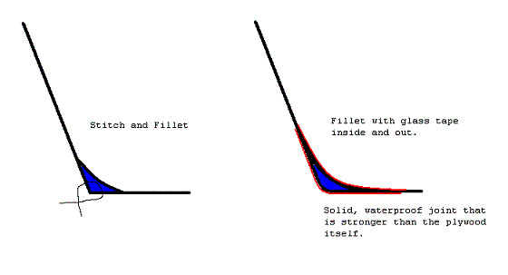

Interior and Finishing:
The next step is to install the frame, seat and trim strips and skeg, then put the finish on the boat. First we start with the frame. Flip the boat over and square it up again, remove the mold if you used it and then fit the frame into the boat at the proper max beam station. This may take a little tweaking. Next we install what we call knees. These are triangular braces in the corners of the boat at the shear. A picture of one is below.



They are made by laying a chunk of 1x stock on a corner and tracing on the underneath along the side panels. That will give you the correct angle, then bevel to fit after you have cut each out. Glue in and tap a few finishing nails in from the outside to keep them in place. Now we fit the in and out wale strips. I like to use either 1x2 furring strips or Mahogany Ranch casing (3/8” x 2”) available at around $.90/ foot, or a combination of the two. The furring strips can sometimes be difficult to bend. If you have a planner or table saw, you can thin them down a little, making them easier to bend. Glue using epoxy or PL Premium and screw them into place along the exterior of the shear, screwing from the inside. Install the inside wale and either screw or clamp everything into place. Recheck the boat for square and then fillet and tape the frame into place then let everything harden. If things aren’t square now, you are pretty much stuck with it, but only you will know so don’t worry about it. Flip the boat over and raise it up so you can glue and screw your keel strips on. Make sure to cut out a slot for your skeg and test fit it before finalizing with epoxy or glue. Glue the keel strips on and screw them from the inside (you can remove the screws and fill the holes later if you wish). Butter up the slot with regular epoxy then thickened epoxy and then put your Skeg in. Wrap a few cords around the boat to act as a clamp and let everything cure hard.
Cut and shape your seat pieces so you are sitting from 10-12” off the bottom and fit the seat supports to your center fillet (in the bottom of the Vee) then assemble the seat and install and glue it into the boat. Fillet all joints with the hull and frame (no need to put glass on the fillets though) and let cure. To finish, sand, primer and paint to your liking. To locate your positions for the oarlocks, you will need to have the hull waterproofed so this is the last step. Tie the boat to shore, launch it and establish your proper trim points for one and maybe 2 people, then mark the positions for your oarlocks. Pull the boat out and install one or more pairs of mounts for your oarlocks and you are done. Enjoy.

Steve Lewis
LewisBoatWorks.

Email me at numbaoneman@aol.com if you have any questions.

