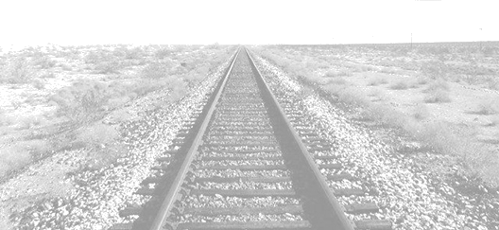
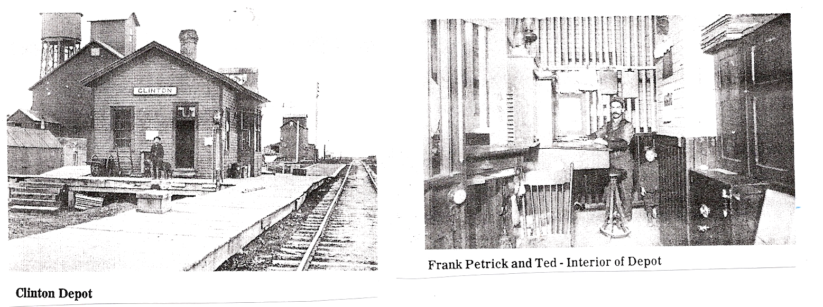
The Fargo and Southern Railroad Company built our
depot back in 1883, the year the town of Clinton
was founded. The depot was a fundamental asset to
the town of Clinton and kept it a booming place. This
therefore created a connection with the depot to
almost all of the town’s history. The depot closed
December 12, 1969 and the tracks were torn as the line
was discontinued March 1, 1980.

Months before our Centennial Celebration in 1983, the depot was in danger of demolition by the local elevator cooperative that had acquired it from the railroad. A group of citizens petitioned the city council and the depot was purchased by the city of Clinton to remove that threat. Years after the purchase date the depot was once again in danger of becoming destroyed. The citizens petitioned the city and came up with funding by August 2007.

On July 4, 2008 we will be celebrating our 125th year of the depot and
still it is continuous danger of demolition. The depot is still standing but the
constant battle with the threat of demolition continues to haunt our city.

Clinton Depot is an important link to the past of our citizens and
fosters a sense of community pride that together we have been taking care of our history. Our depot is a reminder of the past, why our town is here, and how our ancestors lived and traveled.

Architecturally, the building is unlike any other in town and it is easy to tell it was built in 1884. However, the depot is in continuous need of repair.

Please help us keep this valuable landmark a place that
welcomes citizens of Clinton and our visitors and join in the fight to save the Clinton Historical Depot.

The Save the Depot Committee is now working on
raising awareness and funds to support the stabilization of the depot structure. We are looking in to many grant
options, most of which require matching funds. The Save the Depot Committee is also looking for volunteers to help with our project and ideas, networking, and
getting important resources and ideas.
If you are interested in how to get involved or would like more information on the Clinton Depot, please contact Aaryn Arndt at 320-305-1042
Save the Historic Clinton Depot!
Visit us at http://www.angelfire.com/clintondepot/
I have lived here 56 of the almost 125 years the depot has been standing, and I don't want to see it go.
- Darlene Olson
”
Every time I walk by the Depot I think about all the history of Clinton that had taken place there and of all the wonderful memories I have of it.
- Tara Fletcher

