Italian submariners badges 1918 – 1945
Author: Alberto Menichetti, published in “UNIFORMI E ARMI”n.4 – August 1989
Editor: ERMANNO ALBERTELLI EDITORE © 1989
Translation: Massimo Agati © 2004 – version 1.0 (please, if used, quote the source)

During two world wars the crews of our submarine fleet, facing long and dangerous patrols and waiting in ambush for days and nights along strategic routes, had accomplished a large number of missions, rewarded with brilliant successes; special badges were coined for those who fought aboard those boats.

Italy, a country of ancient traditions in sea battles, thanks to its shipbuilding advanced technologies and the skill of its designers, was one of the first nations to develop the practical use of submarines in its combat fleet.

Until World War 2, Italy Submarines fleet has been one among the largest of the world for number of vessels.

Submariners has always been peculiar sailors since the life aboard has been convicted in small and unhealthy places, deprived by the pure air and sunshine, challenging all the risks coming from attacks and ambushes.

For those reasons, since World War 1, they were awarded with unique insignia, which were distinctive from other specialities of the navy.

The act n.36 dated January 16th 1918 issued on “Giornale Ufficiale per la Regia Marina” (Royal Navy Official Bulletin) authorised the badge for the submarine crew: this one had to be worn on the left sleeve of the jacket, above the speciality and the rank insignia, only by Petty Officers, Senior Ratings and Junior Ratings.

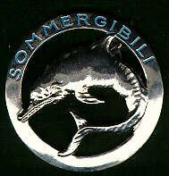
Picture 1 - Submariner Crew badge authorized on January 16th 1918, worn on left sleeve by Petty officers, senior ratings and junior ratings.

It was made in the shape of a silver metal circular pin (46mm diameter), with a leaping dolphin in the centre and the word “SOMMERGIBILI” (Submarines) written on the upper half of the circle.

In 1924 (act. N.491 dated September 25th 1924) was authorised a new badge for Officers and Petty Officers, while for Senior and Junior ratings retained the old design. The new badge, though similar in the overall shape, was made in gilt metal for Officers and white metal for Petty Officers; it took the form of the usual leaping dolphin in a circular ring of smaller diameter (16 mm), surmounted by the Savoy Crown and the word “SOMMERGIBILI”. It was fixed to the uniform by a small brooch, on the left breast, 10 mm above the ribbon bar or in place of that. This badge has been produced in a number of variants, different for shape, dimensions and attachment; there are also specimen made in gold wire embroidered cloth, to be sewn to the uniform in place of the metal one.

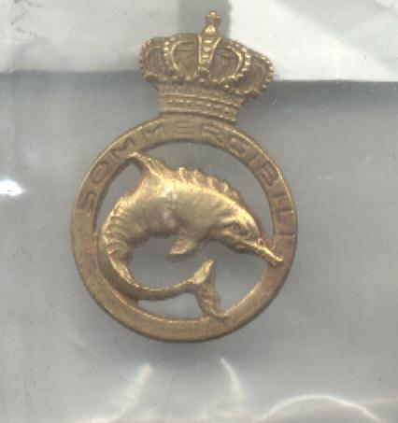
Picture 2 - Badge authorized in 1924: gilt for Officers, silver for Petty Officers.

In December 1939, the regulations for the Officer and Petty Officer small badge and the Senior and Junior Ratings sleeve badge, were superseded; new regulations provided that only the Officer badge should be worn by all, without distinctions.

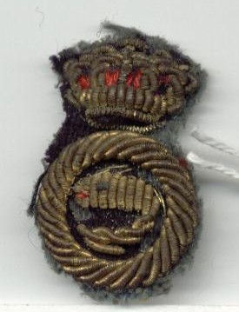
Picture 3 – A not common embroidered version of the traditional badge. Those were intended to be sewn to the uniform in the correct position; there were some embroidered on white cloth for summer uniforms.

In 1941 (act. N. 131 dated March 31st 1941), it has been authorised again the original sleeve white metal badge for senior ratings and junior ratings, while for Officer and Petty Officer was held the small gilt breast badge. Since it was created without Savoy symbols, after the declaration of Republic, the ratings badge was confirmed, although the Officer one was modified in shape, deleting all the monarchy symbols.

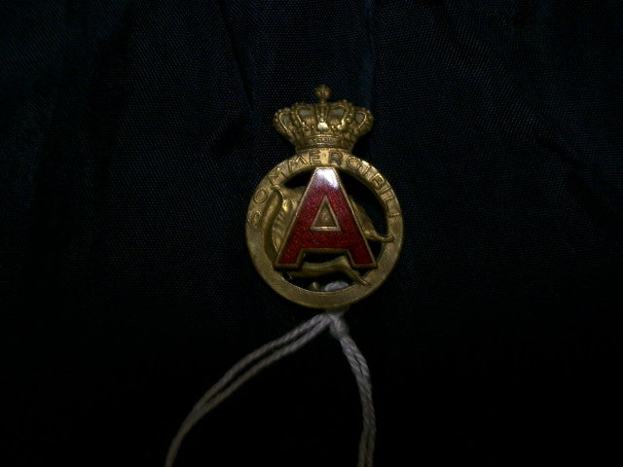
Picture 4 - Traditional badge for the Bordeaux base personnel; not officially authorized, but tolerated by commanders.

During World War 2, Italian personnel based at Bordeaux base, called “Betasom”, worn a peculiar insignia, never officially authorised, though tolerated by the headquarters. It was the same small golden breast badge, with a red enamelled letter “A” placed in the centre of the badge. The “A” stands for the initial of Atlantic Ocean, the operation zone where those submarines were deployed.

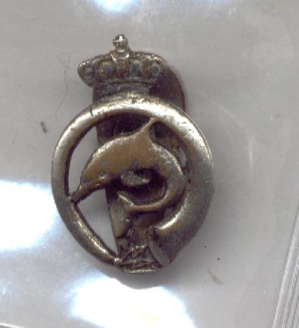
Picture 5 - Silvered variant of the ASDIC operator non official badge; the official insignia was made in shape of an "I" embroidered in gold on the uniform sleeve.

It was also authorised a special Honour badge (Order dated November 11th 1941); this act established that this badge had to be awarded, with a proper document, to all those submariners who had spent over 4 year on the boats; in war time, this period was reduced to three months of combat. It was awarded to the owners of medals and crosses for military value, who had been discarded from the active service because of wounds caused by service aboard submarines. The badge had been also awarded to the civilian personnel detached aboard the submarine, who fulfilled the same requirements as for military personnel. This honour badge should be worn in place of the previous one, for those who had been awarded. The honour badge consisted in a metal pin, depicting a leaping dolphin, surrounded by a laurel wreath and surmounted by the Savoy crown; on the upper part there was the word “SOMMERGIBILI” ; its diameter was 25mm and it was authorised for all the grades without distinction. It had to be worn on the breast, above the ribbon bar, or in place of that if absent.

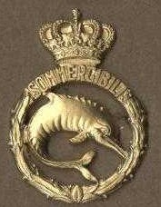
Picture 6 - Submariners Honour Badge; made in gilt metal and meant to be worn on the breast; the same for Officers, Petty officers, senior ratings and enlisted; if awarded, it replaced the other badges worn.

During Repubblica Sociale, the ones who were entitled to wear those badges, removed the crown themselves, though some specimen without crown were factory produced. The Honour badge was retained after the end of the monarchy (Act n.502, dated December 19th 1946), though with the suppression of the crown.

During Regia Marina years, a lot of unofficial insignia had been produced, also for single boats, flotillas or bureaus; at that time, it was deemed fashionable to wear on the uniform or on the civilian clothes an insignia which stated the service on a peculiar boat, or the participation to a special event or the assignment in the navy. Those unofficial badges were usually small pins, with the shape of a boat placed on a gilt or enamelled ring, enriched with the crown and the name of the vessel. Sometime they were made in the form of the regular ones, but with the name of the boats instead of the word “SOMMERGIBILI”.

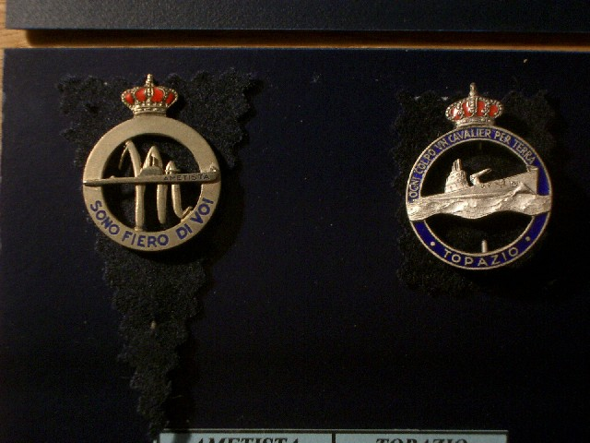
Picture 7 - Some specimens of commemorative or non official badges issued at the end of the '30s.

In 1938, celebrating Hitler’s visit to Italy, It has been held a great naval parade in the gulf of Naples. During this visit, one hundred submarines together sailed underwater and emerged in same time keeping the formation, and after a single shot of gun, they submerged again, producing a great admiration feeling in the host. Mussolini, at the end of the parade, addressed to crews a message with the words “Sono fiero di voi” (I am proud of you), this phrase was written on some badges and medals coined in memory of the event.

During R.S.I. (Repubblica Sociale Italiana: the fascist government at the side of the Germany headed by Mussolini in northern Italy with the purpose to fight Allied Forces, in opposition to the royal family surrender after the September 1943), as consequence of the notorious events which spread confusion among Italian armed forces, the sole surviving usable submarines in the hands of RSI Navy were the “pocket submarines” class C.A. and C.B. (Caproni Type A and Caproni type B) based in the Black Sea and in the high part of Adriatic Sea.

Based in Pola, Decima Mas (tenth Mas) flotilla operated armed C.B.s in a group named “Longobardo” after the famous submariner dead in the Atlantic Ocean.

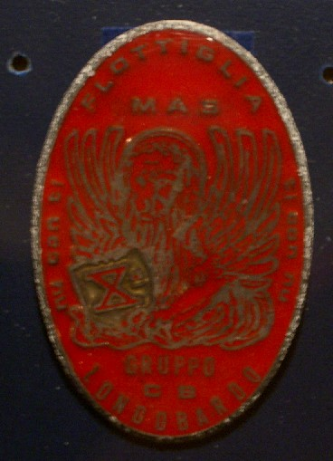
Picture 8 - Submarine Group C.B. Longobardo. The C.B. were pocket submarines operated by X (tenth) Mas from the Pola Base.

The “marò” (crewmen) worn an oval insignia made of red bakelite and fixed by a brooch; it depicted the winged lion of San Marco holding the X Mas emblem on a closed book, around the edge it was written the motto dedicated to the dalmatian people (Pola is in Dalmatia, the northern part of Croatia) by the famous poet Gabriele D’Annunzio, “Nu con ti, ti con nu” (We are with you, You are with us) and the legend “Flottiglia MAS – Gruppo C.B. Longobardo” (MAS Flottilla – C.B. Group Longobardo).

As noted before, Northern Navy hadn’t any real operational submarine due to the defections and damages occurred after the September, 8th 1943 and because of the lacking of any logistic structures to complete the reparations already begun.

Volunteers from the crews of those damaged submarines formed the Naval Infantry battalion “Scirè”.

It’s notorious that battalions and groups of “Decima” were named after ships which sank heroically during the war. “Scirè” battalion was named after the famous submarine and it was made by submariners, so its members chose an insignia which combined traditions of the past and events of the present times.

It was created in the form of a pin, similar to the sleeve badge authorized in 1918, with some peculiarities which gave it a special iconographic appearance: the enamelled emblem of Decima Mas (a red X), was carved on the centre of dolphin and the words “BTG SOMMERGIBILE SCIRE’” replaced the original legend.

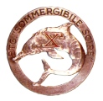
Picture 9 - The “Scirè” battalion Navy Infantry badge; members of this unit were former submariners.

During September of 1943, the BETASOM , the base of Atlantic submarines in Bordeaux, was commanded by Capitano di Vascello (Captain) Grossi and the events of the previous months had weakened the force of our submarines. Only two were operational the “Fiume” and the “Bagnolini”, converted in transport submarines on the routes towards the far east. By the base there were many submariners as specialised crew and reserve personnel. As a consequence of Italy’s armistice with the Allied Force, the submarines were seized by the German but thanks to the mediation of Commander Grossi, the personnel avoided the internment and deportation.

When the R.S.I. was settled, Grossi and most of the men agreed to the appeal for the reconstitution of a new navy force, so the name of the base “BETASOM” was modified in “Base Atlantica dell’Italia Repubblicana”(Italian Republic Atlantic Base). Crewmen created a peculiar badge in zamac (a light metal alloy made by zinc, copper, aluminium and a small quantity of magnesium), its was oval shaped, with a brooch on the back and depicted a sailing submarine surmounted by swastika superimposed on a fasces and surrounded by the phrase “Atlantico Fedeltà 8 Settembre”(Atlantic loyalty 8 September).

Bibliography:

Ministero della Marina – Giornale Ufficiale per la Regia Marina –Album delle divise 1929 – Regolamento sulle divise U.G. 5 1936.

Guido Bonvicini – Decima Marinai, Decima Comandante.

Fausto Sparacino – Distintivi e Medaglie della R.S.I..

Please note: the captions are from the original article. Photos are from my files and my collection and used solely for illustrative purpose until they will be replaced by the original images. M.A.

