New Jerusalem: The future of Christianity
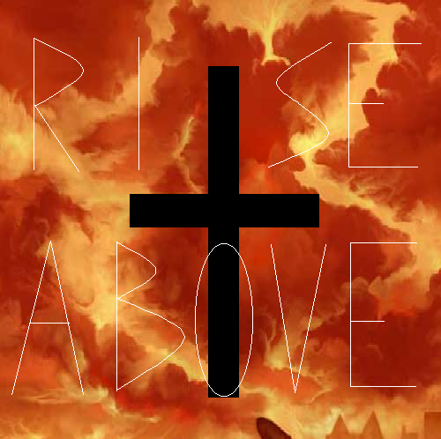
“Rise Above”- that’s the motto of New Jerusalem (formerly Pisces), and of the Bastionist Church. It’s hard to tell where New Jerusalem ends and the Church begins, and for all intents and purposes, one can consider them one and the same. Bastionists consider themselves the last hope good has in a universe turned to evil.

History: New Jerusalem was originally called Pisces, and was set up in 2070 EY, and started business a few years afterward. Back on Earth, during the 2140s, Unity started stirring up trouble, promoting some decidedly un-Christian values. In 2145 EY, in a highly controversial move, Pope Urban IX declared Unity to be agents of the Anti-Christ. Behind closed doors, Urban also stated that it was his belief that Nathan Harrison, leader of Unity, was the Anti-Christ, and that the world-wide schism that was going on was the battle between good and evil. Then in 2154, Unity blew up the Vatican, killing Urban and the whole College of Cardinals. Prominent Archbishops of the Catholic Church met in Jerusalem and tried to come to an agreement about what to do, but could not come to a consensus. One faction, the Bastionists, led by Archbishop Preuett suggested that evil had won the battle for Earth, but good could still live on in the heavens, and that the faithful had to retreat above- to the Colonies. The majority would hear nothing of this, and maintained that the role of the Catholic Church had to remain on Earth, with the people, with the battle that was being fought. A third minority faction suggested that there was no battle between good and evil going on, and held that Urban only believed what he did due to senility. The Bastionists, seeing that negotiations were going nowhere, left for Pisces, and were promptly excommunicated by the Catholics that chose to stay. The Bastionists responded by excommunicating the Catholics.
In 2167 EY, the Bastionists arrived on Pisces, and took control, appealing to the Piscean masses. A few of their Catholic fellows who chose to stay on Earth eventually came to join them, but most perished during the Unification Wars.

Politics: New Jerusalem is ruled by the Bastionists. The Bastionists are modeled after the Catholic Church, and they consider themselves the true Christian church. Not that there’s many factions anymore to oppose them. They’re led by Pope Maximilian III, although he doesn’t handle most of the day to day affairs. Bastionists constantly try to convert those from other planets, but meet with limited success.
New Jerusalem has fought often with the Drentrasi, and suspects future conflicts.

Economics: New Jerusalem has a free market, and the largest player is the Church. New Jerusalem has neglected technological advancement, but does have a large agricultural and craft sector. New Jerusalem’s main import is weapons and military hardware, to fund their massive defense program. New Jerusalem has a significant defense fleet, and that requires a lot of upkeep. New Jerusalem’s main exports are crafts, and food products.

Language: English [New Jerusalean], but all official documents are in Latin.

