Leo: Of the rich, by the rich, for the rich
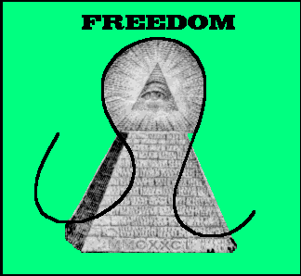
While the preamble to the Leonid Constitution states that ‘All Men Are Created Equal,’ that is not the case in Leonid society. Despite the democratic framework of the government, and entrenched (and constitutionally mandated) party system keeps the rich in charge. A look at the city of New Boston shows the great divide- some of the richest people in the galaxy live in New Boston, but the slums stretch on and away.

History: Leo was farther away than the other Zodiac Colonies, and wasn’t active until 2081 EY. The fact that travel times were longer made it a draw for those more concerned with the financial aspect of using the Colonies- the trip would be easier to afford, and more lucrative if one was already turning a profit. When the final flights to the colonies left in 2167, most of them went to Leo. When the fleet of ships showed up in 2181 EY, the Leonids weren’t sure what to expect. Many of the people were important politicians from the United States or other places, including former President George Verander. Verander and his cronies offered to write up a ‘liberal constitution’ for the people of Leo, and they were only too happy to accept. With the Leonids on his side, Verander deposed the Colony Overseer.

Politics: The Leonid Republic resembles the ancient United States. A popularly elected President is the leader of the Republic, but has to deal with the Senate, the legislative body. Competition between the two official parties, the Democracy Party and the Republic Party is fierce, with both sides vying for the favor of the large Leonid businesses that fund them. President Rudolf Charleston sits on the board of directors of his family’s pet industry, Charleston Steel, although it’s not known if Rudolf is calling the shots or if he’s just a stooge.

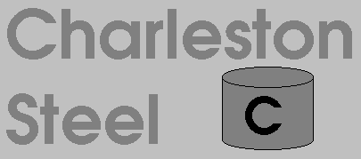

Economics: Business is booming on Leo, and most of the benefits of that flow to those at the top. Taxes are regressive, designed to reward those who succeed. Leo exports raw and refined materials (especially steel), and tends to imports entertainment goods and high-tech electronics, but the various Leonid corporations make a little bit of everything and need a little bit of everything, so market demand changes often.

Language: English [Leonid]

