Sagittarius: Peaceful Anarchy
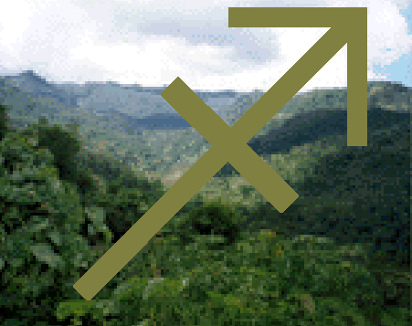
Sagittarius is less densely populated than the other free planets. In fact, except for the spaceport in New Shanghai, there are few Sagittarian cities with more than a few thousand people. That’s exactly the way the Sagittarians like it.

History: Sagittarius began business in 2080 EY, as a rugged alternative to the more tame environments of places like Virgo and Scorpio. Sagittarius is a more temperate planet, and several small ‘cottage towns’ were made for visitors, and when no visitors were present, the Sagittarians engaged in small, localized industries. The current lack of visitors changed little- the Sagittarians just had more time to themselves. Those visitors from Earth who learned they were trapped tended to settle into positions within their community, or moved to New Shanghai.

Politics: Most of Sagittarius is isolated communities, without any overarching government to dictate policy. New Shanghai is bigger and more important, and the City Overseer governs policy. Unlike the old Colony Overseers, the position is elected by the inhabitants of the city.

Economics: Sagittarius is productive, if behind the times in many respects. Those who live in the wilderness settlements are reasonably well-off and independent, usually only dealing with traders from New Shanghai. New Shanghai is more vibrant, the usual order of business being a channel for trade into and out of Sagittarius, with many who live solely off the margins of transactions made for others. Sagittarius tends to import machine supplies and entertainment goods, and is a chief exporter of raw materials.

Languages: English [Sagittarian], Chinese [Sagittarian]

