Mr. Goto

Senior Government

Topic: THE JUDICIAL BRANCH - COURTS
Unit Lesson #3 – The Supreme Court (Wed. 4/14/04)

State Standard:
2SS-P6 Analyze the structure, powers, and roles of the judicial branch of the United States government, including landmark United States Supreme Court decisions.

Objectives and Expectations for Learning:
The students will understand the significance and roles of the United States Supreme Court.

Anticipatory Set:
Review the information from yesterday.
Have the students pair up and read to them Plessy vs. Ferguson, 1928

Direct Instruction:
The teacher will briefly discuss Plessy vs. Ferguson before moving into details of the Supreme court using the attached notes.

Guided Practice:
Students may ask questions or use each other for help.

Closure:
Summary Closure: What is one thing we learned today?
This is what you can expect tomorrow…
Plessy vs. Ferguson
Brown vs. Board of Education, Topeka
Summative Assessment: Notes may be collected for points at the end of class.

I. Plessy vs. Furgeson
II. The Supreme Court
Judicial Review
Jurisdiction
Rule of Four
Writ of Certiorari
Certificate
III. Supreme Court at Work
Briefs
Oral Arguments
Conference
Opinions
Majority Opinion
Concurring Opinion
Dissenting Opinion

IV. Brown vs. Board of Education, Topeka

Objectives
* Understand the significance and roles of the United States Supreme Court.

Distribute and go over the tests from the last unit for review.

I. Plessy vs. Furgeson

Are there certain places where only seniors can go? Freshman not allowed?
Do you think it’s fair?
A Louisiana law required separate seating for white and African-American citizens on public railroads, a form of segregation. Herman Plessy argued that his right to “equal protection of the laws” was violated.
Were his rights violated? 14th Amend., Equal Protection Clause
The Court held that segregation was permitted if facilities were equal. The Court interpreted the 14th Amendment as “not intended to give Negros social equality but only political and civil equality.” Louisiana law was seen as a reasonable exercise of State Police Power.
Was justice served in this case?

II. The Supreme Court
-highest court in the land
Judicial Review- test the Constitutionality of laws and Pres. actions
Jurisdiction-only court with Appellate and Original Jurisdiction, most on appeal
-hears cases that exclusive and original jurisdiction in:
-controversies between two or more states
-cases affecting foreign officials, ambassadors
“Rule of Four”- four of nine judges are needed to accept an appeal
Writ of Certiorari (“to be made more certain”)- request of a higher court to a lower court for records on a case
-Mostly for important constitutional questions or application
Certificate- lower court unsure about application of a law, ask them to answer a specific question
III. Supreme Court at Work
Briefs- documents of your case filed before Oral Arguments
Oral Arguments-lawyers from each side present their case to the court, 30 minute limit
Conference- chief justice states opinion, then others based on seniority
Opinions
Majority Opinion- writes the opinion of the court, what they though, yes or no (Chief Justice unless he was a minority, then it goes seniority to majority)
Concurring Opinion- another judges support of the majority opinion
Dissenting Opinion- judge who disagreed with majority opinions writing
IV. Brown vs. Board of Education, Topeka
Relation to Plessy vs. Ferguson
What was determined in Plessy vs. Furgeson? Separate but equal is ok
10 yr. old girl not allowed to attend school in her neighbor hood because she was African-American. Father brought it to court, court said “separate but equal” had no place in education, Segregation is against the Equal Protection Clause
CLOSURE: Summary Closure- What did we learn today? One thing about courts?
What do you expect to learn about tomorrow?
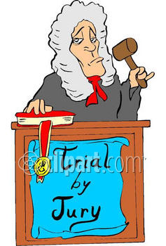
Name ________________________
Period _____

SUPREME COURT OF THE UNITED STATES

Where does the Supreme Court stand in terms of positioning compared to all other courts?

What is a name for all of the courts under the Supreme Court?

What matters does the Supreme Court have jurisdiction over?

What is unique about the Supreme Court in terms of jurisdiction?

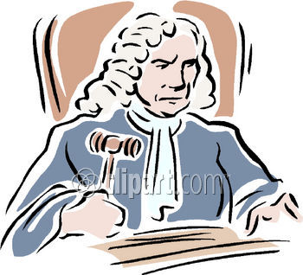
What is the “Rule of Four”?

What is a Writ of Certiorari? What is a certificate?

What happens when a case is in conference?

Who is the first to speak during a conference? How do they determine who follows?

What are the three different types of Court Opinions and define them?
-

-

-

Which opinion is known as the “Opinion of the Court”?
Look in the textbook for information on the following cases.

Plessy vs. Ferguson
What was the subject matter of this case?

How did the court rule?

Brown vs. the Board of Education
What was the subject matter of this case?

How did the court rule?

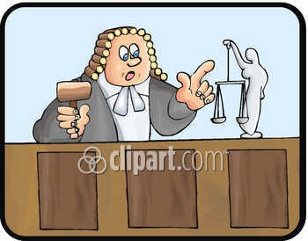
What did each of these cases have to say about the idea of “Separate but equal”?

