Each image is 10.5 inches X 10.5 inches, and the entire print, including the white border, is 18 inches X 13.5 inches. The prints were scanned by a Crossfield 636 Drum Scanner with high-resolution and printed by a Nexpress 2100 on #80 Classic Crest Linen Cover Stock.
Please email you purchase order to lulanart@yahoo.com or www.angelfire.com/ar2/lulan

Prints are available for the following paintings:

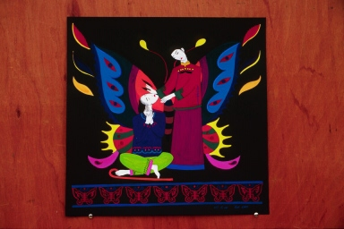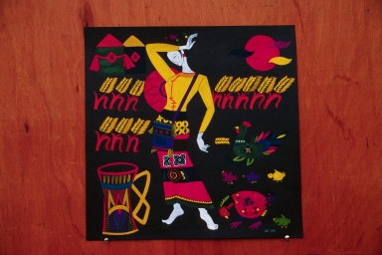

Jesus Heals Blindman Ruth
$40.00, $50.00(matted) $40.00, $50.00(matted)

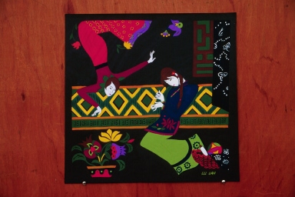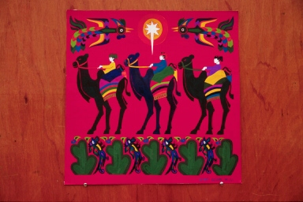

Annunciation 3 Wisemen
$40.00, $50.00(matted) ( by Lu Lan and Lu Wei)
$40.00, $50.00(matted)

* Shipping and Handling are not covered.

